Graduates need better skills if Africa is to more effectively utilize its resources. Billions are spent on education in hopes that its beneficiaries will have the knowledge necessary to impact the continent. The Coalition on Media and Education for Development Africa Forum (CAFOR) helps African youth obtain better skills. Lawalley Cole is the Executive Director of CAFOR and argues that integrating African youth into the labor market with decent and productive jobs remains a considerable challenge that requires regional and international partnerships. Lawalley Cole has pursued his masters’ and doctoral studies in Education and Business Administration at the University of Massachusetts and Walden University. He also studied at Dar es Salaam University for a bachelor’s degree, the University of Franche-Compté in Besançon, France, Université du Bénin in Lomé, Togo and Indiana University, USA. Capital’s Tesfaye Getnet interviewed Lawalley Cole to learn more about what CAFOR does. Excerpts:
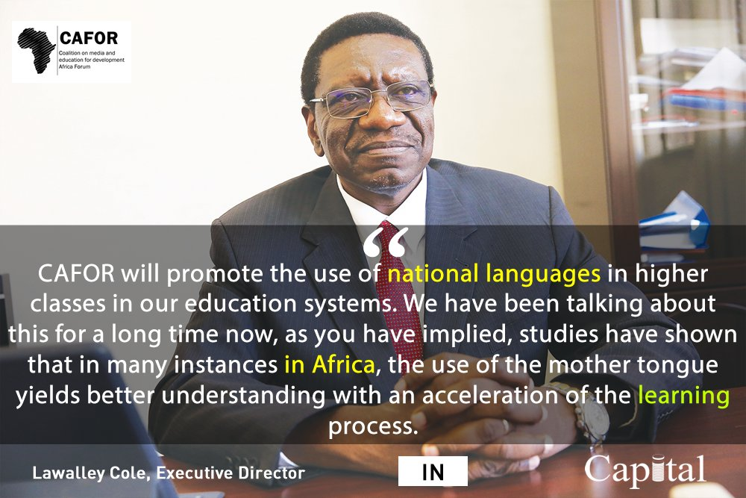

Capital: Why was CAFOR established?
Lawalley Cole: Africa’s youth are not doing so well when it comes to employment. Due to the current demographic transition where the population is steadily rising on the continent, many young people are leaving school without the right skills and quality of education to match them with the labour market. It is mainly with this in mind that professionals from the fields of education, communication, law, media, business and development from across Africa put their heads together in the last quarter of 2017 to establish a Coalition on Media and Education for Development Africa Forum (CAFOR). This initiative was informed by and is a direct contribution towards the adoption of the United Nations’ Sustainable Development Goals (SDGs) -especially Goal 4- at the global level, and the African Union’s Agenda 2063 and its Continental Education Strategy for Africa (CESA) 2016-25. CAFOR is a Coalition and also a Forum for the exchange of practical issues around this subject of young people in Africa and as there are as many stakeholders as possible in this endeavour (including members as well as funding and technical partners); we want to see sufficient networking and collaboration to make this succeed.
Capital: What is CAFOR’s mission and vision?
Lawalley Cole: CAFOR’s mission is to promote communication and evidence-based advocacy as core elements of Education and Youth Development that will focus on Youth Labour Force Participation by targeting reform in the agricultural sector in Africa as a start. This mission will be achieved through resource mobilization, advocacy, capacity building, analysis, research, and documenting best practices. CAFOR will have a particular bias towards the concept of work and training in those areas that equip young people with exceptional skills to meet modern-day challenges.
Our vision is to place communication and evidence-based advocacy at the center of education focusing on youth skills development and the labor market in Africa. CAFOR will become the Leading African Centre of Excellence for Communication in the area of Youth Skills Development and will be the sustainable, independent, continental reference and facilitating agency for excellent communication practices in the field of education for development.
Capital: People in Africa who conduct research often face difficulty obtaining funding. What kind of innovation is CAFOR supporting?
Lawalley Cole: Funding seems to be a problem. However, I want to believe that this is because of the way we perceive this issue. We do have a lot of resources on the continent, but we do not use them adequately, and we tend to depend on others to provide us with material assistance all the time. We must now try to work on our mindsets and change things around. If we can have the right vision to do things, we can make sure that we do the right things and use the resources on the continent. There are many ongoing innovations which are happening now in Africa as a continent because they are a necessity, as they enable us to navigate the daily precariousness of life. CAFOR supports any change that is adaptable to our survival and advancement on the continent. We will, therefore, be advocating for a better focus on science and technology in African nations to build on the momentum of economic growth. We will also elicit ideas on how a change in technology can harness the potential of African youth to advance the African development agenda and stem the steadily rising youth unemployment rates. Indeed, with African fortunes and prospects looking up and the continent making strides in its efforts to achieve its transformation agenda, there is an urgent need to introduce or intensify the use of science and technologies in traditional innovation. CAFOR will, therefore, focus attention on facilitating action research on youth skills development and how they match with the labour market. We want to encourage African governments to ensure that young people engage in technology and innovation, as advances in technology, particularly ICT, have resulted in global interconnectedness and increased opportunities for self-actualization. If harnessed correctly, technology and innovation can offer opportunities for dealing with the challenge of youth unemployment, while a growing economy provides fertile ground for innovation and risk-taking by Governments and citizens. We also want to provide the continent-wide platform for exchanging information, experience and practices about new technologies and innovations among experts in government ministries, CSOs, NGOs, the media, the youth and communities. CAFOR will promote a community practice involving the youth in such areas as agriculture, entrepreneurship and other vocations that will help in the curbing of internal and external migration.
Capital: Is there a specific African approach to higher education that hasn’t been attempted by governments to develop the most skilled and best-educated students from universities and colleges?
Lawalley Cole: Indeed, education must be seen as a challenge that links closely with the youth bulge. In Northern and Southern Africa there has been ‘an obvious and growing quantitative overproduction of higher education graduates compared to what the labour market can absorb, according to the African Development Bank. Governments have increased the number of higher education providers but not focused on the educational curricula and the needs and realities of the productive sectors of the economy. Encouragement of self-employment and Small and Medium Enterprises (SMEs) through business development training and skills upgrading could help, but also access to microfinance services and empowerment programmes for women. The disconnection between higher learning institutions and the private sector has created the twin problems of high youth unemployment and a shortage of middle to upper skills, while in some cases, highly trained individuals lack jobs. For example; in Tunisia – more advanced in many ways than many nations in sub-Saharan Africa – with an unemployment rate of around 14 percent, more than 40 percent of university graduates are unemployed. Now given that fact that we in Africa have the potential to reap our demographic dividend, and that we can also take advantage of the opportunity that depends on an enabling policy environment that includes aiming at reducing fertility rates and promoting relevant skills development, with the promotion of regional markets and circular migration. In this context, CAFOR will encourage African governments to rotate strategies very much around the concept of work and training that gives skills to young people. More attention should, therefore, be given to technical education rather than formal university education that awards degrees to individuals that are not useful in the circumstances and the environment that obtains in Africa. CAFOR is cognizant of the fact that many African economies will not create enough regular jobs to absorb many of the new youth entrants to the labour market. This phenomenon will mean that it is their informal sectors that will have to absorb more young people and that for many economies the informal industry is set to become the ‘new normal’ over the next decade. CAFOR will, therefore, advocate for the proper recognition of Technical and Vocational Education and Training (TVET) as well as training in agri-business as a viable option that will support the development of the informal sector for income generation among talented young Africans with specialized skills.
Capital: How will stakeholders and governments be working with CAFOR?
Lawalley Cole: CAFOR is first and foremost a membership organization comprising institutions, organizations, experts and individuals who are committed to ensuring that education systems in Africa are relevant to young Africans with newly acquired skills that correspond with what obtains in the labour market within the African continent. CAFOR already has a team of experts numbering more than 50 individuals, and also rely a great deal on external experts and its networks of more than 1,000 journalists, communicators and advocates in the field for implementation of activities. These networks will be instrumental in knowledge sharing and stimulating and sustaining a public debate on education and development issues in many countries. CAFOR will focus on radio, television, Internet and other social media programmes to: develop capacities for informed and reliable reporting on skills for youths and develop the media’s awareness of education on all issues about youth participation in economic and social development, develop abilities of all communication professionals so that they view the media as potential allies for the development of education and skills for young Africans, strengthen the networks of trained journalists and communicators in education and skills development within the African media to respond adequately to reporting requirements on thematic youth and sustainable development issues for raising awareness and for advocacy purposes, propound communication strategies for the development of skills for youth for the African labor market, promote African-led education and training solutions to address national and regional needs and leverage a diverse and sustainable partner network.
CAFOR will have additional activities that will be revitalized for proper continuity. These include: studies of African media reporting on education; consultations with African broadcasters to explore policy changes for enhancing and extending the use of community radio for education promotion and develop participative, experiential methods of learning at the community level, preparation of training materials on communication for policy dialogue and action, including the development of a comprehensive toolkit for the training of African journalists and other media practitioners, support to stakeholders active in education promotion and dialogue that involves Parents’ Associations, Teachers’ Unions, Students’ groups, private proprietors and Civil Society Organizations.
Capital: Even though millions graduate from universities in Africa there is still a lack of experts in various fields, how is CAFOR working to solve this problem?
Lawalley Cole: I have already indicated in this interview that CAFOR supports innovations at the continental level. I wish to note further that capacity remains a big problem on the continent, and hence the need for this innovation that I am talking about. We can no longer afford to do business as usual if we want to make the strides that we are advocating. We still depend on these “experts”. As I said, African youth need to receive training that is relevant and directed towards developing the required skills needed to be productive adults to tap their full potential. CAFOR will need to advocate, through its members in the various countries, for a review and adaptation of national curricula to meet the needs of current global situations. For instance, African nations can now introduce business concepts and teach computer literacy in the early stages of education to achieve this. CAFOR will be partnering with another NGO based in Ethiopia called the Emmanuel Development Foundation, which is also a member of our Coalition. I was privileged to meet Dr Tessema Bekele, the Executive of this NGO this afternoon and our discussion focused on how Early Childhood Development or ECD is linked to the problems of youth unemployment we currently see with our youth on the continent. We will work together in this area as we need to start from early childhood if we are to make an impact. CAFOR will, therefore, introduce long-term strategies to stimulate the creativity of young people and provide them with a quality education geared towards the global market.
Capital: Where do you stand on the debate between teaching foreign and local languages in schools?
Lawalley Cole: CAFOR will promote the use of national languages in higher classes in our education systems. We have been talking about this for a long time now, as you have implied, studies have shown that in many instances in Africa, the use of the mother tongue yields better understanding with an acceleration of the learning process. However, with these innovations that we are talking about, we will need to further develop these languages and make them adaptable to modern science and technology initiatives that are being done at the global level.
Capital: How can problems hindering education like poor infrastructure, food and water scarcity and poverty, be alleviated?
Lawalley Cole: CAFOR believes that integrating African youth into the labour market with decent and productive jobs remains a considerable challenge that needs a regional and international partnership. The African Union’s Continental Agenda 2063 calls for action to support young people as drivers of Africa’s renaissance. This step will pass through investment in their health, education, and access to technology, capital, and opportunities. CAFOR believes that Africa needs concerted strategies to combat youth unemployment and underemployment at national and continental levels. CAFOR will undertake studies that will help to define this procedure in practical terms. Despite the ambitious plans by the African Union for young people, African government policies are often not youth-centred and international partners are frequently under-informed. CAFOR studies will help to address these issues with practical and action-oriented recommendations. African governments have tended to respond with poorly targeted interventions that were neither coordinated nor sustainable. Corruption and other poor governance practices have tainted governance practices in Africa.
Capital: How can African research be better promoted?
Lawalley Cole: In the area of research and development, CAFOR will advocate for robust national frameworks for research and development as these are imperative for innovation. Many have questioned whether African Governments are currently providing the support needed for research institutions to flourish. Countries that have successfully developed innovations have intense research and development policies in place, which, along with adequate funding and monitoring of quality, promote partnerships among research institutions and the private and public sectors. Additionally, CAFOR sees how the linkages between academia and industry give students the opportunity to witness the practical application of the theories they have studied.
African innovators, young or old, face tremendous challenges in bringing their innovations to fruition due to lack of funding for research and development, and difficulties developing prototypes, formulating business plans, setting up production facilities and distribution channels, and marketing – all of which require capital investment. Most African banks practice collateral-based financing, making it nearly impossible for young people to apply for loans and grants. CAFOR will advocate for youth-dedicated funds to be set up to provide young innovators with the seed money to help them realize their aspirations. Additionally, CAFOR will work with the relevant authorities at the continental level to ensure that they provide youth-targeted workshops on applying for funding and grants (locally or abroad), budgeting, forecasting and accounting.
Capital: Is there anything you would like to add?
Lawalley Cole: CAFOR has emerged at a critical moment in response to the global and continental agendas which put education at the centre stage of development. Translation and implementation of the international programme at the country level require a robust system of communication and information sharing so that education should remain relevant and be considered a priority by policy makers and implementers. We at CAFOR take this opportunity to call upon all well-meaning individuals, organizations and other stakeholders to come forward with material, technical and financial support that will assist in the achievements of the Coalition’s vision and mission.

