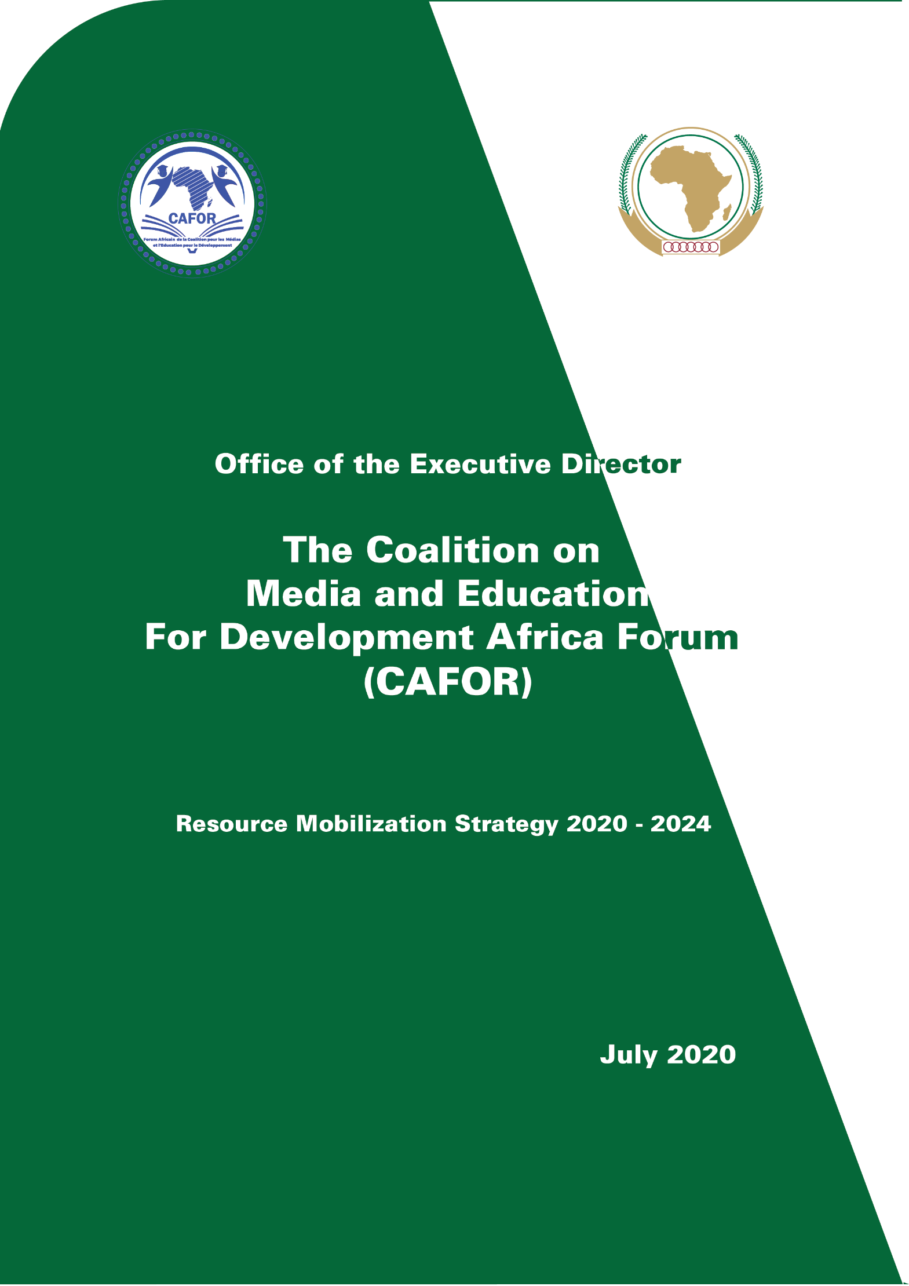

Resource Mobilisation Strategy to CAFOR Activity Report from 2018-2020
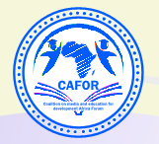
CAFOR AFRICAN UNION

AFRICAN UNION COMMISSION
Roosevelt Street, W21K19, P.O. Box 3243, Addis Ababa, Ethiopia
COALITION ON MEDIA AND EDUCATION FOR DEVELOPMENT AFRICA FORUM (CAFOR) ACTIVITIES REPORT FOR 2018 TO 2020

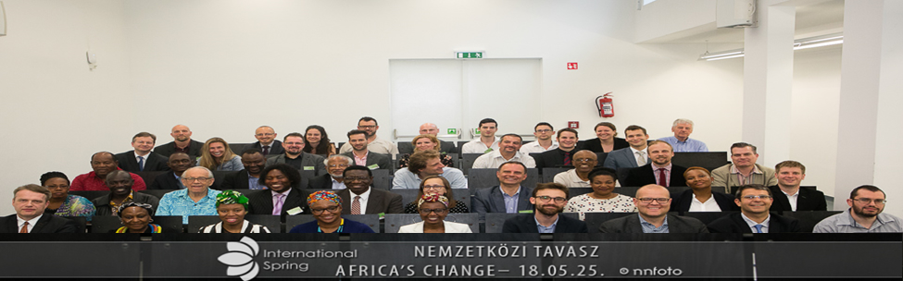

Abbreviations
AFDB : African Development Bank
ASRIC : African Scientific Research and Innovation Council
AU : African Union
AUC : African Union Commission
AUDA – NEPAD : African Union Development Agency – New partnerships for Africa Development
CAFOR : Coalition On Media And Education For Development Africa Forum
CAPA : Commonwealth Association of Technical Universities and Polytechnics in Africa
CESA : Continental Education Strategy For Africa
CIEFFA : The International Centre for Girls and Women’s Education in Africa
CSO : Central Statistics Office
CTMP : Continental Teacher Mobility Protocol
COVID : Coronavirus Disease
DIC : Division of Information and Communication
DRC : Democratic Republic of Congo
EBU : European Business University
ECOWAS : Economic Community of West African States
EU : European Union
GIZ : German Agency For International Corporation
GPE : Global Partnership for Education
HRST : Human Resource Science and Technology
ICT : Information and Communication Technology
IDPs : Internally Displaced Persons
IICBA : International Institute for Capacity Building in Africa
IWPR : Institute of War and Peace Reporting
KOICA : The Korean International Co-operation Agency
MOU : Memorandum of Understanding
MLT : Media Lab of Tripoli
NGO : Non-Governmental Organisation
PACE : Pan Africa High level Conference on Education
PPP : Public Private Partnerships
PWDs : People With Disabilities
REC : Regional Economic Communities
SDG : Sustainable Development Goals
STC- EST : Specialised Technical Committee on Education Science and Technology
STEM : Science Technology Engineering and Mathematics
STISA : Science Technology and Innovation Strategy For Africa
T V : Television
TVET : Technical and Vocational Education Training
UAE : United Arab Emirates
UNDP : United Nations Development Programme
UNESCO : United National Educational, Scientific and Cultural Organisation
UNECA : United Nations Economic Commission for Africa
UNFPA : United Nations Population Fund
UNICEF : United Nations International Childrens Emergency Fund
USAID : United States Agency For International Development
WPFD : World Press Freedom Day

Contents
1. Message from CAFOR Chairperson- Prof Kate Adoo-Adeku 6
2. Message from Executive Director- Dr Lawalley Cole 8
3. General Corporate Information about CAFOR 10
4. List of CAFOR Executive Board, Secretariat and Partner organisations 12
5. CAFOR organization chart & governance structure 17
6. Main CAFOR activities in 2018 19
7. Main CAFOR activities in 2019 29
9. CAFOR Scholarship Programmes 57
10. Future activities 57
11. CAFOR Budget as per 2020-2024 Strategic Plan 61
12. Images of CAFOR Secretariat at Different Occasions. 69


Message from CAFOR Chairperson- Prof Kate Adoo-Adeku
I bring you warm greetings and best wishes on behalf of the Executive Board and members of CAFOR. I also take this opportunity of extending my heartfelt greetings to the African Union Commission, our host institution. We wish to express our profound gratitude for the great support and assistance we continue to get from the Commission. It is my pleasure to convey to you all this messages we release our first activities report which covers two and a half years of our existence. I also take this opportunity to thank all the staff of the CAFOR Secretariat based in Addis Ababa, Brazzaville and Nairobi for their tireless efforts to ensure the smooth running of the CAFOR machinery despite the challenges that you all face daily. We wish to, on this occasion, express our appreciation to you all while we say behind every cloud there is a silver lining.

CAFOR is a relatively young organization established to promote development activities that would enhance Africa's Development Agenda with a focus on the African Youth. A significant ingredient is the promotion of communication in support of Education which is the crucial tool in using to accelerate its work with the three key concepts of Communication, Education and Development. These three conceptions are intertwined to create a healthy environment which would offer space for the youth on the continent to develop employable opportunities for their well-being, families, and their nations.

CAFOR has put in place a strategic plan with critical structures that would help it to promote its work on the continent as consistent with its vision and mission. Young as it is, and despite the challenges it is facing amidst the emergence of COVID 19, CAFOR in its modest manner and within a short space of time has succeeded in making its presence felt in many regions in Africa, and even globally. Consequently, the existence of CAFOR has boosted some remarkable awareness about the situation with young people on the African continent. The strategic plan it has put in place would give both meaning and direction on the key areas it shall be operating on for the next couple of years.

CAFOR will, in the next few years, support qualified, underprivileged young people with demonstrated high potential from Africa, to access education and employable and entrepreneurial skills. CAFOR strives to work with multiple stakeholders to ensure the integration of global and AU continental policy agenda into development policy and practice at the country level. CAFOR's collaboration with the European Business University in Luxembourg which has initially provided 50 scholarships for young African students in TVET and business administration is a highly commendable start. As we expect another 100 scholarships for African youths, we look forward to new employment avenues for the course beneficiaries.

CAFOR also works with media agencies specialized in learning and development reporting, communication researchers and trainers, education specialists and organizations engaged in areas of concern to training for the youth and development. CAFOR will eventually be uniquely placed to provide a continent-wide platform for exchanging information, experience and practices on new technologies and innovations for youth empowerment among experts in government ministries, CSOs, NGOs, the media, the youth, and communities.

CAFOR has also put in place a Resource Mobilization Strategy for the period 2020 – 2024. The strategy will ensure a transparent, systematic, predictable, and well-coordinated approach to soliciting, acquiring, and utilization, management, reporting, monitoring, and evaluating assistance from International Cooperating Partners. It will also support the expanding of the resource base to ensure sustainable resource availability for implementation of CAFOR's programmes as stipulated in CAFOR's 2020-2024 Strategic Plan. In this respect, CAFOR will develop and improve relations and dialogue with the African Union Commission and all Technical and Financial Development Partners in Africa and elsewhere. The organization will establish the framework for resource mobilization and acquire adequate resources to implement all its activities.

CAFOR will further elaborate on and execute an effective resource mobilization strategy with a roadmap for the evolution of strategic partnerships and financial resource mobilization. Business sponsors, organizations providing grants that include individuals and organizations involved in participating financially to the Education and training of young people in Africa would support CAFOR in its efforts to mobilize adequate resources. CAFOR will also develop a business case for financial support that would be sustained with relevant documentation of its policy impact and results since its inception in January 2018, for dissemination to key existing and potential technical and financial partners. We say a big thank you to all who have assisted in diverse ways to help CAFOR achieve some its noble objectives.

Message from Executive Director- Dr Lawalley Cole
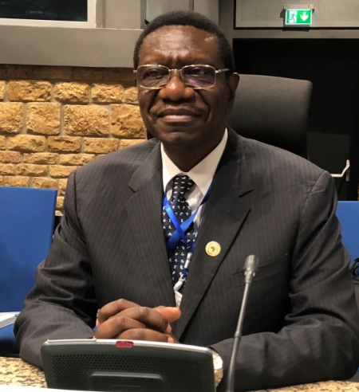
CAFOR has only existed for two and a half years. During much of these two and a half years, the membership of CAFOR expanded to a considerable extent. CAFOR used this period mainly to make itself known around the African continent and even globally through participation in over 40 conferences, workshops and seminars and meetings held in various parts of Africa and the rest of the world including in Ethiopia, Kenya, Nigeria, Hungary, the United Kingdom, the United States of America, Ghana, Botswana, Rwanda, Cote D'Ivoire, and other places.

A significant highlight of CAFOR's activities took place on 18th January 2019 with the signing of a Memorandum of Understanding (MOU) between the African Union and CAFOR. Through the MOU, the two parties CAFOR and the African Union will work together to enhance the integration of global and continental policy agendas. These include the Sustainable Development Goals (SDGs), Agenda 2063, the Science, Technology and Innovations Strategy for Africa (STISA 2024), the Continental Education Strategy for Africa (CESA 16-25), and the Continental Strategy for Technical and Vocational Education and Training (TVET) into country-level developmental and sectoral strategies for the development of the African continent. The MOU will, therefore, enhance dialogue on policy issues as recommended by the African Union through these African Union policy agendas, and promote a shared understanding of the problems in educational reforms for youth participation in their respective national labour force. They will also help build commitment and ownership of the changes.

It was also during this period that CAFOR's Executive Director and staff met with significant members of the diplomatic community and partners of the African Union. These include Ambassadors from Japan, Germany, Qatar, Korea, the United Arab Emirates, Kuwait, Saudi Arabia, India, Brazil, Italy, Turkey, Denmark, Belgium, Australia, New Zealand, Hungary, Poland, the Netherlands, Norway, Sweden, Finland, the United Kingdom, and Spain. CAFOR staff also met and discussed the African Union's plan that includes the Continental Education Strategy for Africa (CESA) with various representatives accredited to Ethiopia and the African Union. These include representatives of the USAID, the GIZ, KOICA, the Korea-Africa Foundation, and the EU delegation to the African Union. CAFOR also met with delegations from China, France, Kuwait, the League of Arab States, and Education Cannot Wait at UNICEF, New York. Dialogue on CESA and other African Union agendas took place through meetings with UNDP, UNESCO and UNFPA. Also, the African Union alerted all the Ministries of Foreign Affairs of its 55 member states and their embassies in Addis Ababa to explain the purpose of the MOU signed between the African Union and CAFOR. The AU also called on its member states to provide the necessary support to CAFOR to accomplish its mission at the country level.

CAFOR is currently engaged in frantic efforts to enhance its partnerships and mobilize resources for its projects and programmes around Africa. We have since produced a Strategic Plan that would run from this year 2020 until 2024, with an annual budget projected at US$15m. We have also equally developed a Resource Mobilization Strategy for the same period. With these instruments, CAFOR will be engaging the African and international community to support programmes in African countries, albeit amidst this current COVID – 19 pandemics, and as we explore new opportunities for the continent-wide platform to implement CAFOR/AU programmes. CAFOR will also work collectively with all its partners to mobilize financial resources to support the short, medium, and long term, COVID-19, and post COVID-19 recovery process in Africa. To this end and following the earlier consultations we made with ambassadors, UN agencies, and other bilateral and multilateral partners, CAFOR has proposed to hold a Virtual Roundtable Conference with all its partners jointly with the HRST Department. The theme of the Roundtable is "Supporting the African Union's post-COVID 19 innovative practices in the fields of education, science and technology with an emphasis on TVET implementation to enhance youth advancement across the continent of Africa."

The objective of the proposed Roundtable Conference is to contribute to the setting up of sustainable funding mechanisms that would accelerate CAFOR's sustainable financing needs and increase CAFOR's impact on the performance of the policy, and the legal framework for advancing education and development for young people in Africa. CAFOR will give much consideration to its post-COVID-19 interventions in the African continent.

CAFOR will also subscribe to the design of a long-lasting financing management plan in collaboration with the African Union Commission, its organs and all partner agencies and member states by considering the results of its interventions at the country level.

General Corporate Information about CAFOR
The Coalition on Media and Education for Development Africa Forum (CAFOR) is first and foremost a forum with various organizations, experts and individuals who are committed to ensuring that education systems in Africa are relevant to young Africans with newly acquired skills that correspond with what obtains in the labour market within the African continent. The primary reason for this coalition is to gain maximum influence and potential that an individual organization would otherwise not be able to have. The Coalition strives to achieve this through the following means:
- Having the Coalition owned by its members
- Combining resources and working together and having the groups or parties accomplish more along than they would work on their own
- Leadership becomes a shared activity
- Accountability shifts from strictly individual to both individual and collective
- The team develops its purpose and mission
- Problem-solving becomes a way of life, not a part-time exercise
- Measure effectiveness through the group’s combined outcomes and products
The principal orientation of CAFOR includes:
- By becoming a technical arm for the development in Africa, by participating with the cooperation of donor agencies operating in Africa such as - African Union Commission (AUC), the Regional Economic Communities (REC) and Specialised United Nations (UN) bodies in the area of communication for youth skills development and their integration into the African labour market
- Developing advocacy to integrate communication components in agricultural development for young Africans, TVET and other educational and skills development policies
- Promoting better knowledge of educational facts for young Africans among the media and journalists
- Providing advice and quality services in communication to the development cooperation agencies operating in Africa including the African Union Commission, the Regional Economic Communities and Specialized United Nations Bodies, and ministries of education, agriculture, labour and finance in Africa, the media, and civil society organizations intervening in education and youth development
- Contributing to the expansion of support to policies and reforms in education and youth development
- Mobilizing matching financial resources
- Generating opportunities for sustainable social development by designing, implementing, and evaluating communication strategies for youth training and development in Africa
- Examining and enforcing mapping strategies for identifying institutions for creating jobs in the fields of agriculture for young people, technical schools or institutes such as vocational training institutes, especially agricultural institutes;
- Mapping the competencies and the specialization of each institute, examining the opportunities for African capacity in agriculture and technology, cross-pollinating centers of excellence and establishing a research laboratory on education and development issues and use the data collected for programme interventions.

List of CAFOR Executive Board, Secretariat and Partner organisations
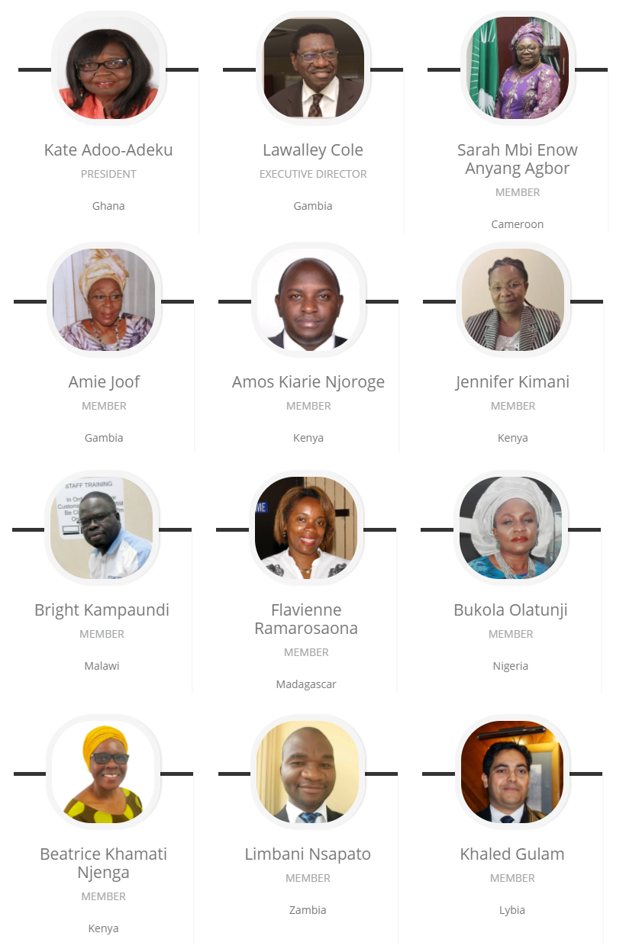

CAFOR SECRETARIAT

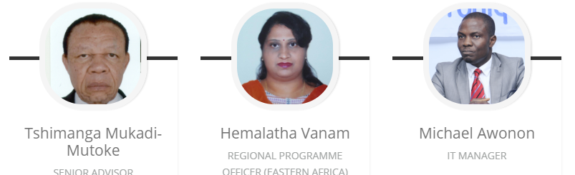
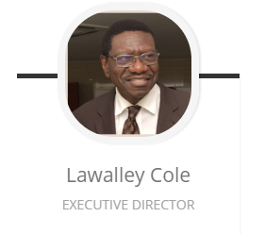
CAFOR MEMBERS NAMES, COUNTRY, ORGANISTAION AND MEMBER PHOTOS
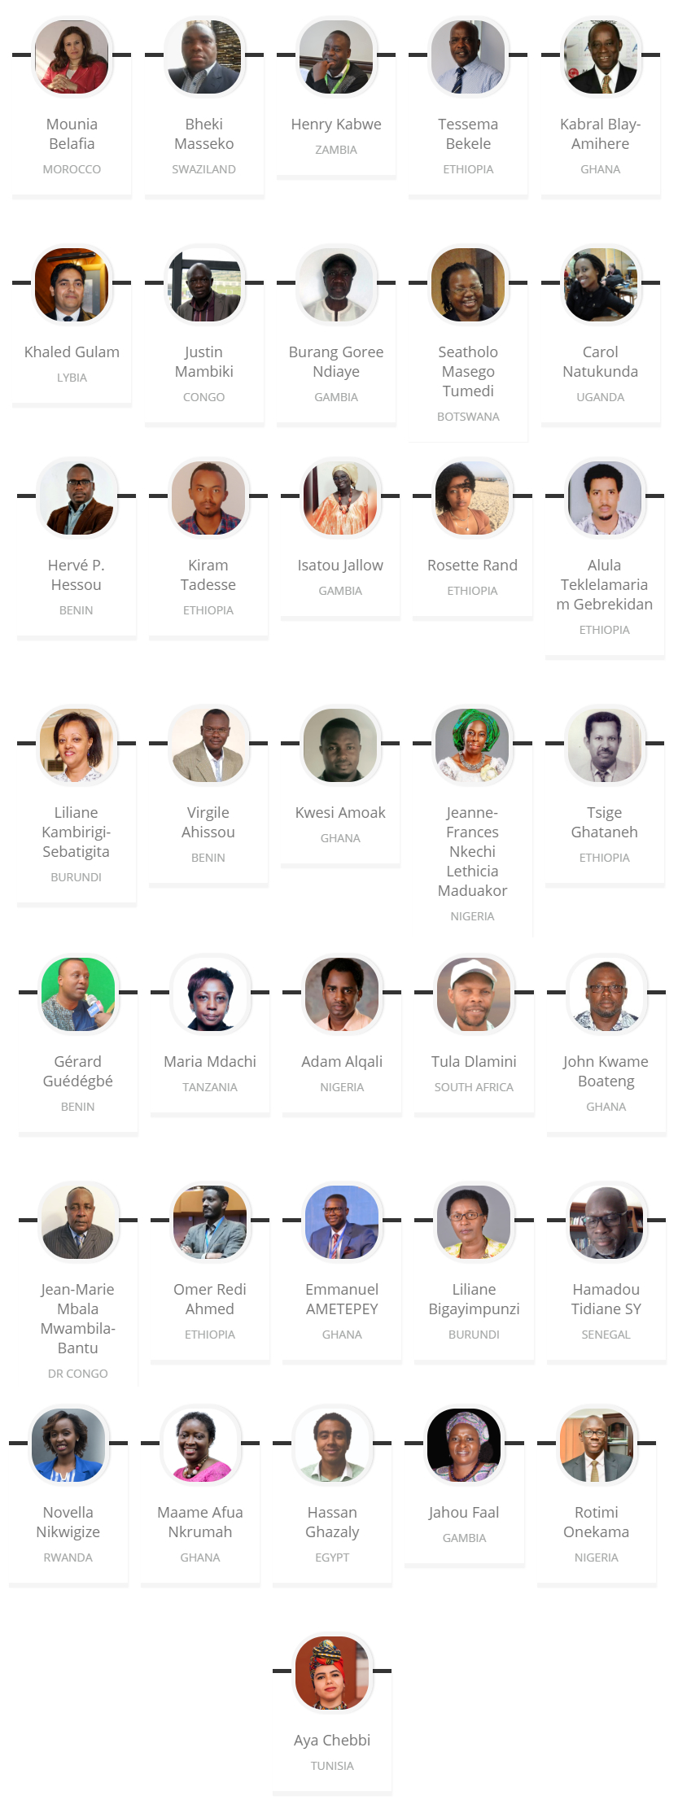
CAFOR Partner’s Organisation’s , Logos & Countries + add 3 more logos, + AU should go in the front
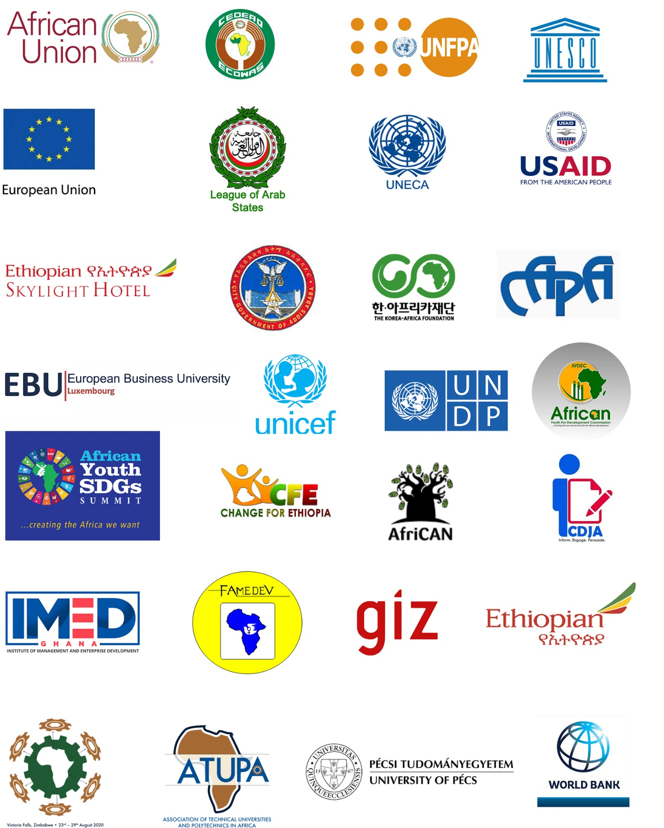

CAFOR organization chart & governance structure
CAFOR’s core central team is located in Addis Ababa- Ethiopia along with its regional offices in Kenya and Malawi regions of Africa. Further CAFOR intends to extend to other regions as Abuja, Rabat and Kinshasa.
HEAD OFFICE
Regional Office Kenya
Regional Office Malawi
Regional Office
Morocco
Regional Office Democratic Republic of Congo
Regional Office
Nigeria

The Executive Board of CAFOR constitutes a 12member board led by a chairperson. The board supports the enhancing of coordination, the establishment of guidelines, provides strategic leadership and policy direction and guides all CAFOR-related programs The board participates in significant decision making involving expertise in journalism, communications, education, youth, economic and social development. The CAFOR Secretariat hosted by the African Union Commission in its Headquarters in Addis Ababa is led by an Executive Director who is the global chief of CAFOR’s management. The Executive Director is supported by: a) Senior Advisor b) Special Assistant c) Information technology & knowledge management officer d) Financial officer.
CAFOR SECRETARIAT- ADDIS ABBABA- ETHIOPIA
EXECUTIVE DIRECTOR
SPECIAL ASSISTANT
SENIOR ADVISOR
IT & KNOWLEDGE MANAGEMENT OFFICER
FINANCE OFFICER

CAFOR’s regional offices are headed by Regional representative and supported by a communication officer, programme officer, finance officer, technical officer for programmes, programme assistant and an administrative assistant.
REGIONAL REPRESENTATIVE
COMMUNICATIONS OFFICER
ADMINISTRATIVE ASSISTANT
PROGRAMME OFFICER
FINANCE OFFICER
TECHNICAL OFFICER FOR PROGRAMMES
PROGRAMME ASSISTANT

Main CAFOR activities in 2018

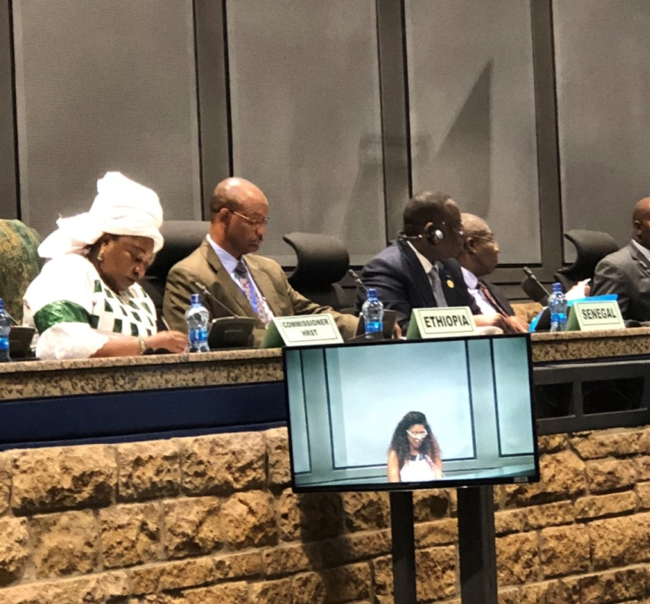
Operationally, CAFOR effectively started on January 1, 2018, and the year was very eventful with CAFOR participating in many major world events in Africa and abroad. In January 2018 soon after its inception, CAFOR participated in the AU/ CIEFFA High-Level Dialogue on "Enhancing policies and practices to promote STEM" held on January 24, 2018, on the margins of the African Union Heads of State Summit in Addis Ababa. This high-level dialogue focused on Technical and Vocational Education and Training for African women and girls. H.E. Mr Jakaya Kikwete, former President of Tanzania, delivered the keynote address. Also on January 27 2018, CAFOR participated in the First High-Level Dialogue on Financing Education in Africa with the theme: "Financing Africa's future: Unlocking development potentials through education". This High-level dialogue was co-organized by the African Union Commission's Human Resources, Science and Technology (HRST) Department, the Global Partnership for Education (GPE) and ONE Campaign (Africa). H.E. President MackySall of Senegal chaired the Conference.
HRST Commissioner Professor Sarah Ebienow Ayang Agbor at High – Level dialogue on Enhancing policies and practices to promote STEM

CAFOR was invited to participate and had representation in the World Literacy Summit held from 25th – 27th March 2018 at Sheldonian, Oxford University in the United Kingdom. One highlight of the summit was the exposure to the many and varied literacy activities in a wide variety of settings around the world. CAFOR's representative spent time with professionals that included young people from all over the world who brought together the enthusiasm and commitment to make a positive impact on the world through literacy.

In March 2018, CAFOR worked intensely with UNESCO's International Institute for Capacity Building in Africa (IICBA) in Addis Ababa on 1. The Peacebuilding for African Youths Project through teacher development in the Horn of Africa and the Sahel, and 2. Support for the development of a new Strategic Plan for UNESCO-IICBA. Also, from 27-29 March 2018, CAFOR participated in the U.N. Human Rights Office's Regional Consultation on the Practical Implementation of the Right to Development: Identifying and promoting good practices – held at the United Nations Economic Commission for Africa (UNECA) in Addis Ababa, Ethiopia.
( Mr Lawalley to add 2 more photos here )

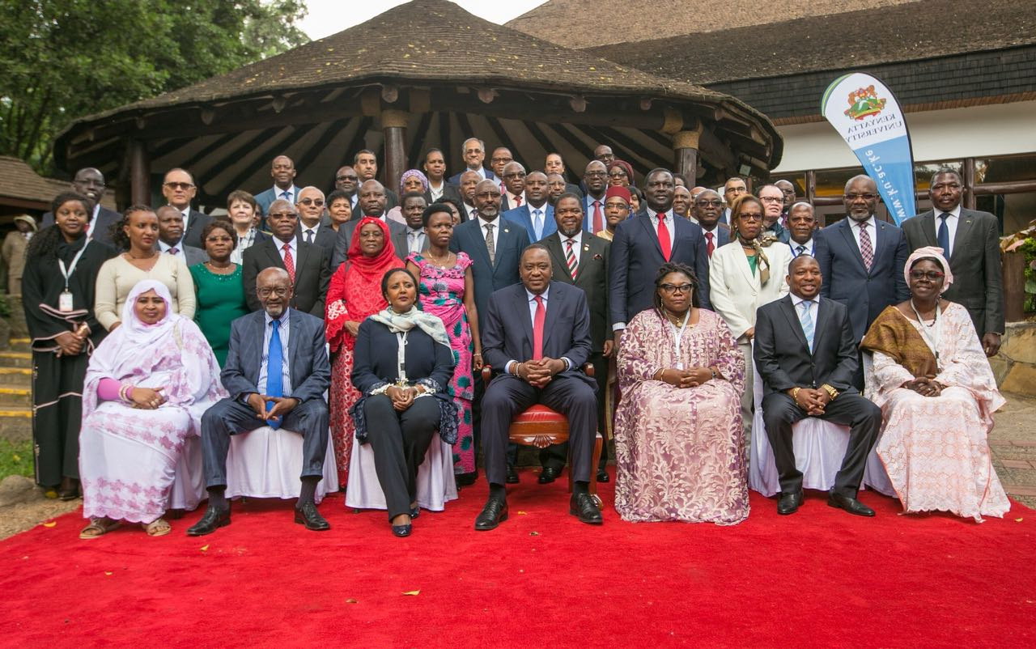

PACE Conference participants in group photo with President Uhuru Kenyatta

In April 2018, CAFOR participated at the Pan-African High-level Conference on Education (PACE, 2018) held in Nairobi, Kenya and organized by UNESCO Headquarters in Paris in collaboration with the UNESCO Regional Office for Eastern and Southern Africa. The Conference called for the building of a conducive environment for education transformation in Africa with the utmost consideration for African ownership of CESA 16-25 and SDG4-Education 2030 at continental, regional and national levels. Also, given the broader development ambitions, the Conference called for more integrated approaches to education policies and strategies in a "life-long" perspectives, and promote a truly "system-wide articulation and inter-sectoral collaboration."

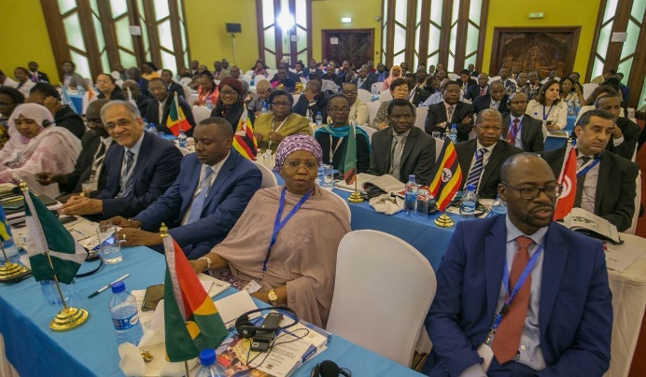

Participants at PACE Conference
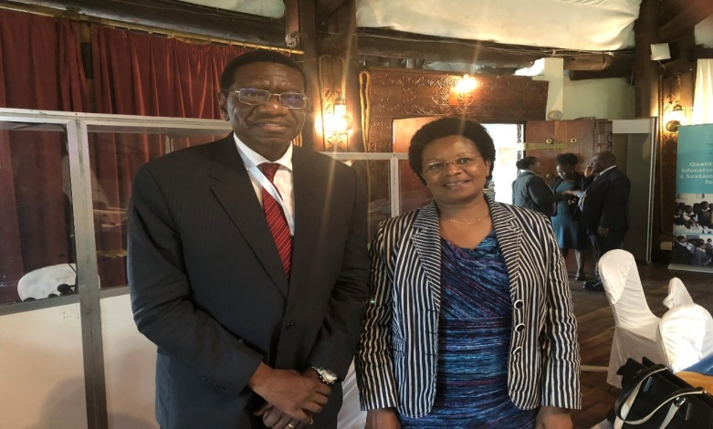
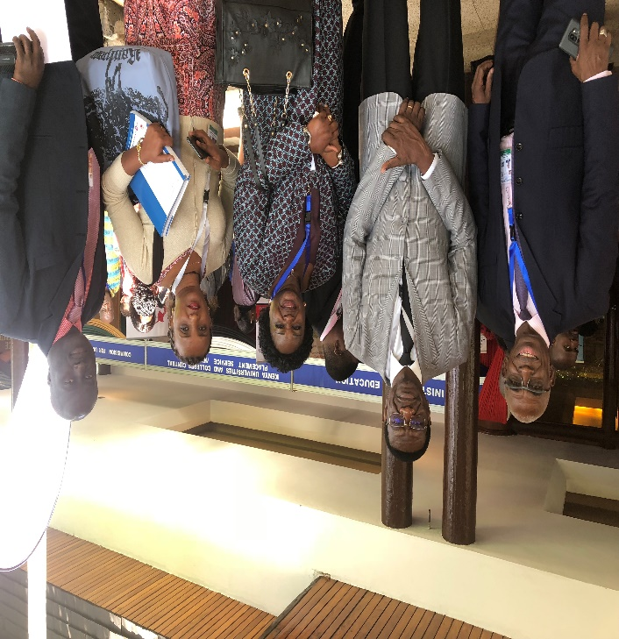

PACE, 2018 photos with the Minister of Education of The Gambia, Claudiana Cole, UNESCO expert Seydou Jallow and Jennifer Kimani, CAFOR Executive Board member.

Fifth Pecs African Studies Conference at the University of Pecs in Hungary

In May 2018, CAFOR’S Executive Director was a special guest at the Fifth Pecs African Studies Conference at the University of Pecs in Hungary from 24-26 May 2018. He delivered the keynote lecture for the Conference whose theme was "Africa's Changing International Relations and Realities." The topic of his address was "Creating and Enhancing Capacity in Africa for Efficient Economic and Social Development."

(Photos on Page 22 to be labeled by Mr Lawalley)
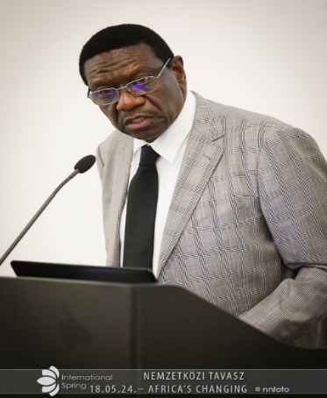
Image: CAFOR Executive Director delivering the Keynote address in Pecs
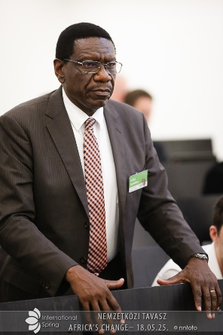
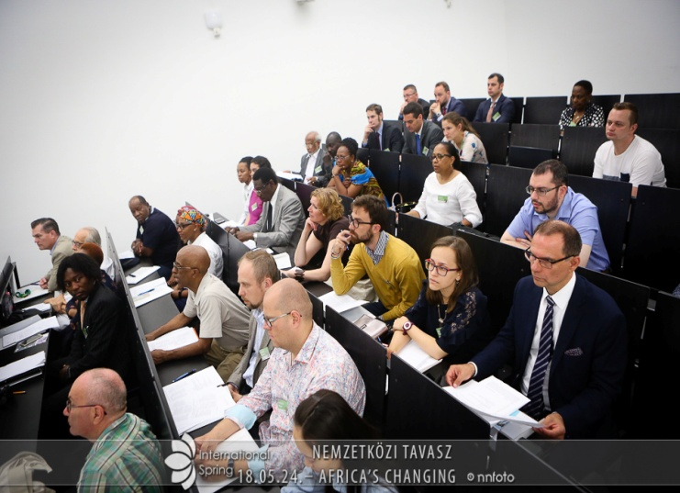
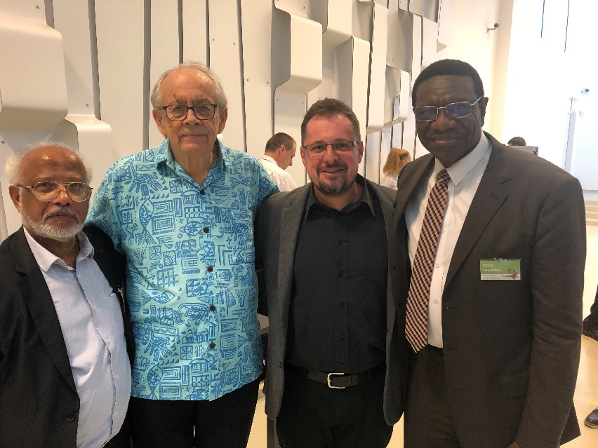

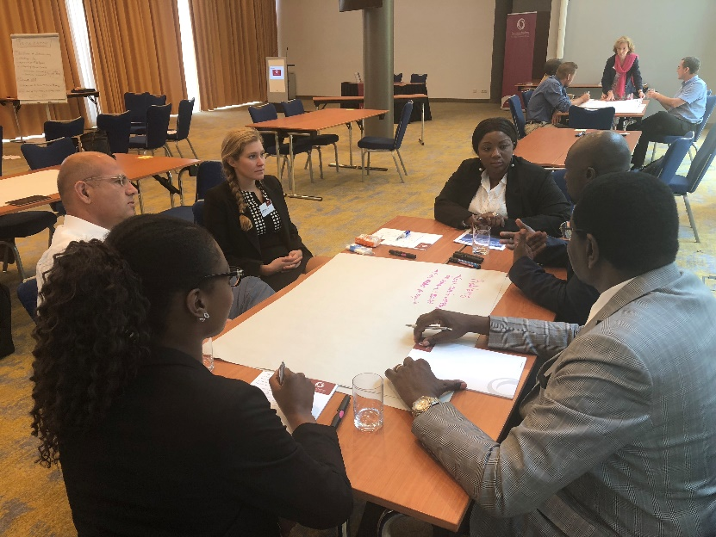
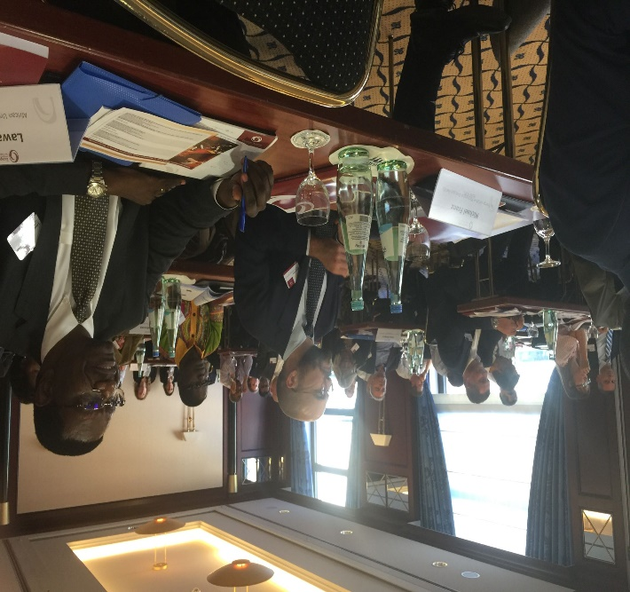

At the Global Energy and Infrastructure Conference in Berlin, Germany

In June 2018, the European Academy for Taxes, Economics and Law invited CAFOR's Executive Director to attend and chair the Global Energy and Infrastructure Conference held in Berlin, Germany from 27-29 June 2018. Apart from heading the Conference, his two presentations focused on education and youth skills development for the energy sector in Africa. Also, on June 22 2018, the Executive Director participated in the launch of the African Development Dynamics Report and SHaSa II organized by the African Union Commission Economic Affairs Department in Addis Ababa.

UNICEF-AU Engagement Strategy 2019 – 2021.

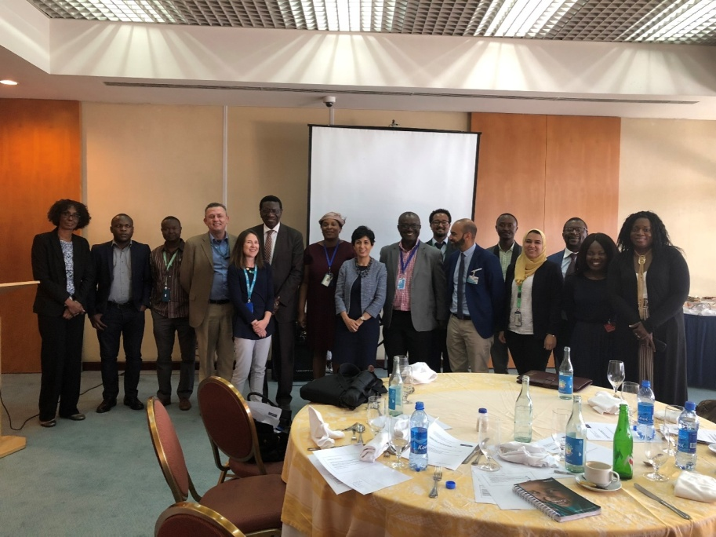
On August 20, 2018, CAFOR participated in the Conference on the UNICEF-AU Engagement Strategy 2019 – 2021. The UNICEF Liaison Office in Addis Ababa organized this Conference with the UNICEF Regional Director for Eastern and Southern Africa as well as some senior UNICEF staff from UNICEF Headquarters in New York attending. CAFOR has opted to support the implementation of the strategy with the African Union Commission. Following this Conference, CAFOR's Executive Director visited some of the participants who attended the Meeting at UNICEF Headquarters in New York in September 2018 and held extensive discussions on Adolescent and Youth programmes for Africa. CAFOR is following up on these activities during 2019.

Africa-America Institute Conference

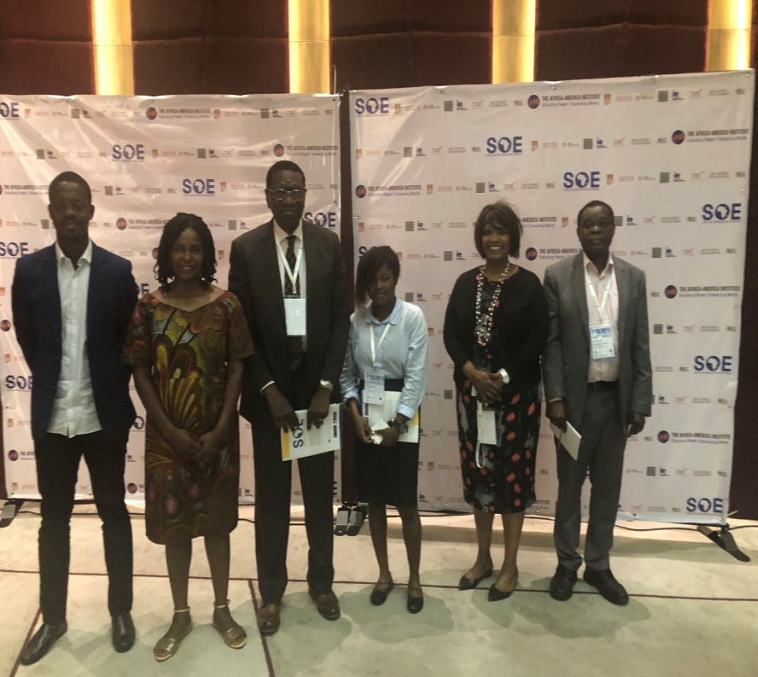
From 8 – 10 October 2018, CAFOR participated in the State of Education Conference organized by the Africa-America Institute in Abidjan, Cote D'Ivoire. The theme of the Conference was "Shifting Paradigms: Building Future capacities and New Narratives through African Education." The President of Cote D'Ivoire, H.E. Dr Alassane Ouattara, delivered the keynote address. CAFOR's Executive Director moderated the session on "Transforming Higher Education in Africa" and was a panelist" in the session on Global Connections: Media and Narratives." The networking at this Conference was excellent, and CAFOR is now participating in many activities with the African diaspora that will include a Yale University project involving selected brilliant African Secondary School students participating in short courses at Yale University.

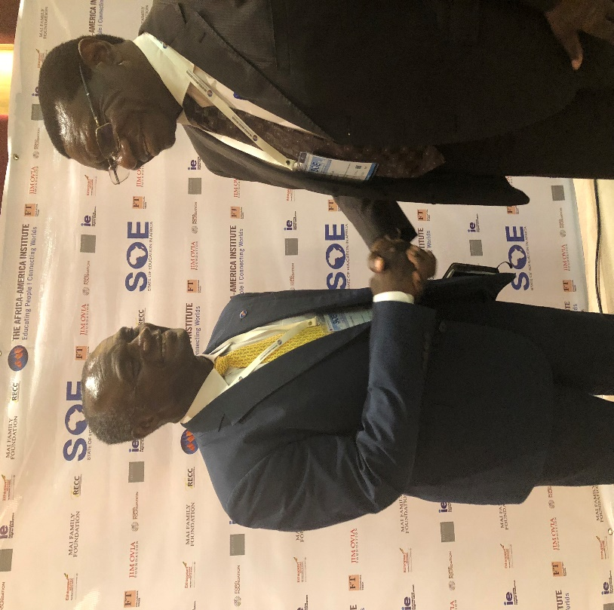

CAFOR Executive Director with CEO of the Africa-America Institute, Kofi Appenteng
Second African Youths SDG Summit

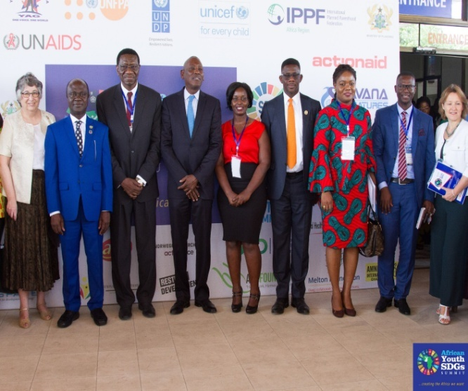
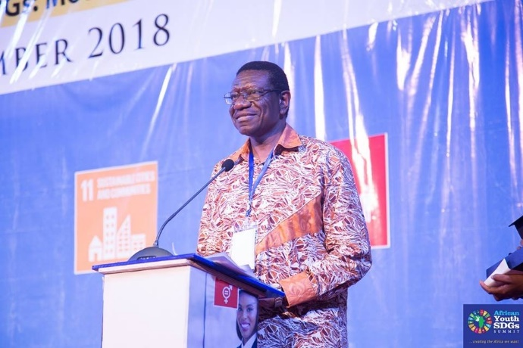
From 7 – 9 November 2018, the Second African Youths SDG Summit was held in Accra, Ghana. CAFOR's Executive Director was one of eight patrons of the summit. This summit was a significant highlight of the year for CAFOR with more than 1,200 youths from 44 countries participating in the Conference. CAFOR would like to commend the leadership of Youth Advocates Ghana for organizing this summit and for making it one of the most successful youth conferences on the African continent. CAFOR will ensure that it works and coordinate initiatives with the African Union and other partners and entities on the continent. CAFOR will ensure that programming in advocacy and partnership mobilization for youths aligns well with the vision that young people in Africa have for their future as they well-articulated those aspirations in this Conference. We must understand their real needs and what they have always longed for in Africa. We must be in an excellent position to be also able to tap into their energy and dynamism.

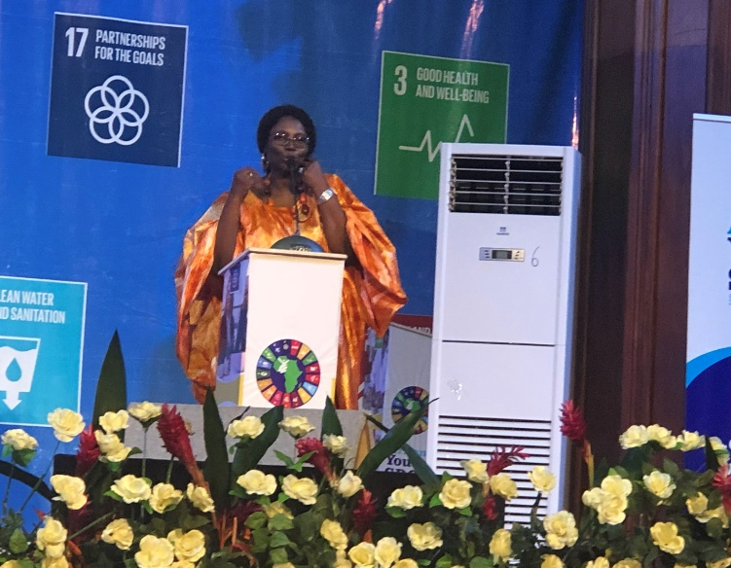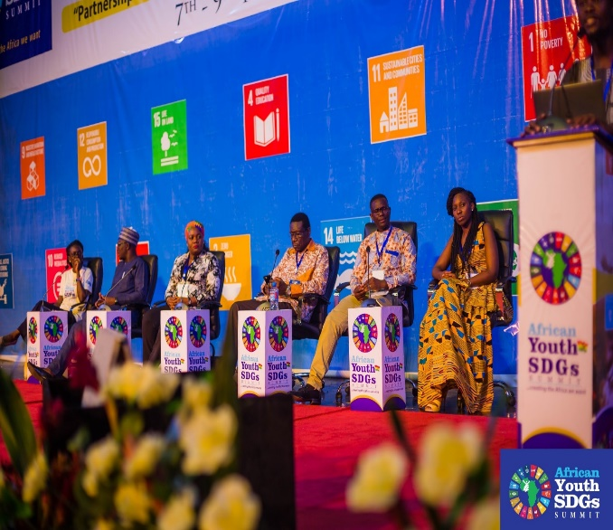
Top Photo: CAFOR Executive Director
Group Photo -Ministers of Planning & Youth from Liberia, Ghana & UN Resident Coordinator
Below Photo: Global Nutritionist Istaou Jallow addressing youth on nutrition

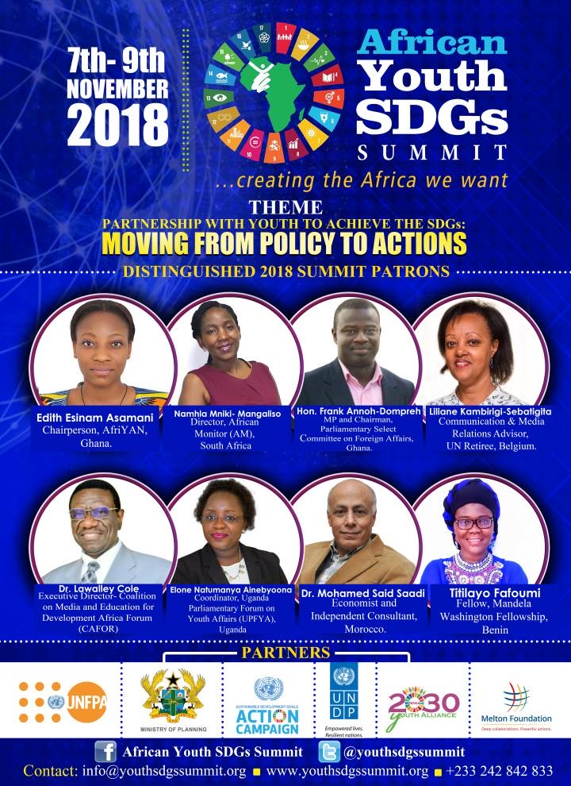
- African Scientific Research and Innovation Council (ASRIC)

CAFOR participated in the AUC-HRST– African Scientific Research and Innovation Council (ASRIC) Congress from 27-29 November in Abuja, Nigeria. This Conference brought together leading scientists and science researchers from all the regions of the African continent. The Congress reviewed the statute of ASRIC and elected its first bureau. CAFOR joined the Communication Cluster of ASRIC that would be advocating for more scientific research and development in Africa. The Conference concluded that Africa needs a healthier and more dynamic, inclusive, and sustainable research enterprise, especially in science and technology, to mobilize different segments of the economy to achieve the long-term aspirations of the continent.
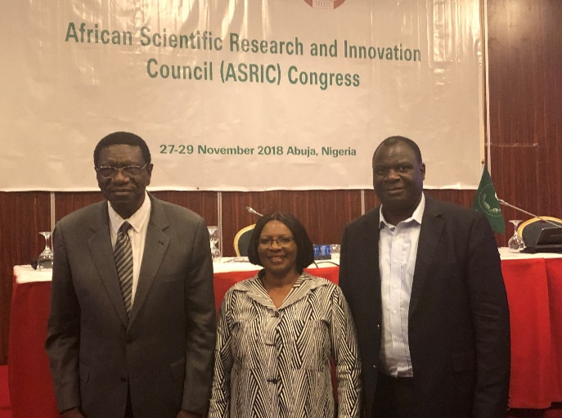
As a member of the Communication Cluster of ASRIC, CAFOR is currently participating in the visibility study for the establishment of ASRIC Scientific Journal. The ASRIC Bureau and the Secretariat manage the Journal. The vision is for the Journal to be Africa's highest quality journal, attracting African scientific excellence within the continent and the diaspora. The scientific/thematic areas of interest include Natural Sciences, Engineering and Technology, Medical and Health Sciences, Agricultural Sciences, Social Sciences and Humanities.

(Mr Lawalley to lable the photo)
In December, CAFOR participated in three workshops at the African Union Headquarters in Addis
Ababa. The Education Division of the HRST Department organized these meetings. They are 1. the launch of the CESA Curriculum Cluster where the issues confronting education quality, relevance and responsiveness, as a necessary part of ensuring that education contributes to the achievement of Agenda 2063 are adequately addressed. CAFOR will now serve as a member of this CESA 16-25 Curriculum Cluster. 2. CAFOR also participated in the meeting of the CESA thematic cluster leaders, and 3. The technical consultation workshop to set up the Pan-African Quality and Accreditation Agency. This agency will now advance African standards and guidelines for quality assurance and its domestication at national and regional levels once it becomes functional.

Main CAFOR activities in 2019

- The signing of the MOU:

2019 has had a perfect start for CAFOR with the signing of a Memorandum of Understanding (MOU) between the African Union and CAFOR on January 18 2019. Through the MOU, the two parties CAFOR and the African Union agree to work together to enhance the integration of global and continental policy agendas. These include the Sustainable Development Goals (SDGs), Agenda 2063, the Science, Technology and Innovations Strategy for Africa (STISA 2024), the Continental Education Strategy for Africa (CESA 16-25), and the Continental Strategy for Technical and Vocational Education and Training (TVET) into country-level developmental and sectoral strategies for the development of the African continent. The MOU will, therefore, enhance dialogue on policy issues as recommended by the African Union and promote a shared understanding of the problems in educational reforms for youth participation in their respective national labour force. They will also help build commitment and ownership of the policy agendas at the country level.
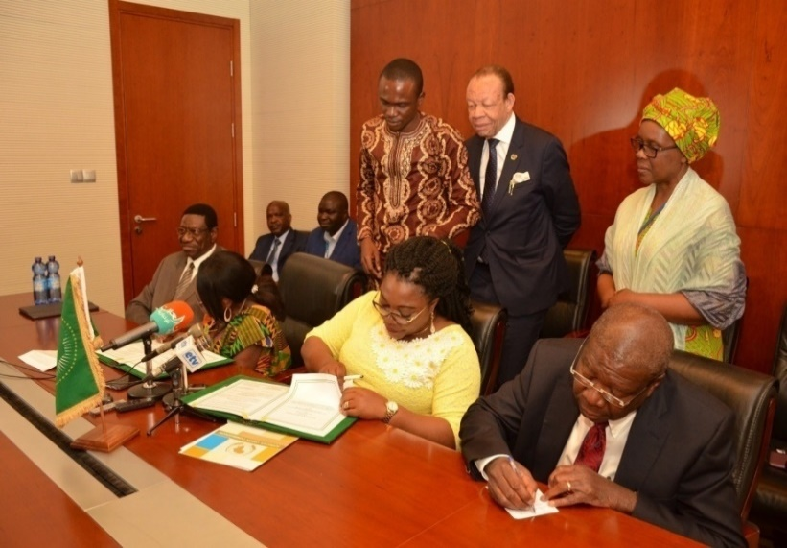
CAFOR will, therefore, work very closely with the Department of Human Resources, Science and Technology of the African Union Commission to ensure a fruitful and viable partnership. The two parties will function with other organizations and entities in the African continent and beyond to ensure the implementation of this MOU coherently and consistently. CAFOR is working through its country representatives to promote a shared understanding of the problems in educational reforms for youth participation in the national labour force.

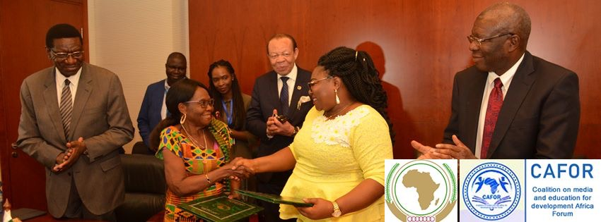
- New members of CAFOR participating in CESA activities at country level:

From January to date, CAFOR has welcomed several new members at the country level bringing the total number of countries active in CAFOR to 21 with an additional 25 countries to be registered by the end of 2019. The 21 participating countries are Benin, Botswana, Burundi, Cameroun, Congo Republic, Democratic Republic of Congo, Ethiopia, Gambia, Ghana, Kenya, Libya, Madagascar, Malawi, Morocco, Nigeria, Senegal, South Africa, Swaziland, Tanzania, Uganda, and Zambia. The remaining countries will be inducted in CAFOR's programmes in 2020, thus covering all the 55 member states of the African Union.

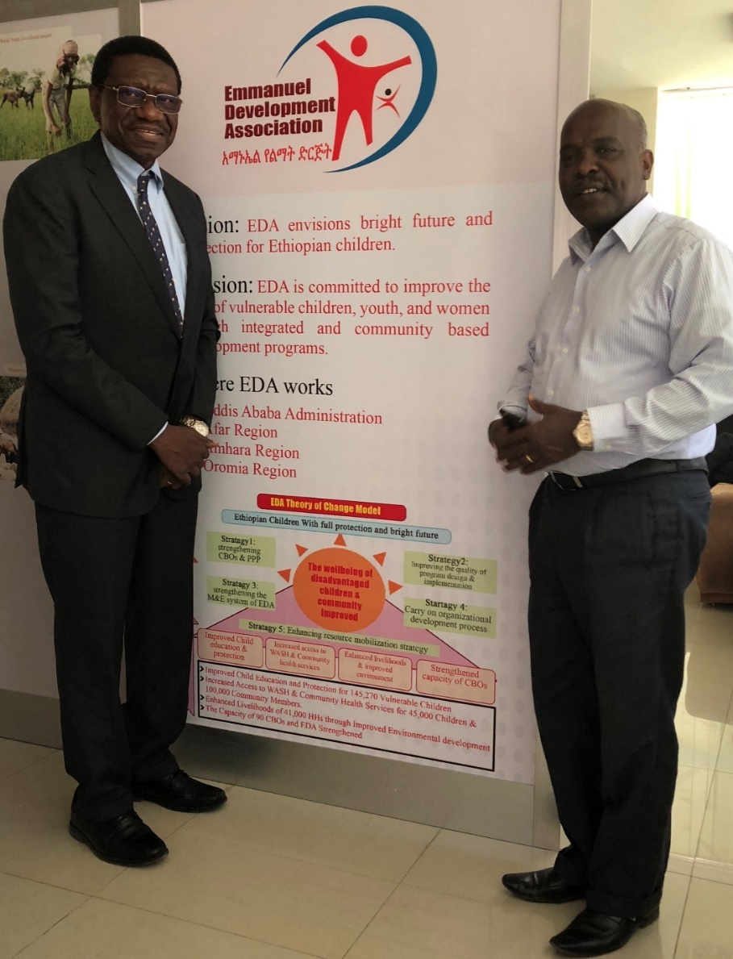
CAFOR Executive Director with Dr Tessema Bekele from EMD

CAFOR is already working to enhance partnerships with African based organizations, including several youth-led organizations for the implementation of the CESA communication strategy that the Organization developed recently. CAFOR looks forward to the continued support of its partners and stakeholders as it continues to make a move to higher levels in its flight towards the "Africa We All Want".

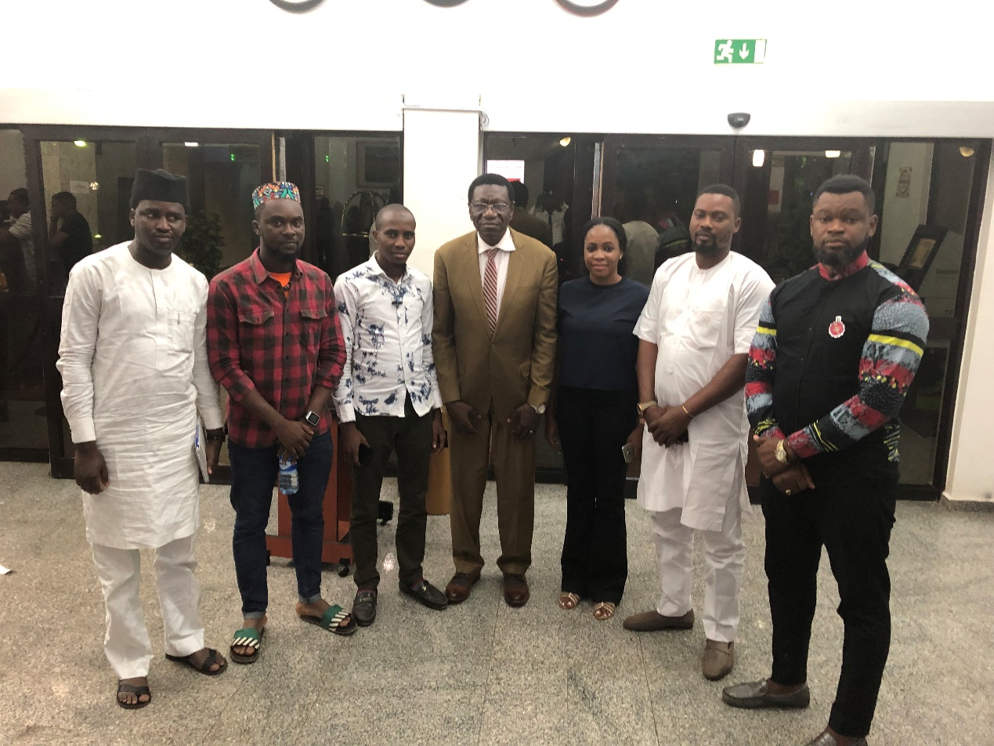

CAFOR Executive Director met with a group of Nigerian youths in Abuja who are bent on working together to advance youth development in Nigeria. He had previously met some of them in Ghana about three earlier at the 2nd African Youths SDGs Summit. It was gratifying for them to pay him a courtesy visit and to continue the dialogue about CAFOR and youth development, education, science, technology, and innovations in the African continent. They had a group photo (seen here) after the meeting. The Executive Director thanked all these young people as he told them that “The future of Africa is in your hands”.

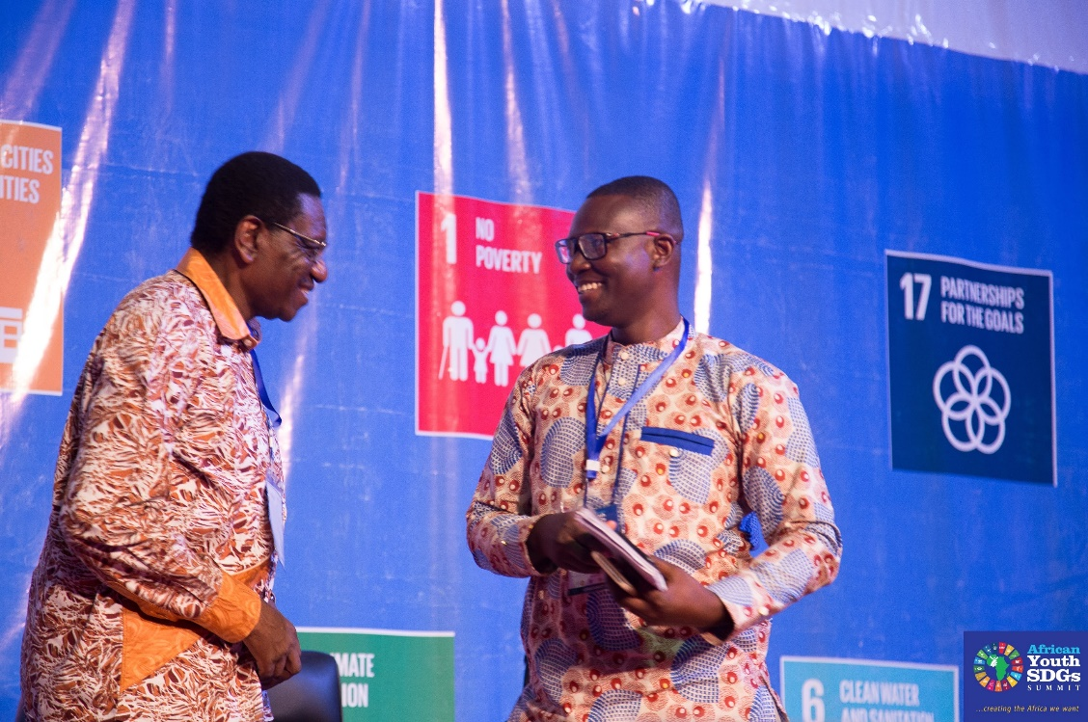
With Emmanuel Amatepey at the SDG Youth Summit in Accra, Ghana

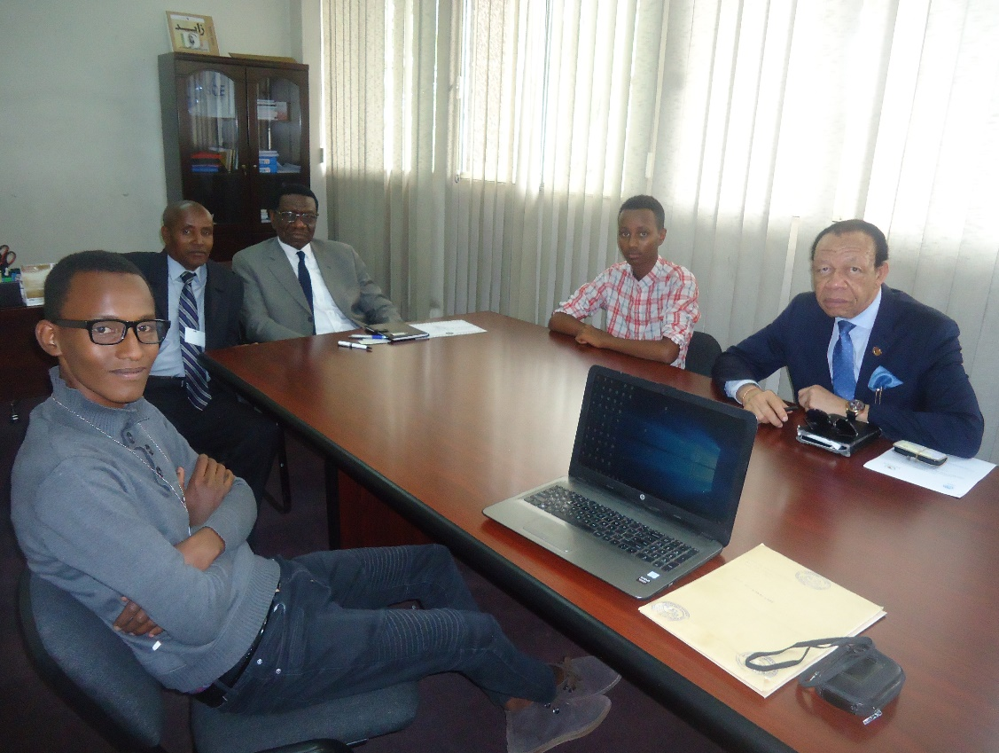

(Mr Lawalley to label the photo )
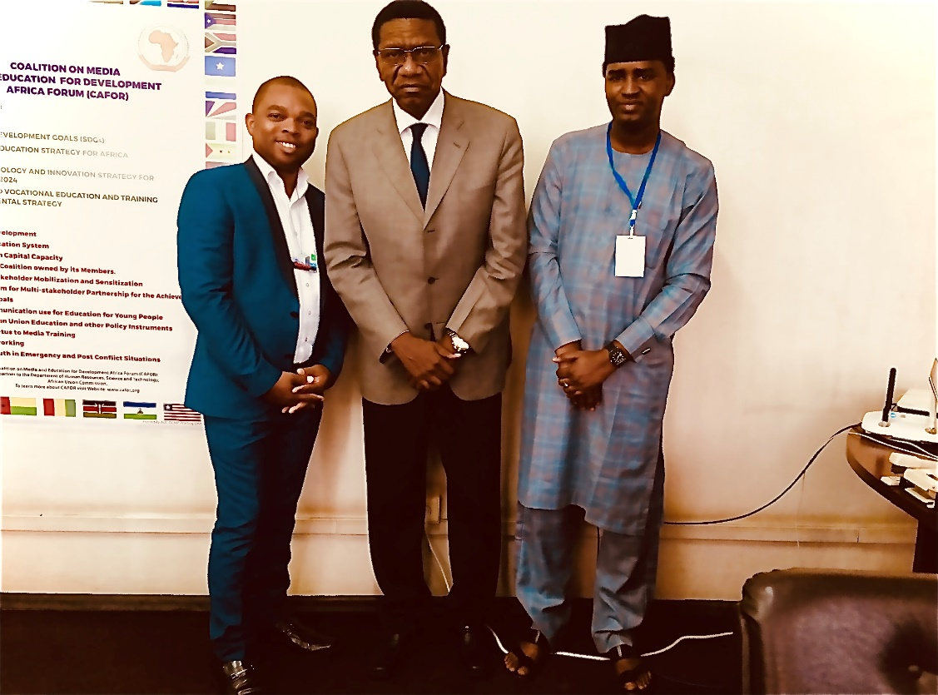
Image: Youth from Ghana and Nigeria – names to be inserted

- The A.U. High-level Dialogue on Gender, Education and Protection of schools

CAFOR participated in the High-level Dialogue on Gender, Education and Protection of schools in humanitarian settings held on February 5, 2019, at the AUC Headquarters in Addis Ababa on the topic "Internally displaced persons, refugees and returnees: Securing access and quality education for girls, women and boys". The meeting aimed to improve understanding of the impact of humanitarian situations on education, especially for girls and women, and the role of education in peacebuilding. Through the effective implementation of Agenda 2063 and the CESA 16-25, the proposed ways of addressing the vulnerability of girls, boys and women IDPs, refugees and returnees to ensure their schooling in a humanitarian context, were widely distributed by CAFOR to its networks of more than 1,500 members for dissemination throughout the African continent and beyond.

- The Meeting of the CESA 16-25 Teacher Cluster, March 19 2019

The CESA teacher Development Cluster meeting held on the margins of the Joint consultations on teacher development workshop, in Addis Ababa, Ethiopia on March 19 2019. The focus of the meeting was to discuss the activities of the cluster members, the cluster work plan and the Continental Teacher Mobility Protocol (CTMP).

UNESCO-IIICBA, the lead agency for the cluster welcomed members to the meeting and reviewed the meeting agenda and encouraged cluster members to share ongoing activities in their institutions. CAFOR's Executive Director stated that his Organization has about 50 members in 20 countries in Africa and an extensive network of more than 1,500 journalists, communication experts and other professionals, and works closely with the A.U., UNESCO and other partners. CAFOR's role is to ensure the implementation of AUC policies at the country level, through working with ministries. CAFOR is developing a strategy and ensuring that young graduates are employable by reviewing the training teachers receive at teacher training colleges. CAFOR emphasizes STEM education and encourages young people to embrace the teaching profession.

Inputs and activities from cluster members are incorporated into the existing cluster work plan. Key points raised on the work plan include:

  - Clarity on the role of the CESA Teacher Development Cluster in support to teachers in Africa
  - Legal framework for the teaching profession already exists across countries
  - Synergizing efforts and resources of the cluster members to ensure cohesion when working with teachers and supporting member states
  - Establishing continental parameters for the development and certification of teachers
  - The synergy between different CESA 16-25 implementation clusters
  - Aligning the teacher curriculum with the primary and secondary curriculum
  - Continental teacher mobility
  - Developing continental teaching standards

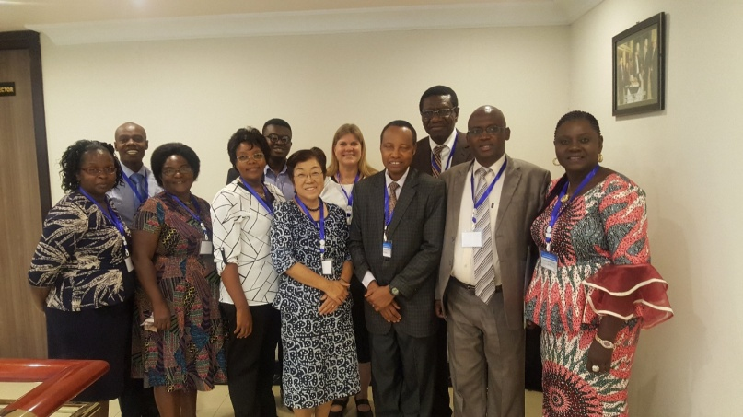

With participants at the CESA 16-25 Teacher Cluster meeting in Addis Ababa.

- MasterCard Foundation – Secondary Education in Africa Conference – 18th – 19th March 2019.

CAFOR participated in this two-day meeting for secondary school teachers held in Addis Ababa. The meeting reviewed a study conducted by MasterCard entitled "Secondary Education in Africa: Preparing Youth for the Future of Work". CAFOR's Executive Director used the occasion to network among the participants who were mainly secondary school teachers from various regions of the African continent and discussed strategies for a continental communication programme that would focus on employment issues for African youths.

- CESA Clusters Coordinating meeting – 22 – 23 April 2019

CAFOR participated in the Coordinating Agencies for the Thematic Clusters of the Continental Education Strategy for Africa (CESA) meeting in an ordinary technical session from 22nd to April 23, 2019, at the A.U. headquarters in Addis Ababa. The purpose of the meeting was to build the capacity of the agencies for effective coordination, to share experiences and tackle challenges faced in the operationalization of the CESA Implementation Platform. The meeting also reviewed and endorsed new e-platforms for facilitating communication, monitoring, and reporting of the work of the Clusters.

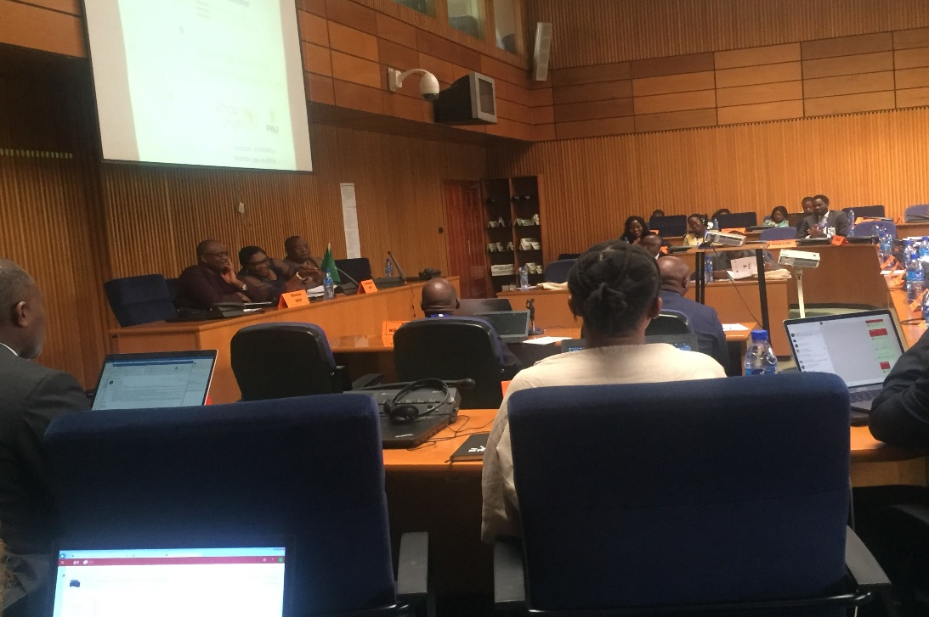

CAFOR and other participating agencies committed to supporting the work on CESA implementation towards strengthening the quality and value of education for 'the Africa we want'. They mentioned challenges including communication, resource mobilization and effective coordination.

- Participation at the African Union Commission Chairperson's Second Youth Forum

The late Dr Olubunmi Owoso, Executive Board member is sitting in the middle
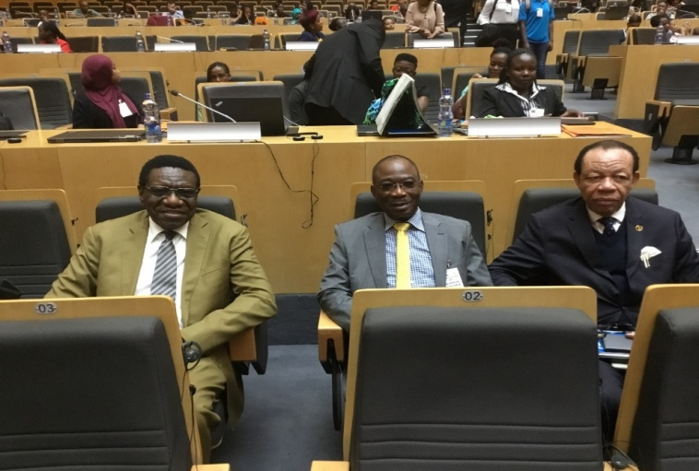
From 24 -27 April 2019, the African Union Commission convened a huge Youth Forum – the second of its kind for the young people of the African continent and an initiative by the Chairperson of the Commission, His Excellency Moussa Faki Mahamat. Her Excellency Prof. Sarah Anyang Agbor, African Union Commissioner for Human Resources, Science and Technology graced the occasion with her dynamism.
There were also a considerable number of private sector leaders, development partners, high profile innovators, and youth co-creators. Civil society organizations and members of the African diaspora were also represented. The Deputy Chairperson of the Commission, His Excellency Quartey Thomas Kwesi and other Commissioners also honoured the occasion.

CAFOR was represented by members of the CAFOR Secretariat in Addis Ababa and a couple of young CAFOR members in Ethiopia and elsewhere in Africa. CAFOR's Executive Director was also there with one member of the Executive Board of CAFOR, Dr Olubunmi Owoso from Nigeria. Two other members of the Executive Board of CAFOR. Commissioner Prof. Sarah Anyang Agbor, also a key organizer of the Forum as AUC Commissioner, vigorously moderated the plenary sessions. Also, Dr Beatrice Njenga, the Head of the Education Division at the AUC helped us to reinforce CAFOR's full support to the implementation of the outcome of this Forum.
(Mr Lawalley to insert 2 more photos here and label them)
CAFOR seized the opportunity to salute the AUC leadership for taking this initiative and ensuring that it was a complete success. At the end of the deliberations and after receiving pledges of financial, technical and moral support from about 20 partners and institutions in Africa and abroad, the Chairperson of the African Union Commission, H.E. Moussa Faki Mahamat on Saturday, April 27, 2019, formally launched the "1 million by 2021 Initiative" as a demonstration of the African Union's commitment to young Africans. This initiative seeks to concretely provide opportunities in the critical areas of Employment, Entrepreneurship, Education and Engagement (4E's) for millions of African Youth by the year 2021. The initiative calls for the pooling together of efforts and resources to enable an enormously useful shift. As Chairperson Mahamat says "I hope that all stakeholders: governments, civil society and youth, and partners, both public and private sector, will join me on this bold new initiative as we demonstrate our sustained commitment to a developed, united and peaceful Africa".

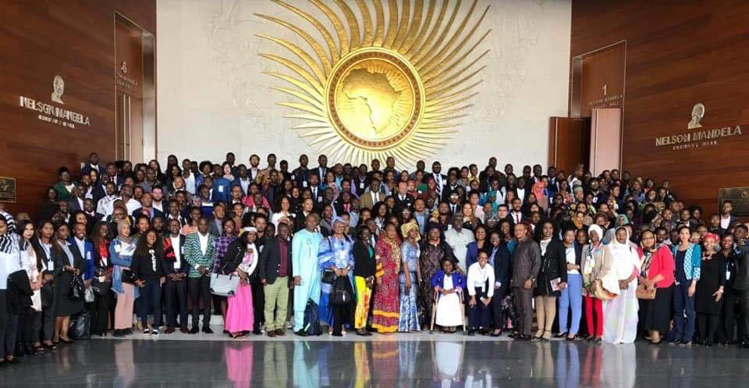
Participants at the youth conference

- CAFOR participation at the World Press Freedom Day conference 1-3 May 2019 in Addis Ababa ( Mr Lawalley to provide image for that )

CAFOR participated in the celebrations of the World Press Freedom Day. This event considered the emergence of citizen journalism, civilian oversight, the challenges and opportunities for the media in an age of disinformation, as well as the significant role social media has played in providing news in real-time; but also fake news. Over two thousand journalists, activists, government representatives and influencers from all over the world assembled in Addis Ababa for the WPFD 2019, under the theme "Media for Democracy: Journalism and Elections in Times of Disinformation". CAFOR could network with journalists around the world to play a supporting and facilitation role in analytical work, mobilization and provision of experts, technical and institutional capacity building, exchange of experiences and sharing of knowledge among countries and professionals, advocacy, dissemination and communication. Through these contacts, CAFOR would be able to better support the implementation of the communication strategy for CESA 16 - 25 through its networks of journalists on the continent and communication units in ministries of Education in Africa, and universities, individual experts and ensuring visibility and enhanced public support for CESA.

- Meetings with A.U. ambassadors and partners

In 2019, CAFOR's Executive Director and staff met with significant members of the diplomatic community and partners of the African Union. These include Ambassadors from Japan, Germany, Qatar, Korea, Norway, Kuwait, Saudi Arabia, India, Brazil, Turkey, Australia, Finland, the Netherlands, the United Arab Emirates, Poland, Spain, Italy, and New Zealand. CAFOR staff also met and discussed the African Union's plan that includes the CESA with various representatives accredited to Ethiopia and the African Union. These include representatives of the USAID, the GIZ, KOICA, the Korea-Africa Foundation, ECOWAS, and the E.U. delegation to the African Union. CAFOR also met with delegations from China, Luxembourg, France, Sweden, Kuwait, the League of Arab States, and Education Cannot Wait at UNICEF, New York. Dialogue on CESA and other African Union agendas has also started through meetings with UNDP, UNICEF, UNESCO and UNFPA. In addition to all of these meetings, Her Excellency the Commissioner for Human Resources, Science and Technology, Prof. Sarah Anyang Agbor, sent a Note Verbal to all the Ministries of Foreign Affairs of the 55 Member States of the African Union and their Embassies in Addis Ababa to announce and explain the purpose of the MOU signed between the African Union and CAFOR. She also invited the Member States of the African Union to provide the necessary support to CAFOR in the accomplishment of its mission at the country level.

In total, CAFOR met with 42 delegations among them 26 Diplomatic Representation to the African Union, 12 non-conventional stakeholders, and 4 private sector establishments in order to present its vision and mission and as a privileged partner of the Department of Human Resources, Science and Technology of the African Union. The objective of CAFOR consultations were also geared toward building trust and confidence for resource mobilization for the implementation of its activities and programmes. CAFOR has therefore designed a mapping of potential partners for future collaboration the most important among them being UNESCO, UNFPA, UNICEF, CAPA, GIZ, UNDP, ECOWAS, Korea Africa Foundation, GIZ and USAID.

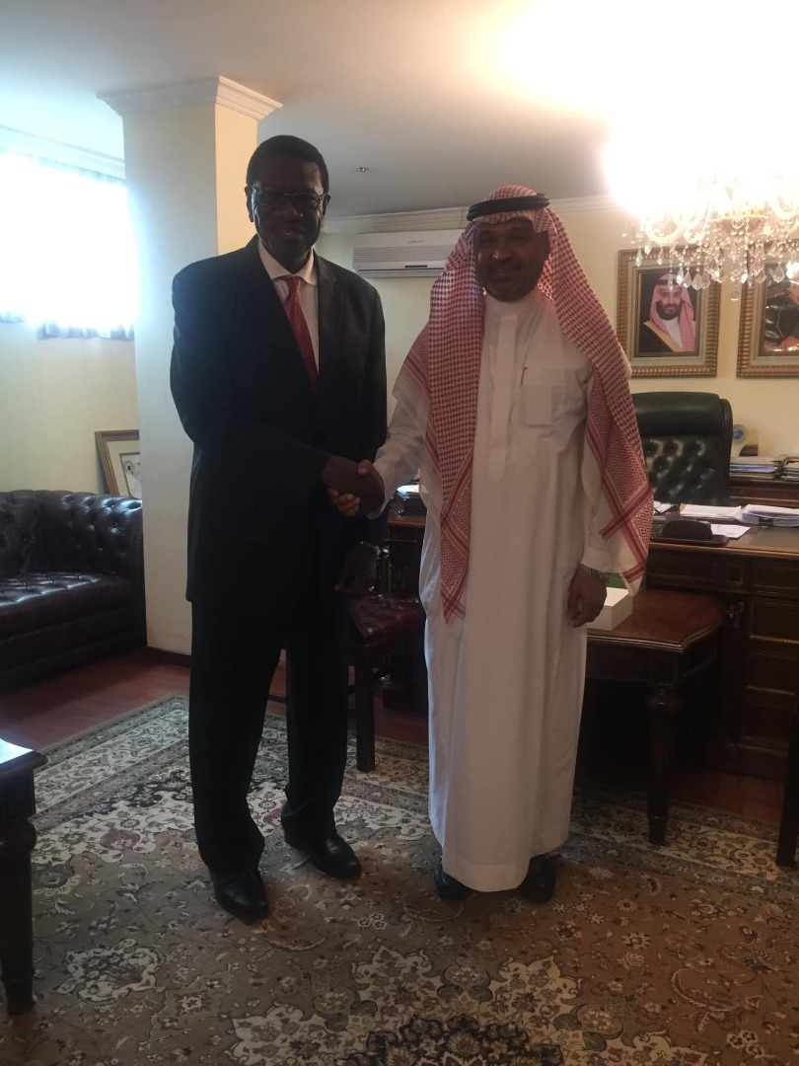
CAFOR Executive Director with H.E. Ambassador Sami J. Abdallah, Ambassador of the Kingdom of Saudi Arabia to Ethiopia and the Representative of the Kingdom to the African Union

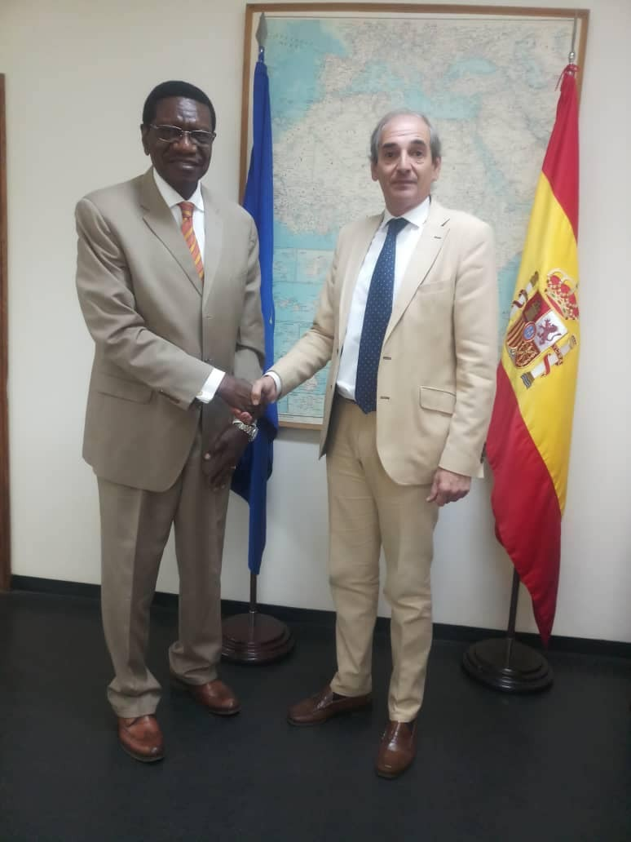

CAFOR Executive Director with H.E. Ambassador Borja Montesino, Ambassador Spain to Ethiopia and Representative to the African Union.

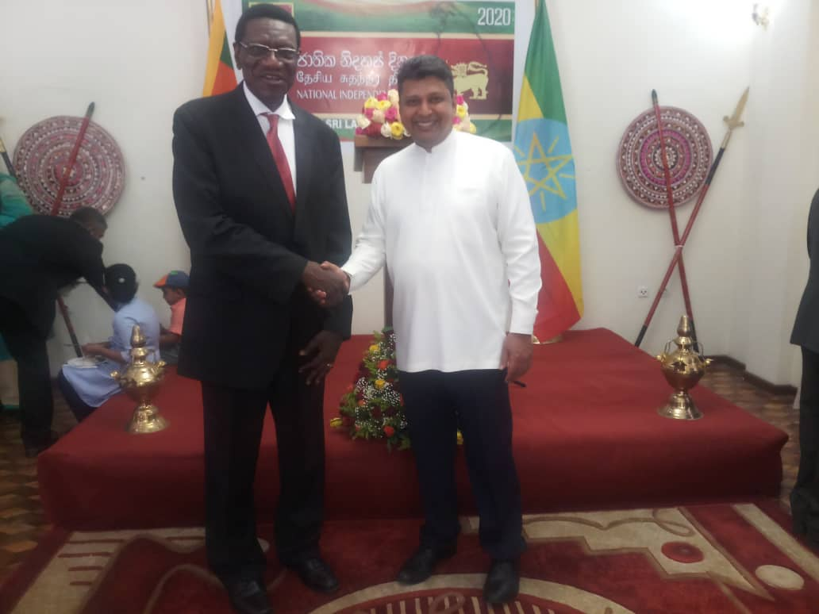
CAFOR Executive Director with H.E. Ambassador Sugeeshwara Gunaratna, Ambassador of Sri Lanka to Ethiopia and Permanent Representative to the African Union

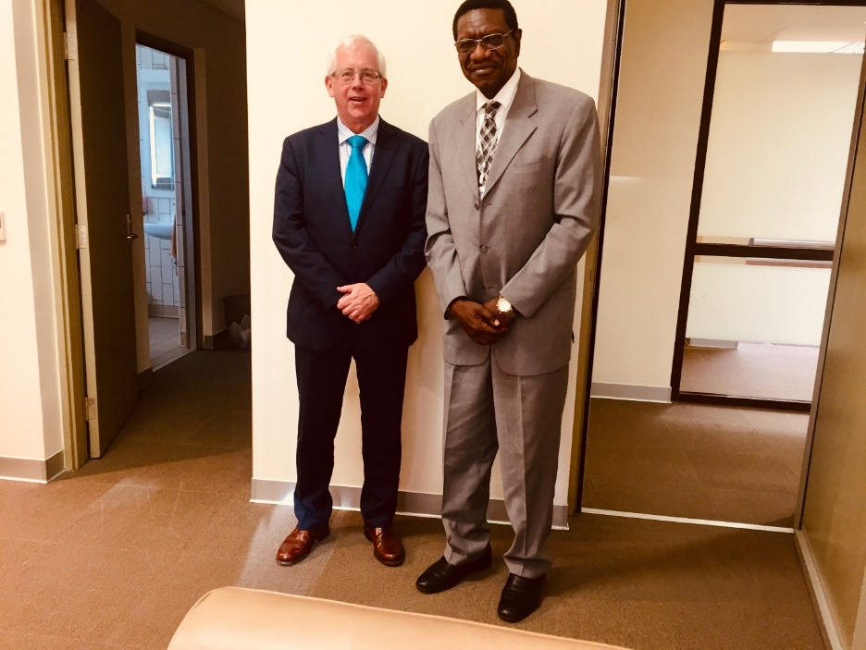
CAFOR Executive Director with H.E. Ambassador Peter Doyle, Ambassador of Australia to Ethiopia and Permanent Representative to the African Union

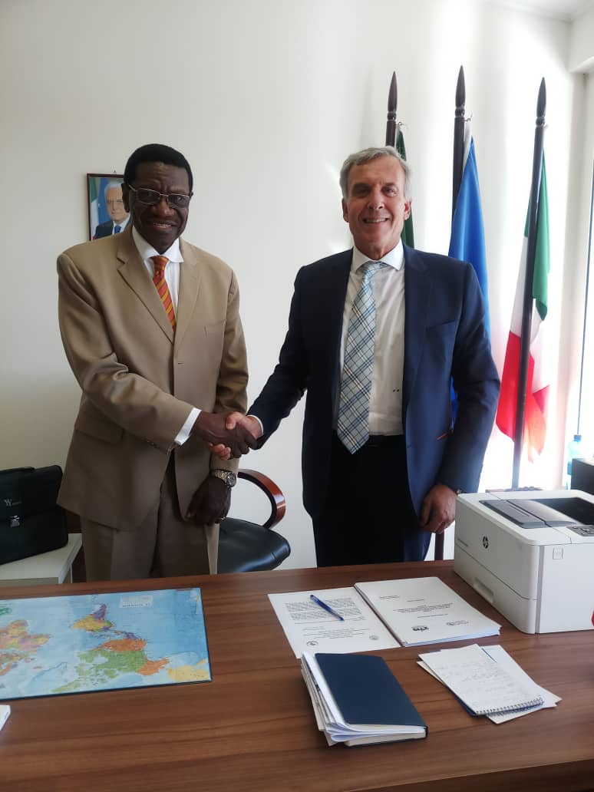

CAFOR Executive Director with H.E. Ambassador Guiseppe Berlendi, Ambassador of Italy Ethiopia and Permanent Representative to the African Union.

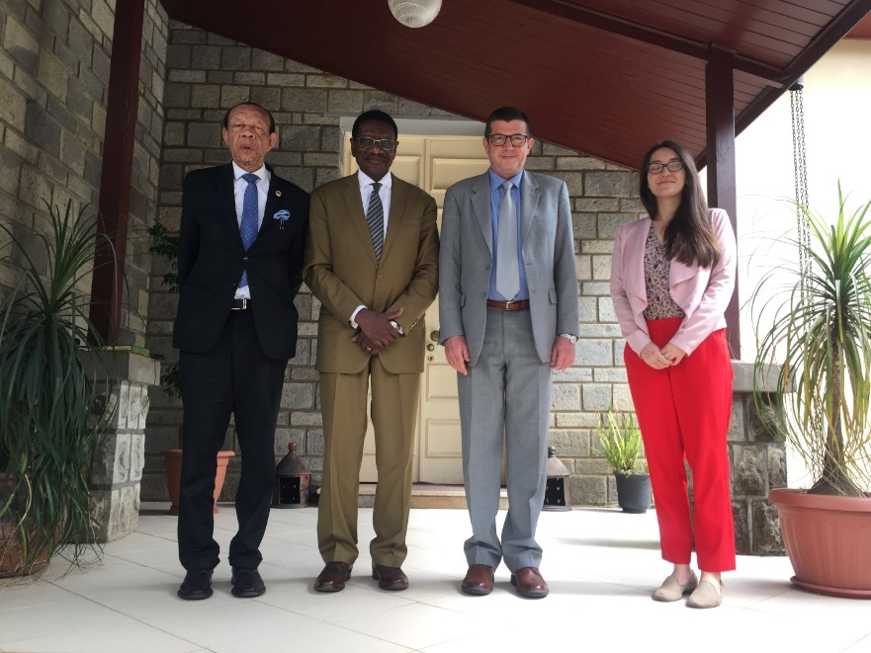
CAFOR Executive Director and Senior Advisor with H.E. Ambassador Aleksander Kropiwnicki, Ambassador of the Republic of Poland to Ethiopia and Permanent Representative to the African Union

.

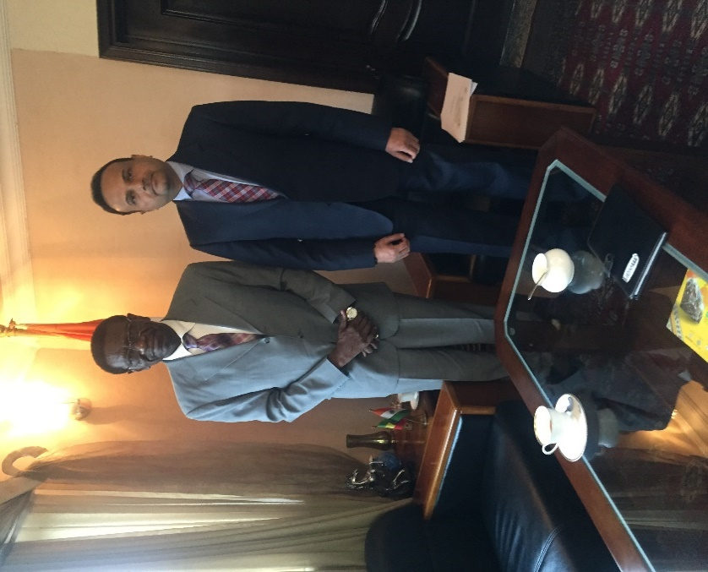

CAFOR Executive Director; Dr. Lawalley Cole with the Indian Ambassador to Ethiopia, A.U. and UNECA; H.E Anurang Srivastava

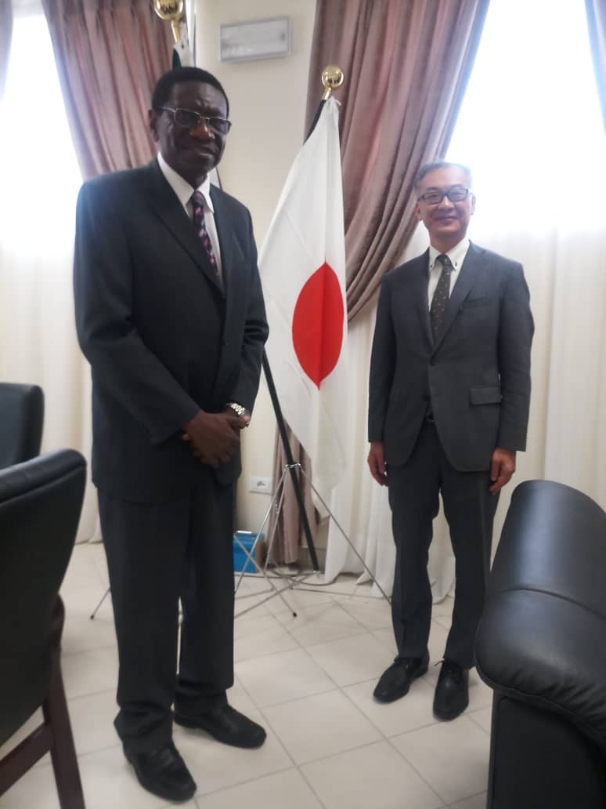
CAFOR Executive Director with Japan Ambassador to A.U.; H.E Fumio Shimizu
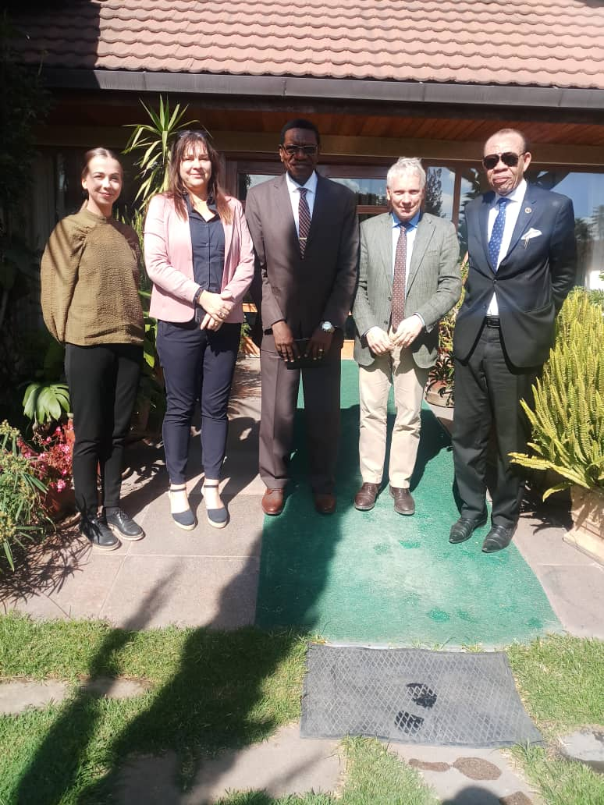

CAFOR Executive Director and Senior Advisor with H.E. Ambassador Morten von Hanno Aasland, Ambassador and Permanent Representative of Norway to the African Union. Also, in the photo is Ms. Vigdis Christofoli, Education Advisor at the Norwegian Embassy in Ethiopia.

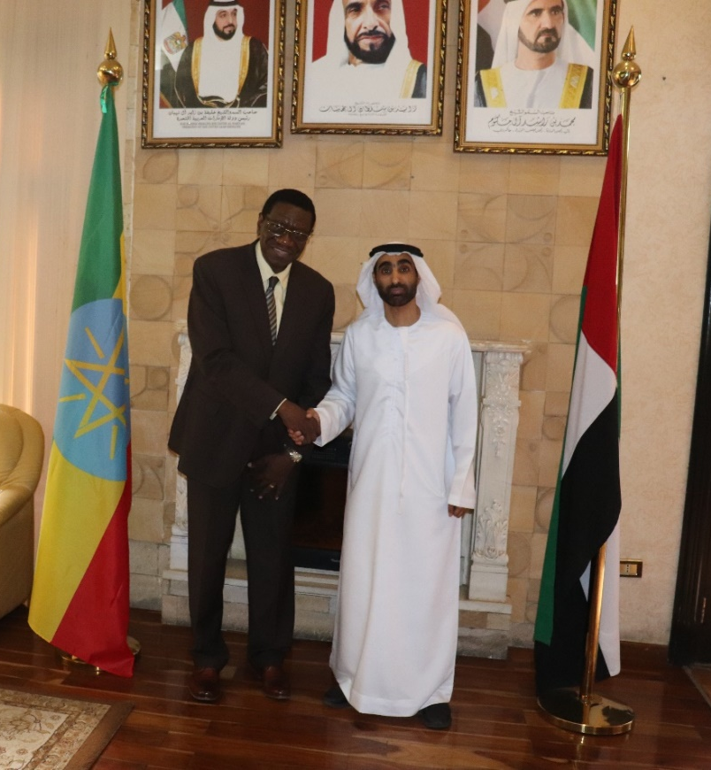

CAFOR Executive Director with UAE Ambassador to Ethiopia and A.U.; H.E Mohamed Al Rashedi

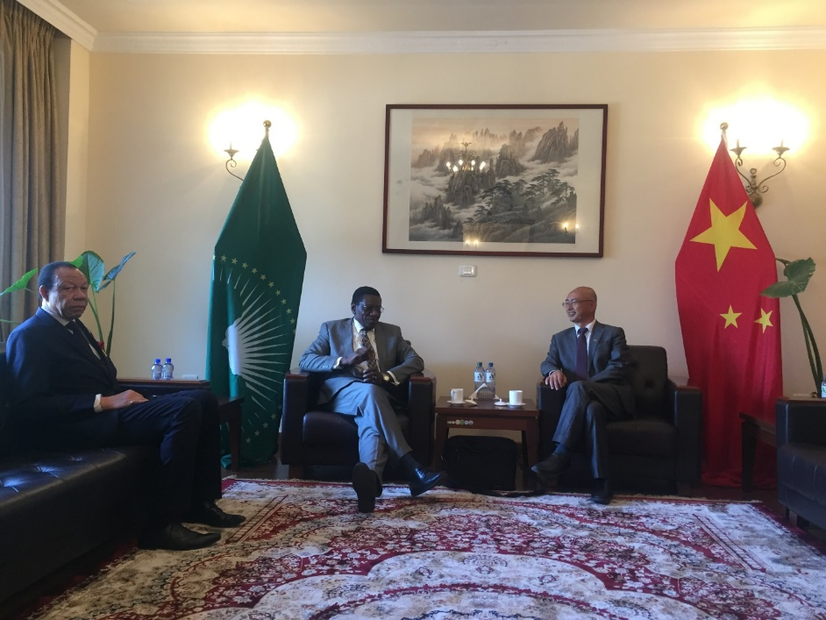
CAFOR Executive Director and Senior Advisor with Economic and Commercial Counsellor in Mission of the People's Republic of China to the African Union; Mr. Lin Zhiyong

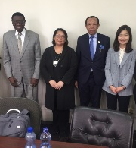

CAFOR Secretariat with the team of Korean African Foundation

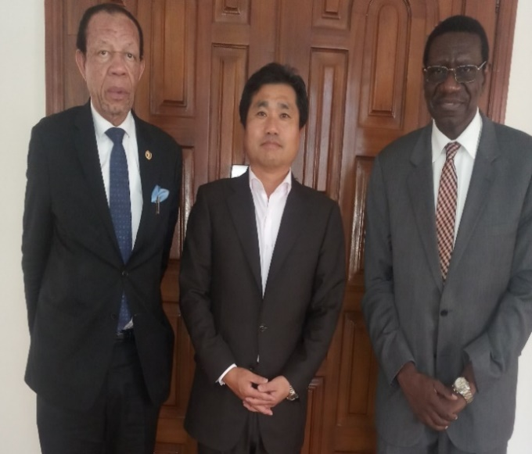

CAFOR Secretariat with the Republic of Korean Ambassador to Ethiopia, A.U. ad UNECA

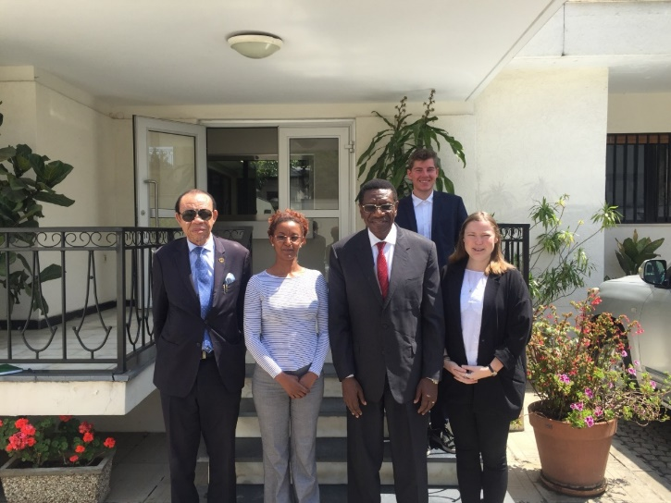

CAFOR Secretariat with the team of Denmark Embassy

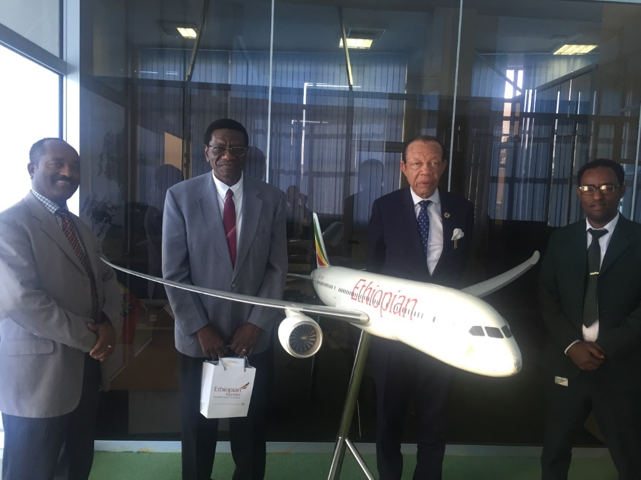
CAFOR Executive Director and Senior Advisor with Ethiopian Airlines manager Mengistu Adelahu and Passenger Sales Representative Abel Yifru. The Business Sector in Africa will become an important partner to CAFOR.

- African Curriculum Association

CAFOR's Chairperson, Prof. Kate Adoo-Adeku, recently participated in the Conference of the African Curriculum Organization held in Accra, Ghana from 26th to May 30 2019. A key recommendation from this Conference was the need for more communication and publicity on the work of the Africa Curriculum Association, and to create and strengthen partnerships with organizations working in the area of curriculum development in African institutions.

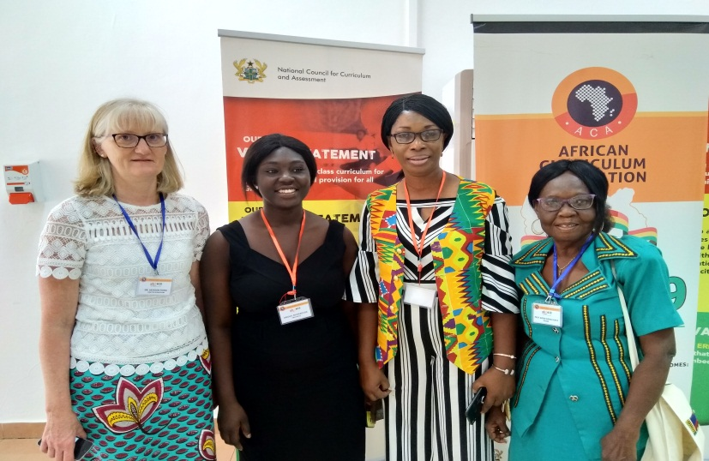

In this photo, CAFOR Chairperson Prof. Kate Adoo-Adeku is with Dr Fiona Jackson, Development Manager, Curriculum Programmes at Cambridge International and two other participants.
- Innovating Education in Africa Expo 2019, Gaborone, Botswana - 20 to August 22 2019.

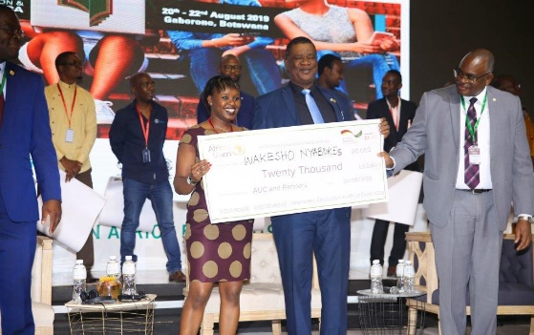
CAFOR submitted one paper at the Expo 2019 in Gaborone, Botswana as a partner of the African Union and contributed to the development of a Communication Plan for the Expo to be implemented jointly by CAFOR and the Division of Information and Communication (DIC) of the African Union Commission. CAFOR focuses on (i) Advocacy for education innovation and strengthened continental collaboration; and (ii) Engaging in critical debates and discussions on the full range of pressing education challenges and opportunities related to ICT in Education, with diverse practitioners, policy-makers, the business sector and financiers committed to supporting and promoting innovation in education.

In terms of practical innovation, CAFOR showcased an ICT-based innovation that successfully increased inclusion, quality and impact in education and training in an African country in crisis. CAFOR presented a descriptive field study which was also an innovation entitled "Using the Media Lab to teach courses for Journalism, Radio and Television Sections in a Media Department". A CAFOR member from Tripoli, Libya, Dr Khaled AbouKacem Ghulam, Professor in Journalism Section, and Head of the Tripoli Media laboratory in the Media Department of the University of Tripoli with two of his colleagues, Prof. Tarek Rajab Guerfal, Professor in the Radio Section, Prof. Ali Amari Salem, also from the Radio Section at the University of Tripoli conducted this study. The Tripoli Media Laboratory of the University of Tripoli has provided hands-on training in Journalism to numerous youths, who would otherwise never receive that type of quality training in a country embedded in a severe factional conflict.

Briefly, the Media Lab of Tripoli (MLT) was established in March 2014, supported by the Institute for War and Peace Reporting (IWPR). It contains two T.V. and Radio studios and fifteen workstations and fifteen cameras and recording devices.

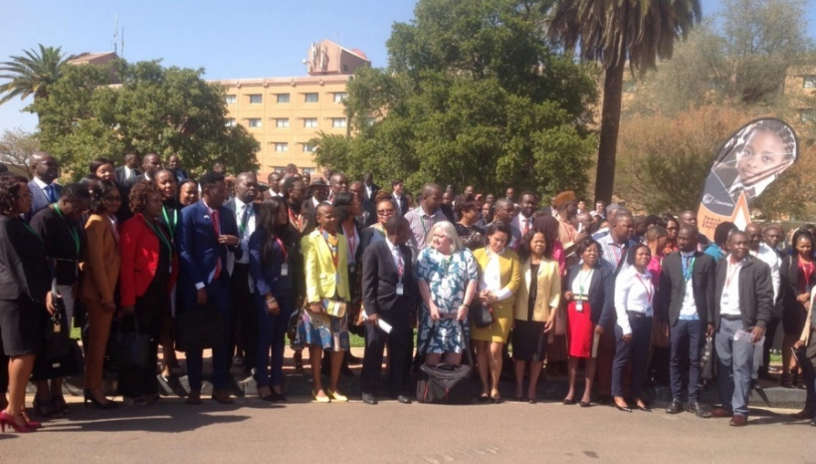
Participants of the Botswana Innovation Expo 2019

MLT is providing practical journalism training in a country embroiled in a civil war. It has been the foundation stone for the transformation from the theoretical to the practical side in teaching the media models. Since established in the early 1990s, the Tripoli University Media Department focused mainly on theory, lecture and classroom exercises. The MLT is currently filling this critical gap in this emergency.

The Media Lab has trained more than 4,000 students, most of them women over the past five years. In a war situation, the need arises to have this kind of innovation. Therefore, in an emergency, this innovation serves to guarantee continual education and training for young people in Libya. The MLT has hosted and trained tens of young journalists and students from other Libyan cities and universities during the summertime. It also offered media and communications training to more than one hundred media officers and journalists of the Government of National Accord in Libya. Despite the ongoing conflict in Tripoli, and the limited sources of funding, the Media Lab continues to provide training to the students and other trainees.

This study has shed light on the training experience within the Media Lab of the Media Department (Sections of Journalism, Radio and Television). It is essential because of its effects on the level, capacity and efficiency of the human element (students). This experience drew the attention of both the stakeholders at the University of Tripoli and the other Libyan universities, who may use it to spread the training and practical application in the academic sphere, at the departmental level or the sections.

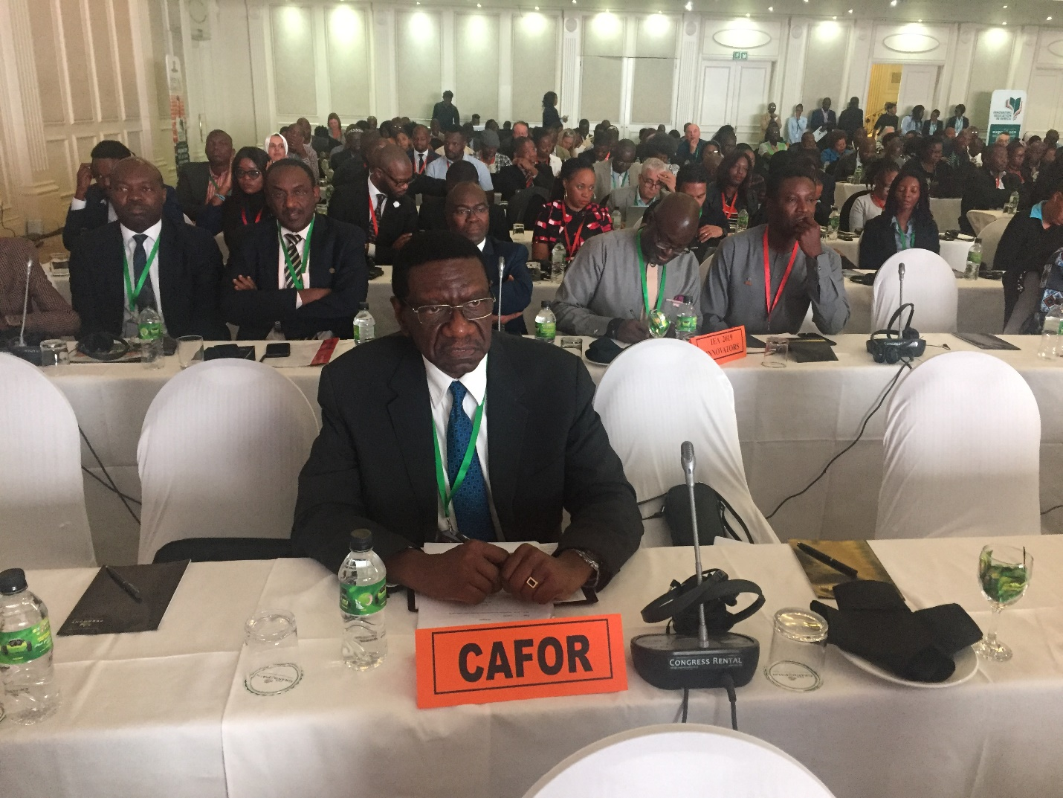
Image: Executive Director of CAFOR at the 2019 Botswana Innovation Expo 2019

CAFOR embarked on an aggressive publicity and communication campaign over the Innovation Education in Africa Expo 2019 in all member countries of the African Union. CAFOR has also endeavored to achieve record participation of youths and youth organizations, educational institutions, media organizations, development partners, and the governments of A.U. member states. These include sub-national government authorities, e.g. local governments that are closer to the grass root in innovation initiatives in many forms that would benefit the young people of Africa. CAFOR has publicized the outcome of Innovation Education in Africa Expo 2019 in all African countries, for possible replication, adaptation and upscaling. Forty innovators were awarded various prizes during this Expo with the first winner Ms Susannah Farr of South Africa and CEO at Gold-Youth and Gold-Enterprises winning a cash prize of U.S. $50,000, out of more than 300 applications across Africa. Ms Farr shared Gold-Youth's engagement in creating a movement to implant long-term peer role models and mentors into all schools and communities measuring concrete improvements in social mindset and behaviour change, improved educational outcomes and job creation.

- Commonwealth Association of Technical Universities and Polytechnics in Africa (CAPA) Conference from 25th – 31st August 2019 in Kigali – Rwanda

CAFOR's Executive Director participated in a panel as a Keynote Speaker in the Conference of the Commonwealth Association of Technical Universities and Polytechnics in Africa (CAPA). The theme of the Conference was "Building Partnerships for the Promotion of TVET for Innovation, Entrepreneurship and Youth Employment in Africa". The Conference aimed among other issues to raise the need for rapid industrialization of African economies to the centre stage for policy initiatives and strategic action by governments and stakeholders and highlighted points on private-public partnerships (PPPs) in expanding the TVET space and developing vocational education and skills in African countries. CAFOR's Executive Director animated the Conference with the topic" The Leadership Challenge: Harnessing TVET for Africa's transformation".

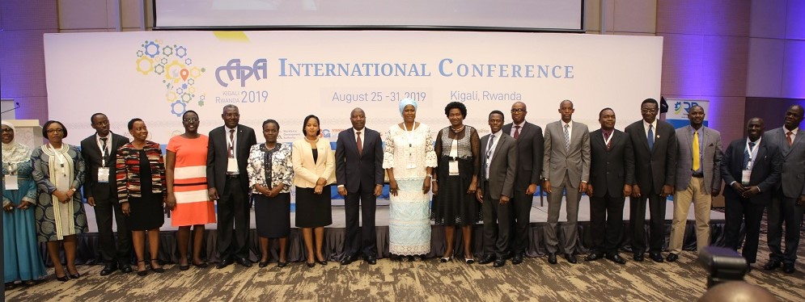

The Conference in Kigali, Rwanda with the Prime Minister of Rwanda standing next to Mrs Jahou Faal, Secretary-General of CAPA. Also in this photo are CAFOR’s Executive Director with Ministers of Education from Namibia, Rwanda and Tanzania.

In his intervention, CAFOR's Executive Director linked the theme of the Conference with the question of leadership in Technical and Vocational Education and Training (TVET) and equated this link with the resolve to develop human capital's ability to react as a leader. He noted that Technical and Vocational Education and Training (TVET) is an educational approach that is oriented by a training process that emphasizes on what is to be done in the workplace to meet the businesses requirements and also to enhance individual development. However, in this challenging world, the combination of job-oriented skills and knowledge is not sufficient to develop an individual's full potential. Therefore, to build excellence in human capital, the application should be started in the early stages of education. Leadership can mean the ability of an individual to influence, motivate and enable others to contribute toward effectiveness in the decision-making process and setting the goal for an organization. Without proper leadership in TVET, the goals set to prepare excellence in human capital and self-reliance would be hard to attain.

- The Third Ordinary Session for the Specialized Technical Committee on Education, Science and Technology (STC-EST) – 10th -12 December 2019, Addis Ababa, Ethiopia.
CAFOR's Executive Director, Dr Lawalley Cole and Senior Advisor for Partnerships and Resource Mobilization, Mr Tshimanga Mukadi- Mutoke participated at the Third Ordinary Session for the Specialized Technical Committee on Education, Science and Technology (STC-EST) held in Addis Ababa from 10th -12 December 2019, by its The meeting provided a common platform for Education, Science and Technology experts to discuss and review progress on the implementation of the decisions of STC-EST II as well as the implementation of critical policies and programmes in Africa on Education, Science and Technology. It was also the opportunity to advocate for investment in Education, Science, Technology and innovation towards the attainment of the African Union's agenda 2063 and the Global Sustainable Development Goals.
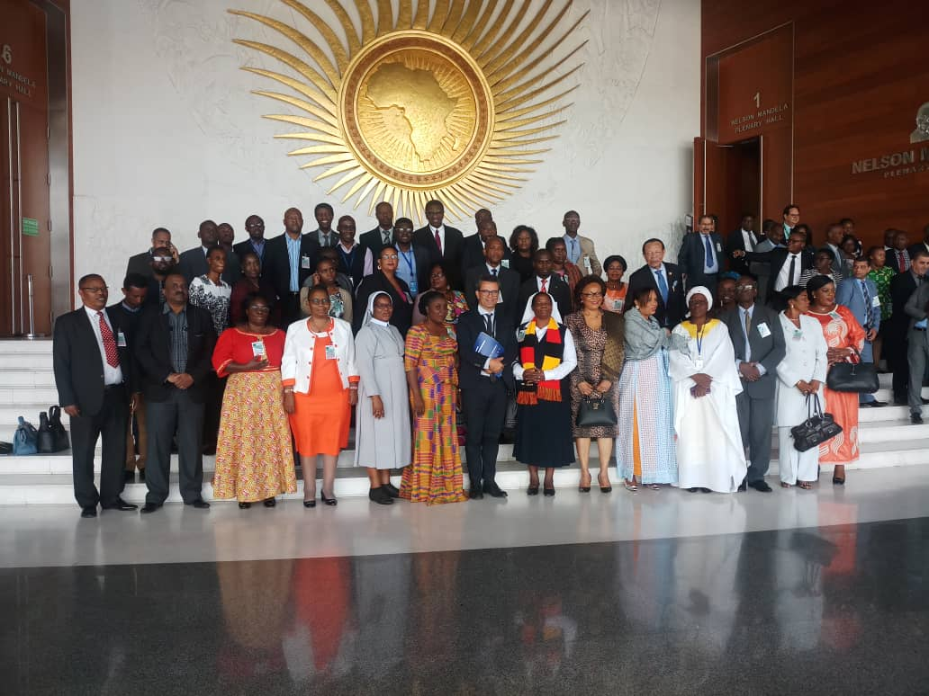
Group photo of participants at the Third Ordinary Session for the Specialized Technical Committee on Education, Science and Technology (STC-EST)
The Conference had two sessions. There was the Experts ‘Session held from 10-11 December and a Ministerial session held on the last day of the Meeting, December 13 2019. Key issues discussed at the Experts Session included matters arising from the outcomes of an extraordinary summit of the Committee of Ten Heads State and Government who are championing on Education, Science and Technology, the A.U. Chairperson's One Million by 2021 Initiative, and the Digital Transformation Strategy of the African Union. Among other key issues, the Ministerial Session elected a new Bureau and considered the Experts Report on Education, Science and Technology, from the Commission, Partner Organizations and Civil Society, and made recommendations for consideration by the Assembly of Heads of State and Government.

- Dubai Expo 2020

CAFOR participated in preparatory activities for the Dubai Expo with the African Union Commission and considered one of the largest global events connecting governments, the private sector, civil society and international organizations, and the general public to showcase innovation, promote progress and foster cooperation. In its quest of engaging new partnerships for supporting the effective implementation of the continental development vision embedded in the Agenda 2063, a large-scale platform for education and international dialogue such as the Expo 2020 Dubai remains a promising opportunity for the A.U. and its Member States.

The central theme of the Dubai Expo 2020 is: "Connecting Minds, Creating the Future"to enable nations, organizations and the general public taking part in the event to explore the power of connection and its impact on people's lives today. This theme is split into three interrelated subthemes: Opportunity, Mobility and Sustainability, which also remain a central focus in the global development agenda, the Sustainable Development Goals (SGDs) and the need to move away from the usual approach towards an interdependent network committed to generations to come.

CAFOR's Senior Advisor, Mr Tshimanga Mukadi-Mutoke, represented the Organization in this two-day Continental Workshop relating to the African Union participation at EXPO 2020 Dubai.
The workshop intended to bring participants and businesses closer to the world's fastest-growing markets and create opportunities for accessing more than 3.2 billion people. The main objectives of the Continental Workshop were to advance the collaboration between the African Union and the organizing country, the United Arab Emirates. The African Union being designated by the Government of UAE as a vital partner and stakeholder would be offered a pavilion during the EXPO 2020 Dubai.
(Request Mr Lawalley to Change photo)
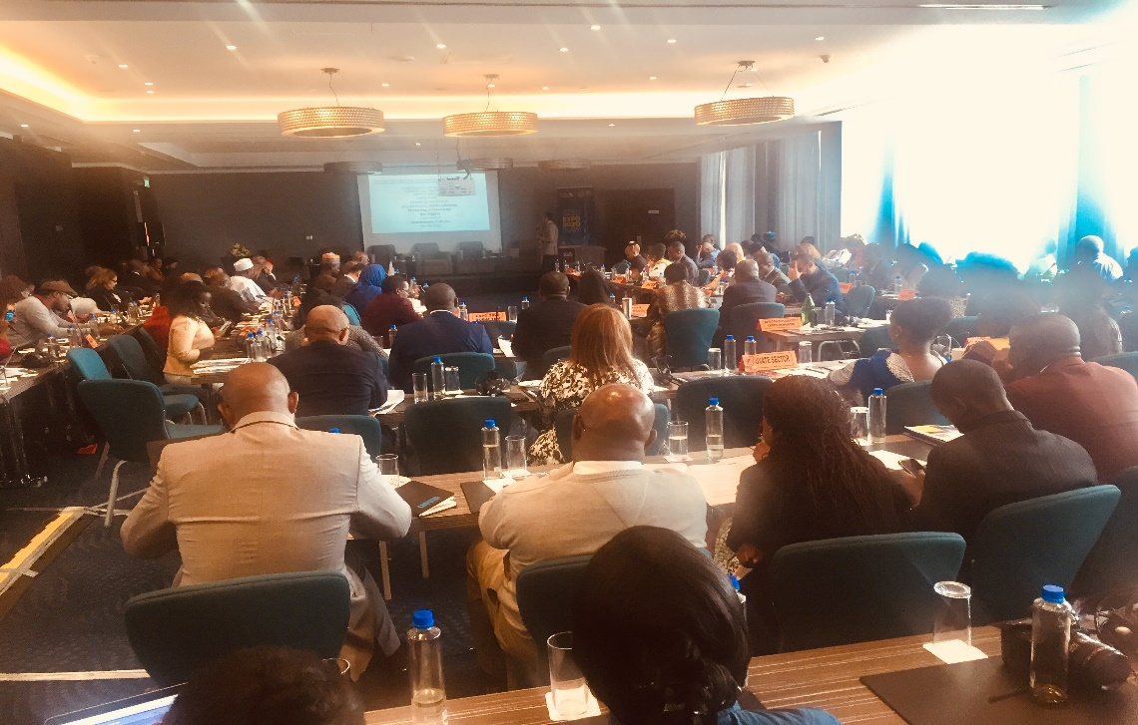

Participants at the Expo 2020 Dubai meeting in Nairobi, Kenya

The African Union participation to the EXPO is justified by the opportunity for the Organization's quest to develop relevant partnerships to support the implementation of the Agenda 2063 and to capitalize on the strong concordance between the EXPO's themes of opportunity, mobility and sustainability and the Agenda's flagship initiatives and priority programmes.

The African Union welcomes all its stakeholders, mainly member states, including A.U. affiliated institutions, Regional Economic Communities, Financial Institutions, Private Sector, Civil Society Organizations, and Academia. CAFOR would take an active part in the EXPO with the understanding that a series of workshops will be held to define objectives and deliverables expected from showcasing Africa at the EXPO 2020 Dubai.

The 2nd Continental Workshop to project A.U. Participation at EXPO 2020 Dubai was held on October 30 to November 1 2019, in Nairobi, Kenya. The meeting gathered a high-level delegation from the Expo 2020 Dubai Team led by Ms Hind Alowais, Vice President, International Organizations and Non-official Participants, Expo 2020 Dubai, A.U. Commission Staff, A.U. Organs, AUDA-NEPAD, the African Capacity Building Foundation (ACBF) and other Specialized Agencies, Focal Points concerned with A.U. Strategic Partnerships and International Cooperation, Regional Economic Communities (RECs), the Private Sector, the African Development Bank (AfDB), Financial Institutions (Trade and Development Bank, African Financial Corporation), CSOs, Academia, the Diaspora, Think Tanks, Regional and Continental Chambers of Commerce, Fundraising Experts, Technical Partners and Partnership Experts, African Disability Alliance, among others. The Executive Director of CAFOR, Dr Lawalley Cole, represented CAFOR in this workshop.

The Conference discussed various issues related to the participation and promotion of the Private Sector, Entrepreneurship, Trade and Investment opportunities in Africa, the promotion of African Culture and Creative Industries, Africa's strategy for the Blue Economy, Agriculture and Climate Change, critical attention on issues related to People With Disabilities (PWDs), the importance of reaping the demographic dividend, Women and Gender mainstreaming at Expo 2020 Dubai as well as issues related to how the African Union should brand itself at Expo 2020 Dubai and how A.U. should promote infrastructure and Social Development as well as ICT at Expo 2020 in line with A.U's Agenda 2063.In that regard, the Conference welcomed the opportunity given to engage various stakeholders in the preparatory process of A.U.'s participation at EXPO 2020 Dubai and agreed on the following recommendations and way forward:

(i). Encourage the A.U. to continue engaging all stakeholders and coordinate the contributions of all the parties involved.

(ii). Call on all participants to continue to provide their ideas, contributions, and concrete proposals to finalize A.U. programming component (Spotlights on Africa) during Expo 2020 Dubai through virtual tools.

(iii). Stress on the importance to finalize A.U. Communication Strategy and the A.U. sponsorship plan to mobilize funds for A.U. participation at EXPO 2020 Dubai.

(iv). Commence immediately with necessary consultations on the engagement of the Regions through the holding of Regional sensitization workshops and the execution of the Roadshows, which of course would depend on the accelerated progression of mobilization of necessary processes.

(v). Call on all the leads in the various Group sessions to continue engaging with the members of their Groups to finalize the different concept Notes for A.U. Activities programming at Expo by or before November 152019.

(vi). Encourage that the preparatory process for the A.U. participation at the Expo 2020 Dubai should accommodate the interest of People with Disabilities (PWDs);

(vii). Express the need for better coordination of all African Union Member States Commissioner Generals to ensure harmonization of Africa's participation at Expo 2020.

(viii). Express gratitude to the Expo 2020 Dubai Team and Encourage the Expo 2020 Dubai Team to continue to work closely with the African Union and its stakeholders towards the implementation of the mandate for A.U. participation at the Expo 2020 Dubai.

- Youth Connect
On Friday, December 20, 2019, the ceremony marking the official launching of the Youth Connect Ethiopia was held in Addis Ababa, Ethiopia. CAFOR's senior Advisor, Mr Tshimanga Mukadi-Mutoke, represented the Organization at the launch. The ceremony was presided over by Mrs Yalem Tsegay, Ethiopian Minister of Women, Children and Youth. In her opening address, the Ethiopian Minister stressed the importance her country gives to the promotion of youth, primarily through the Youth Connect platform which aims at creating supporting synergy for young people in close partnership with the United Nations Development Programme, (UNDP). The Youth Connect Initiative is devoted to improving the future of young people by providing them with the required skills, entrepreneurship, and financial support for job creation and access to the job market. Ethiopia has about 70% of Africa's population under the age of 30. Mrs Tsegay concluded that any plan devoted to improving the future and role of young people in development is highly encouraged by her government, noting Ethiopia's rapidly growing youth population.
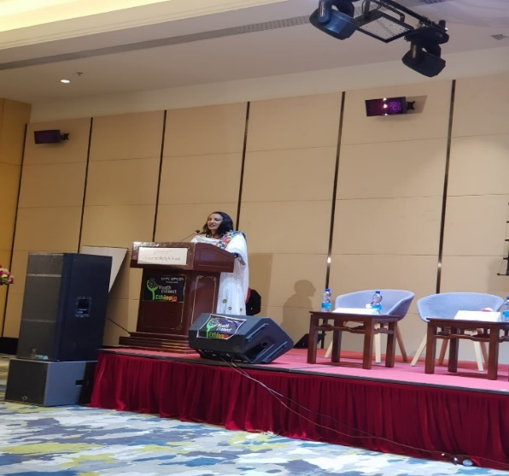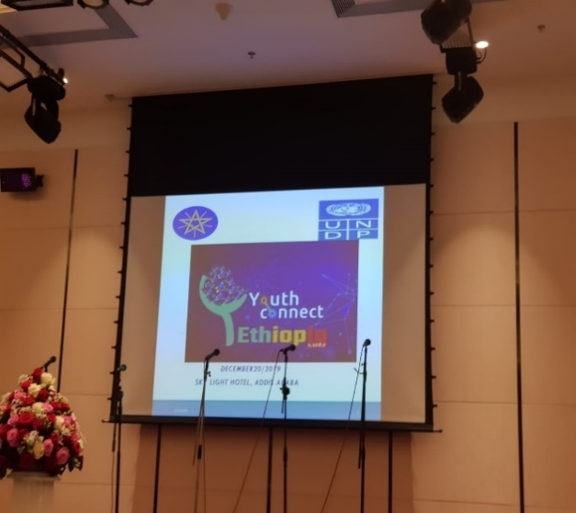
Ms. Yalem Tsegay, Ethiopian Minister of Women, Children and Youth.

According to UNDP which is providing support to this programme, young African entrepreneurs with innovative start-ups that have the potential for scale-up across the region would benefit from financing and a support structure through the Youth Connekt Africa Hub and Youth Connekt Innovation and Empowerment Fund. UNDP will continue to provide the necessary financial and technical support to the youth initiative in Africa and Ethiopia for the realization of skills development and entrepreneurship among them. Young people continue to face enormous challenges due to a lack of job opportunities and growing unemployment. UNDP will further continue to lend support to youth organizations by providing them with knowledge in Information and Communication Technology, (ICT), and promote youth voluntarism.

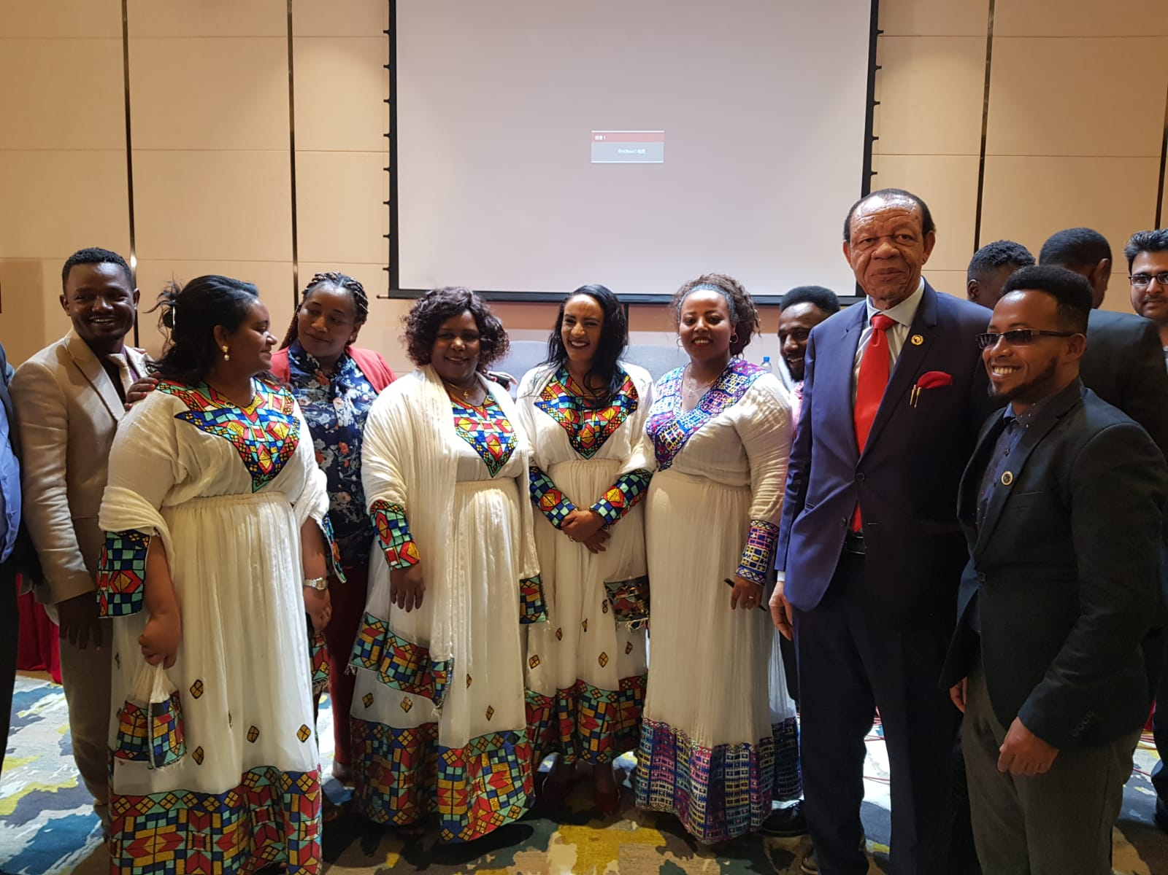
Ms. Howit Hailu, State Minister, Ms. Semegne Wube, State Minister, Ms. Yalem Tsegay, Minister WCY, Mr. Tshimanga Muadi-Mutoke,Senior Advisor,CAFOR, Matiyas Assefa, Director Ministry WCY
The establishment of the Hub and Innovation and Empowerment Fund was agreed to at the inaugural YouthConnekt Africa Summit held in July 2017 in the Rwandan capital, Kigali.
Youth Connekt was initiated by Rwanda in 2013 and designed to realize the demographic dividend by combining elements of skills development, entrepreneurship, access to jobs and finance, awareness-raising on issues related to youth development, and promotion of youth citizenship through community work and inclusion in local and national policy dialogue.

Since its launch, Youth Connekt has enabled four million young people aged between 16 and 34 to actively participate in Rwanda's development through job creation, ICT innovations, skills development, and citizen engagement. Based on this success, UNDP is working with the Government of Rwanda to scale up the Youth Connekt Initiative to the regional level. UNDP is already supporting the roll-out of the initiative in five African countries—Congo Brazzaville, Democratic Republic of the Congo (DRC), Liberia, Sierra Leone, and Uganda. By connecting government, private sector and youth, the Youth Connekt Hub will work to identify start-ups that are solving challenges on the continent and provide access to appropriate infrastructure and support to have an African footprint.

The launching of Youth Connect Ethiopia included panel discussions during which the necessity to strengthen networking of youth organizations to share experience and maintain dialogue were high points for discussion. The launching ceremony also provided a logo and website for the Youth Connect Ethiopia programme. CAFOR is looking forward to working closely with the Ministry of Women, Children and Youth Affairs and UNDP to boost the programme in Ethiopia and other participating countries in the region.

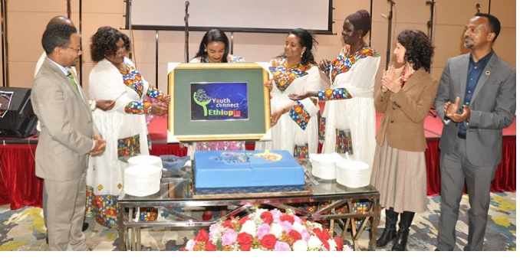
Official announcement of the Youth Connect Ethiopia Logo by Minister, Yalem Tsgegay, in the presence of Alessandra Casazza, UNDP Director a.i, Regional Service Center of Africa

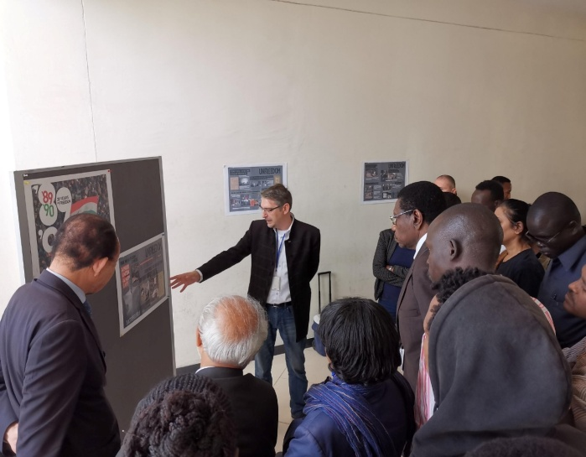
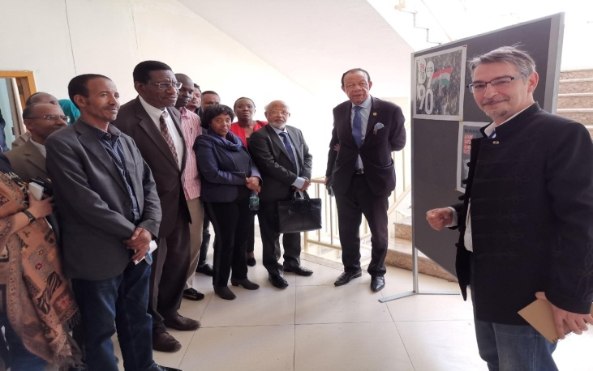
  - Other Collaboration
Following the keynote lecture delivered by CAFOR’s Executive Director at the University of Pecs in Hungary, CAFOR continued its collaboration with Hungary. In these photos, CAFOR’ Executive Director and Senior Advisor participate in the seminar organized by the Embassy of Hungary to Ethiopia, the Ethiopian Civil Service University in Addis Ababa, the National University of Public Service in Budapest, Hungary, and the University of Pecs in Hungary.
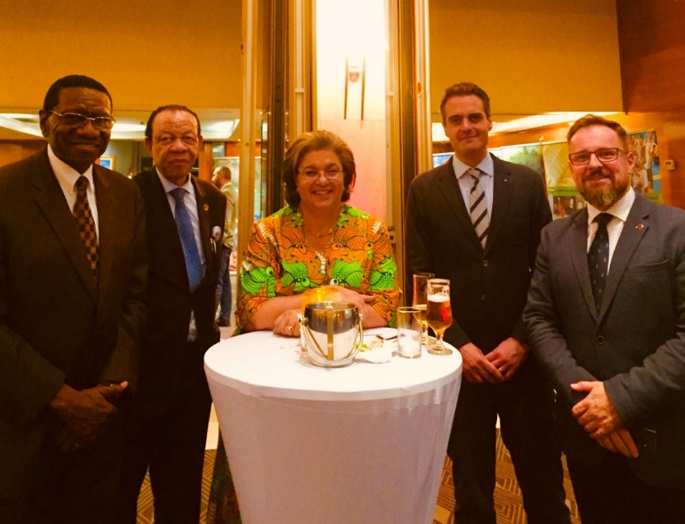
With the Hungarian delegation from the University of Pecs and Ms. Hannah Tetteh, the UN Secretary-General’s Special Representative to Ethiopia and the African Union.

CAFOR Scholarship Programmes
    - Successfully placed 50 African youth in a scholarship programme with the European business university, Luxembourg.
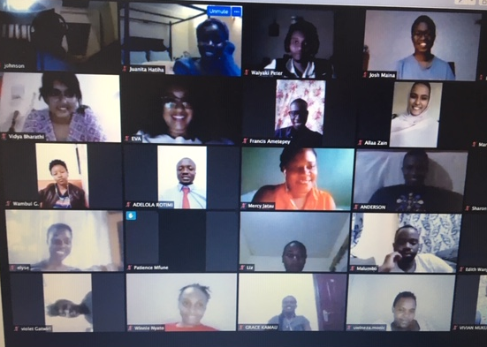
Bridging the youth employment skills gap is one of the major areas of concerns of CAFOR. In June 2020, CAFOR got an opportunity of placing 50 African youth from 19 different countries of Africa comprising- Ghana, South Africa, Nigeria, Kenya, Gambia, Senegal, Burundi, Congo, Zimbabwe, Benin, Malawi, Togo, Libya, Botswana, Zambia, Egypt, Uganda, Algeria and Mauritania. The candidates are successfully undertaking the courses of financial accounting and Business Administration from the European business university. Thus, CAFOR strives to contribute to Africa’s development by enhancing the skills of youth in Africa in every possible way.

Scholarship candidates who have been placed in EBU

On way ahead on this scholarship programme European Business University (EBU) has declared to release another 100 scholarships for enhancing youth skills in Africa. That has been a big achievement for CAFOR and CAFOR strives to contribute to empowering African youth with employable skills and thus contribute to the growth of Africa. CAFOR takes this opportunity to extend its most sincere gratitude to all its members, partners, associates and stakeholders who contributed to making this such a great success for the new organization with many achievements recorded.

Future activities

This report has highlighted CAFOR's achievements and short\comings as we anticipate paving the way forward with our plans for the remainder of the period ending 18th January 2025. CAFOR has extended its arms to securing new partnerships with numerous countries and agencies around the globe. CAFOR welcomed several new members at the country level bringing the total number of countries active in CAFOR now to 44. The remaining countries in Africa will be inducted in CAFOR's programmes in the coming years, thus covering all the 55 member states of the African Union.

The current Coronavirus pandemic will have long-term effects on education systems in Africa, and CAFOR must be fully prepared to accompany and support its partners and members in their various interventions. There is undoubtedly the new paradigm shift that CAFOR will learn to cope with now and even in the distant future. As schools and other learning institutions in Africa close and reopen due to the COVID -19 pandemic, a large proportion of students will be prevented from attending school in the coming months, and even few years to come. As of now, more than one billion children and students have been forced out of schools and universities in more than 150 countries, with over 100 governments closing schools nationwide and 25 others imposing localized school closures. A vast majority of those – 700 million – are between preschool age and 18 years old. Those numbers can only continue to rise.

For education continuity, which is essential for productivity and competitiveness, schools around the world, including many in African states, have been preparing to provide online instruction. However, even the best and most well-intentioned efforts would mean that students suffer. In Africa, technology is at a low level of development, and students from low-income families and rural students are unlikely to have access to the technology necessary for online learning. There is a high risk that most of the poverty-stricken, marginalized and refugee children in Africa will be left alone and in environments that are not at all ideal for education.

Besides, the technological deficiencies in Africa would suggest that not only that students generally learn less in online environments, compared with in person, but that disadvantaged students learn the least. Poor connectivity, lack of computers and high data costs are just some issues among many others. This phenomenon is real even when online teachers have experience and training with online teaching. Under the current emergency, most teachers in Africa would not have any experience at all with this online approach. It can be a tough situation for everyone, but it is most likely to harm low-income and rural students. The risk of having a massive dropout of students from the schools' system in Africa, with severe consequences from the resulting deficiency that would ensue in the shortage of the human capital that the continent has strived to build over the past sixty years.

Therefore, CAFOR will advocate with all stakeholders ensuring that African governments and their citizens take extraordinary measures in the provision of the necessary resources to support new and innovative initiatives to ensure that learning continues and that the momentum continues in the nick of time.

Africa already has a significant deficiency of teachers, with more than 19 million teachers needed to curb this deficit, according to UNESCO's Institute of Statistics. While teacher shortages are one thing, the quality of existing teachers is another. Despite this deficiency, the available teachers must heed the call to continue teaching to help their students. Schools in Africa might have to take emergency measures to require teachers to participate. This matter is not the only step to take. Schools should be well equipped with resources for online teaching to enhance their online teaching capacity, which can be useful beyond emergencies such as this (and in preparing for other possible future emergencies). There are issues related to curriculum design, class sizes, teacher training, the interactivity of platforms and learning assessments to tackle. Teachers must continue to be paid during school closures to allow economic stability during the crisis and make them remain in the profession. We also must consider that many families count on schools to feed and provide other services for children, so closing schools removes a lot more than just academic learning.

It is in this context that CAFOR will vigorously pursue its agenda with the African Union Commission. CAFOR has elaborated its strategic plan for the next five years with a proposed annual budget of US $15,000,000. CAFOR has enormous capacity at the field level with highly skilled professionals in various walks of life. These range from University professors to high-level officials in African Government Ministries to business entrepreneurs, and senior consultants and participants in civil society organizations. With COVID 19 issues in the background, CAFOR will, in broad terms, engage in the following:

- Provide a continent-wide platform for exchanging information, experience and practices about new technologies and innovations among experts in government ministries, CSOs, NGOs, the media, the youth, and communities. CAFOR will promote a community practice involving the youth in such areas as agriculture, entrepreneurship and other vocations that will help in the curbing of internal and external migration.
- Sensitize and mobilize stakeholders on good communication practices among key stakeholders.
- Build the capacity of media professionals and other interested stakeholders to stimulate robust public debate on education and development issues.
- Promote policy change and measures for ensuring an enabling policy environment for youth to engage in the innovative enterprise in Africa.
- Translate ideas into action on the ground by testing technological innovations and institutionalizing what works
- Promote relationships of trust and meaningful multi-stakeholder partnerships for the achievement of education goals on the continent.
- Undertake advocacy and lobbying to meet Africa's current economic and social challenges.
- Collaborate with the African Union Commission, the Regional Economic Communities, the United Nations, donors, civil society networks and other cooperating partners in areas of communication for education and development for the achievement of CESA and SDGs, with a stronger emphasis on youths.

CAFOR will also work collectively with all its partners to mobilize financial resources to support the short, medium, and long term, COVID-19 and post COVID-19 recovery process in Africa. To this end and following the earlier consultations we made with ambassadors, UN agencies, and other bilateral and multilateral partners, CAFOR has proposed to hold a Virtual Roundtable Conference with all its partners jointly with the HRST Department. The theme of the Roundtable is "Supporting the African Union's post-COVID 19 innovative practices in the fields of education, science and technology with an emphasis on TVET implementation to enhance youth advancement across the continent of Africa."

The purpose of the proposed Roundtable Conference is to contribute to the setting up of sustainable funding mechanisms that would accelerate CAFOR's sustainable financing needs and increase CAFOR's impact on the performance of the policy, and the legal framework for advancing education and development for young people in Africa. CAFOR will also subscribe to the design of a long-lasting financing management plan in collaboration with the African Union Commission, its organs and all partner agencies and member states by considering the results of its interventions at the country level. The Roundtable will, among other things, allow CAFOR to determine its financing and technical assistance needs with the support of the African Union Commission's HRST Department, cooperating partners, and member states of the African Union. It will also be able to ascertain the strategic partners to mobilize and map the relevant entities who will provide the required resources – both technical and financial.

The Roundtable will result in the production of a database of prospective technical and financial partners for CAFOR and their collaborative work with the African Union Commission. It will also result in the confirmation of indicative and firm commitments from the technical and financial partners for CAFOR and validate the general situation of financing opportunities to the CAFOR Secretariat and the opportunities therein for sourcing and mobilizing funding. We will also be able to determine the available tools for planning the establishment of new financing mechanisms for the CAFOR networks located in the 55 member states of the African Union. The Roundtable will also allow us to determine a management plan to support CAFOR's financing mobilization for plan implementation and with a programme to ensure funding sustainability. The Roundtable Conference will take place as soon as possible if our donor partners would honour their promises to finance it. Post Roundtable activities will include a review of HRST's work plan for the second quarter of 2020 to determine how CAFOR's programme can fit in.

CAFOR Budget as per 2020-2024 Strategic Plan

 | 2020 | 2021 | 2022 | 2023 | 2024
Total programme (core) costs | 10,121,841 | 9,838,667 | 9,545,231 | 9,228,924 | 8,887,008
Total administrative cost | 4,878,159 | 5,161,333 | 5,454,769 | 5,771,076 | 6,112,992
Grand total | 15,000,000 | 15,000,000 | 15,000,000 | 15,000,000 | 15,000,000

CAFOR DETAILED BUDGET
CAFOR Strategic Draft Budget 2020-2024 | Financial Year (All fig in USD)
Budget per annum | 15,000,000 | 15,000,000 | 15,000,000 | 15,000,000 | 15,000,000
Costs Details | 2020 | 2021 | 2022 | 2023 | 2024
Running Costs | 5,136,259 | 5,445,243 | 5,767,070 | 6,114,608 | 6,490,876
Anticipated total expenditure
Total Income
Total Fund To Raise
CAFOR Strategic Plan Detailed Budget Framework
Proposed Indicators
% Income International partners (Pledged)
Running costs growth (10%) | 513,626 | 544,524 | 576,707 | 611,461 | 649,088
Total number of staffs
Growth (10%)
Sub-total for travels and miscellaneous expenses
CAFOR Secretariat
Operating Budget
STAFF COSTS (including mission costs)
Full time staff | 2,853,159 | 2,933,833 | 3,004,519 | 3,075,801 | 3,148,189
Consultants | 600,000 | 660,000 | 726,000 | 798,600 | 878,460
SUB TOTAL STAFF COSTS | 3,453,159 | 3,593,833 | 3,730,519 | 3,874,401 | 4,026,649
MEETINGS
Meetings, events and PR | 150,000 | 165,000 | 181,500 | 199,650 | 219,615
OVERHEADS
Utilities (rent, maintenance, insurance …) | 375,000 | 412,500 | 453,750 | 499,125 | 549,038
Communications (telephone, postage…) | 175,000 | 192,500 | 211,750 | 232,925 | 256,218
Stationery, supplies, and other bank charges…)
SUB-TOTAL OVERHEADS | 550,000 | 605,000 | 665,500 | 732,050 | 805,255
INFRASTRUCTURE
Building and improvement to premises | 375,000 | 412,500 | 453,750 | 499,125 | 549,038
SUB-TOTAL INFRASTRUCTURE | 375,000 | 412,500 | 453,750 | 499,125 | 549,038
EQUIPMENT
Office Equipment | 950,000 | 1,045,000 | 1,149,500 | 1,264,450 | 1,390,895
SUB TOTAL EQUIPMENT | 950,000 | 1,045,000 | 1,149,500 | 1,264,450 | 1,390,895
SUB TOTAL OPERATING BUDGET | 5,478,159 | 5,821,333 | 6,180,769 | 6,569,676 | 6,991,452
Proposed Budget For East Africa- Nairobi | 2020 | 2021 | 2022 | 2023 | 2024
Budget per annum | 1,000,000 | 1,500,000 | 2,000,000 | 2,500,000 | 3,000,000
 |  |  |  |  |  | Per diem per day | Return tkt
Admin staff cos (including top-up) | 482,453 | 494,517 | 506,581 | 518,762 | 531,136 | (As per RT doc)
Programme staff cost (including tickets and accommodation) per head per trip for 5 days | 1,350 | 1,485 | 1,634 | 1,797 | 1,977 | 200 | 350
Consultants costs | 100,000 | 110,000 | 121,000 | 133,100 | 146,410 | 10%
Programmatic activities costs | 175,000 | 192,500 | 211,750 | 232,925 | 256,218 | 10%
Events, PR and meetings | 50,000 | 55,000 | 60,500 | 66,550 | 73,205 | 10%
Overheads (Utilities, maintenance, communications, supplies, bank charges…) | 50,000 | 55,000 | 60,500 | 66,550 | 73,205 | 10%
Infrastructure (buildings rent and improvements) | 75,000 | 82,500 | 90,750 | 99,825 | 109,808 | 10%
Equipment (Office, vehicle rent , research facilities…) | 200,000 | 220,000 | 242,000 | 266,200 | 292,820 | 10%
SUB TOTAL NAIROBI REGIONAL OFFICE | 1,133,803 | 1,211,002 | 1,294,714 | 1,385,709 | 1,484,777
Proposed Budget For South Africa- Lilongwe | 2020 | 2021 | 2022 | 2023 | 2024
Budget per annum | 1,000,000 | 1,500,000 | 2,000,000 | 2,500,000 | 3,000,000
 |  |  |  |  |  | Per diem per day | Return tkt
Admin staff cos (including top-up) | 476,523 | 488,175 | 499,827 | 511,598 | 523,559
Programme staff cost (including tickets and accommodation) per head per trip for 5 days | 1,350 | 1,485 | 1,634 | 1,797 | 1,977 | 200 | 350
Consultants costs | 100,000 | 110,000 | 121,000 | 133,100 | 146,410 | 10%
Programmatic activities costs | 150,000 | 165,000 | 181,500 | 199,650 | 219,615 | 10%
Events, PR and meetings | 25,000 | 27,500 | 30,250 | 33,275 | 36,603 | 10%
Overheads (Utilities, maintenance, communications, supplies, bank charges…) | 25,000 | 27,500 | 30,250 | 33,275 | 36,603 | 10%
Infrastructure (buildings rent and improvements) | 75,000 | 82,500 | 90,750 | 99,825 | 109,808 | 10%
Equipment (Office rent , vehicle rent , research facilities…) | 150,000 | 165,000 | 181,500 | 199,650 | 219,615 | 10%
SUB TOTAL LILONGWE REGIONAL OFFICE | 1,002,873 | 1,067,160 | 1,136,710 | 1,212,170 | 1,294,188
Proposed Budget For West Africa- Abuja | 2020 | 2021 | 2022 | 2023 | 2024
Budget per annum | 1,000,000 | 1,500,000 | 2,000,000 | 2,500,000 | 3,000,000
 |  |  |  |  |  | Per diem per day | Return tkt
Admin staff cos (including top-up) | 484,867 | 496,874 | 508,879 | 521,003 | 533,318
Programme staff cost (including tickets and accommodation) per head per trip for 5 days | 1,350 | 1,485 | 1,634 | 1,797 | 1,977 | 200 | 350
Consultants costs | 100,000 | 110,000 | 121,000 | 133,100 | 146,410 | 10%
Programmatic activities costs | 150,000 | 165,000 | 181,500 | 199,650 | 219,615 | 10%
Events, PR and meetings | 25,000 | 27,500 | 30,250 | 33,275 | 36,603 | 10%
Overheads (Utilities, maintenance, communications, supplies, bank charges…) | 25,000 | 27,500 | 30,250 | 33,275 | 36,603 | 10%
Infrastructure (buildings rent and improvements) | 75,000 | 82,500 | 90,750 | 99,825 | 109,808 | 10%
Equipment (Office rent , vehicle rent , research facilities…) | 150,000 | 165,000 | 181,500 | 199,650 | 219,615 | 10%
SUB TOTAL ABUJA REGIONAL OFFICE | 1,011,217 | 1,075,859 | 1,145,763 | 1,221,575 | 1,303,947
Proposed Budget For Central Africa- Kinshasa | 2020 | 2021 | 2022 | 2023 | 2024
Budget per annum | 1,000,000 | 1,500,000 | 2,000,000 | 2,500,000 | 3,000,000
 |  |  |  |  |  | Per diem per day | Return tkt
Admin staff cos (including top-up) | 478,688 | 500,904 | 513,142 | 525,498 | 538,047
Programme staff cost (including tickets and accommodation) per head per trip for 5 days | 1,350 | 1,485 | 1,634 | 1,797 | 1,977 | 200 | 350
Consultants costs | 100,000 | 110,000 | 121,000 | 133,100 | 146,410 | 10%
Programmatic activities costs | 150,000 | 165,000 | 181,500 | 199,650 | 219,615 | 10%
Events, PR and meetings | 25,000 | 27,500 | 30,250 | 33,275 | 36,603 | 10%
Overheads (Utilities, maintenance, communications, supplies, bank charges…) | 25,000 | 27,500 | 30,250 | 33,275 | 36,603 | 10%
Infrastructure (buildings rent and improvements) | 75,000 | 82,500 | 90,750 | 99,825 | 109,808 | 10%
Equipment (Office rent , vehicle rent , research facilities…) | 150,000 | 165,000 | 181,500 | 199,650 | 219,615 | 10%
SUB TOTAL KINSHASA REGIONAL OFFICE | 1,005,038 | 1,079,889 | 1,150,026 | 1,226,070 | 1,308,676
Proposed Budget For North Africa- Rabat | 2020 | 2021 | 2022 | 2023 | 2024
Budget per annum | 1,000,000 | 1,500,000 | 2,000,000 | 2,500,000 | 3,000,000
 |  |  |  |  |  | Per diem per day | Return tkt
Admin staff cos (including top-up) | 485,452 | 497,540 | 509,625 | 521,828 | 534,253
Programme staff cost (including tickets and accommodation) per head per trip for 5 days | 1,350 | 1,485 | 1,634 | 1,797 | 1,977 | 200 | 350
Consultants costs | 100,000 | 110,000 | 121,000 | 133,100 | 146,410 | 10%
Programmatic activities costs | 150,000 | 165,000 | 181,500 | 199,650 | 219,615 | 10%
Events, PR and meetings | 25,000 | 27,500 | 30,250 | 33,275 | 36,603 | 10%
Overheads (Utilities, maintenance, communications, supplies, bank charges…) | 25,000 | 27,500 | 30,250 | 33,275 | 36,603 | 10%
Infrastructure (buildings rent and improvements) | 75,000 | 82,500 | 90,750 | 99,825 | 109,808 | 10%
Equipment (Office rent , vehicle rent , research facilities…) | 150,000 | 165,000 | 181,500 | 199,650 | 219,615 | 10%
SUB TOTAL RABAT REGIONAL OFFICE | 1,011,802 | 1,076,525 | 1,146,509 | 1,222,400 | 1,304,882
Proposed Budget For Ethiopia - Addis | 2020 | 2021 | 2022 | 2023 | 2024
Budget per annum | 1,000,000 | 1,500,000 | 2,000,000 | 2,500,000 | 3,000,000
 |  |  |  |  |  | Per diem per day | Return tkt
Admin staff cos (including top-up) | 445,176 | 455,823 | 466,465 | 477,113 | 487,876
Programme staff cost (including tickets and accommodation) per head per trip for 5 days | 1,350 | 1,485 | 1,634 | 1,797 | 1,977 | 200 | 350
Consultants costs | 100,000 | 110,000 | 121,000 | 133,100 | 146,410 | 10%
Programmatic activities costs | 200,000 | 220,000 | 242,000 | 266,200 | 292,820 | 10%
Events, PR and meetings | 25,000 | 27,500 | 30,250 | 33,275 | 36,603 | 10%
Overheads (Utilities, maintenance, communications, supplies, bank charges…) | 25,000 | 27,500 | 30,250 | 33,275 | 36,603 | 10%
Infrastructure (buildings rent and improvements) |  |  |  |  |  | 10%
Equipment (Office rent , vehicle rent , research facilities…) | 150,000 | 165,000 | 181,500 | 199,650 | 219,615 | 10%
SUB TOTAL ADDIS REGIONAL OFFICE | 946,526 | 1,007,308 | 1,073,099 | 1,144,410 | 1,221,903
SUB TOTAL FOR ALL REGIONAL OFFIICES | 6,111,259 | 6,517,743 | 6,946,820 | 7,412,333 | 7,918,374
Total Budget per annum for 5 regional offices & 1 head office | 15,000,000 | 15,000,000 | 15,000,000 | 15,000,000 | 15,000,000
Total Admin Staff Cost | 4,878,159 | 5,161,333 | 5,454,769 | 5,771,076 | 6,112,992
% Admin Staff Cost | 33% | 34% | 36% | 38% | 41%
Total Programme Cost | 10,121,841 | 9,838,667 | 9,545,231 | 9,228,924 | 8,887,008
% Programme Cost | 67% | 66% | 64% | 62% | 59%
TOTAL ADMIN & PRG COST | 15,000,000 | 15,000,000 | 15,000,000 | 15,000,000 | 15,000,000

Images of CAFOR Secretariat at Different Occasions.
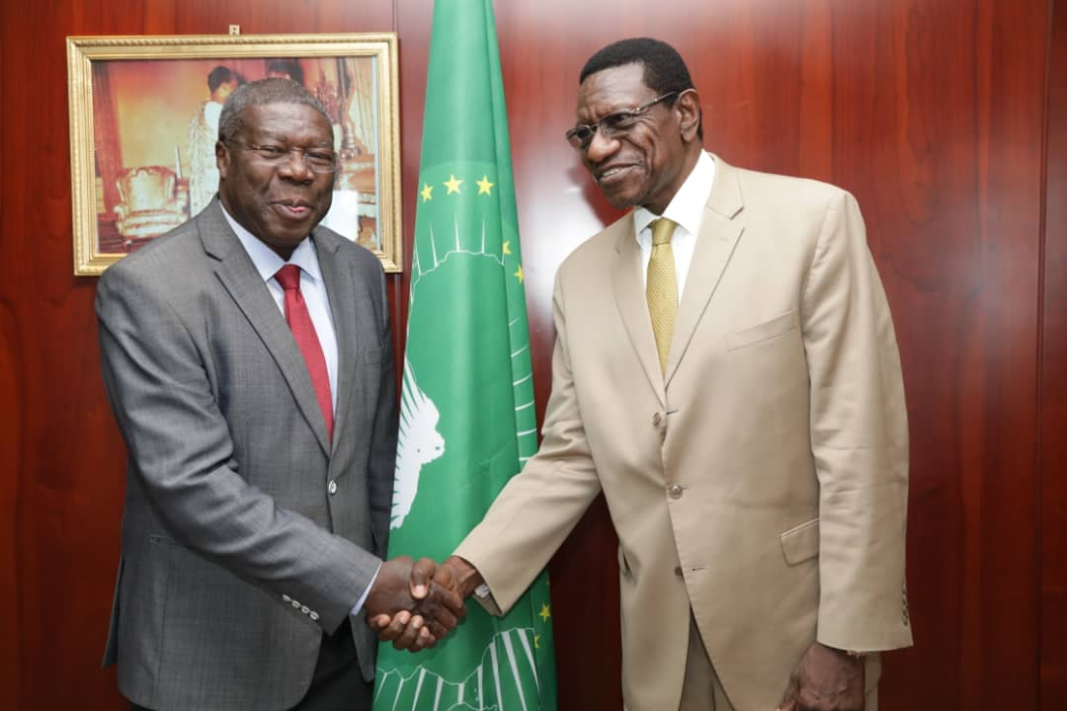
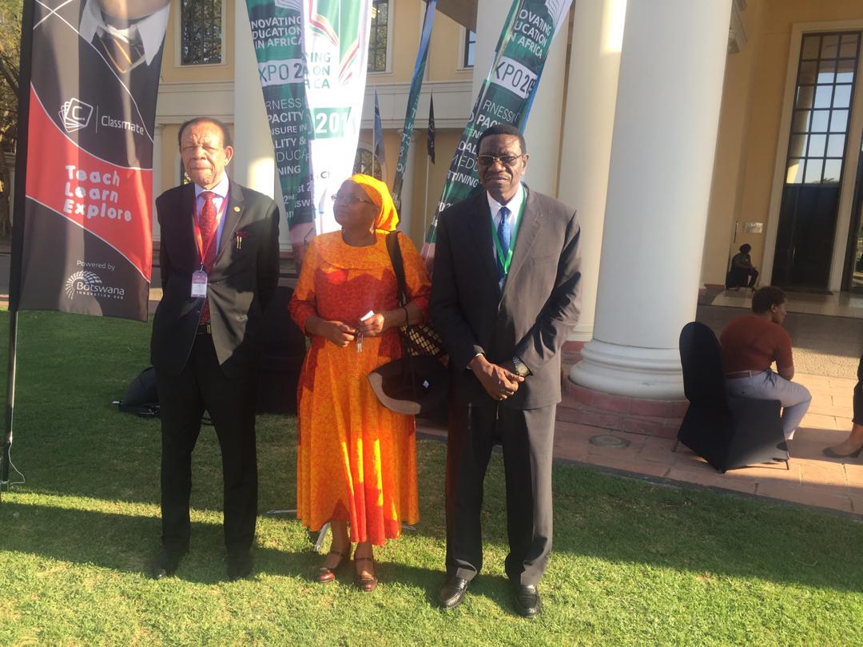
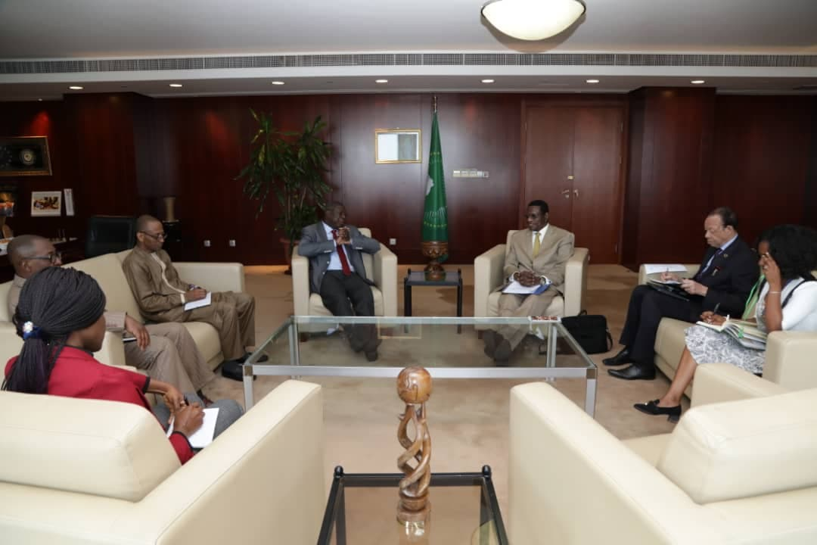

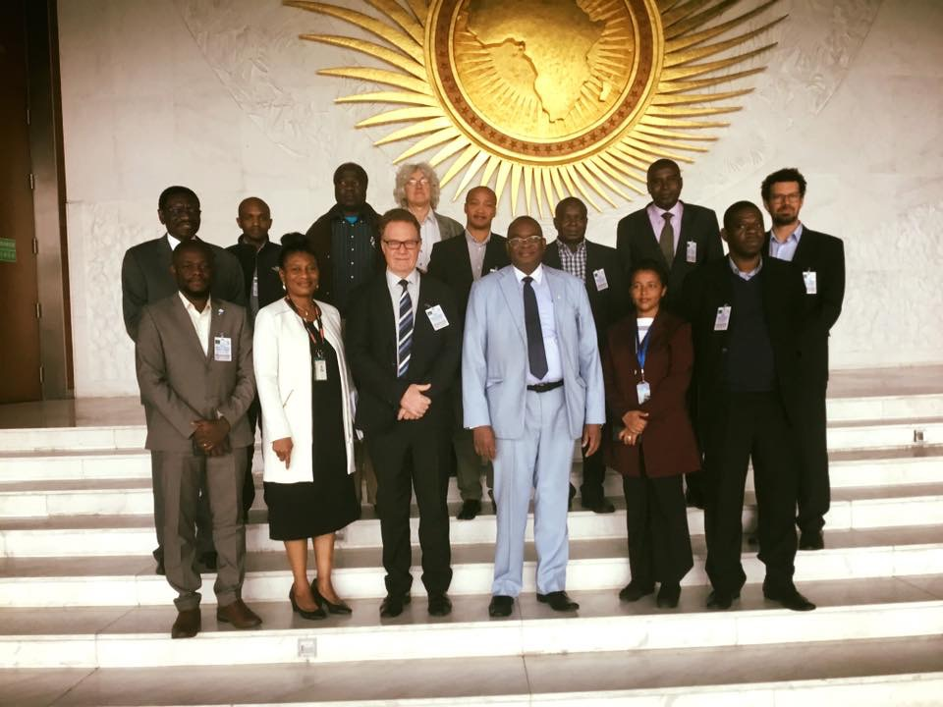

https://www.youtube.com/watch?v=tKvUBnPxQcc

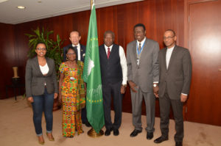

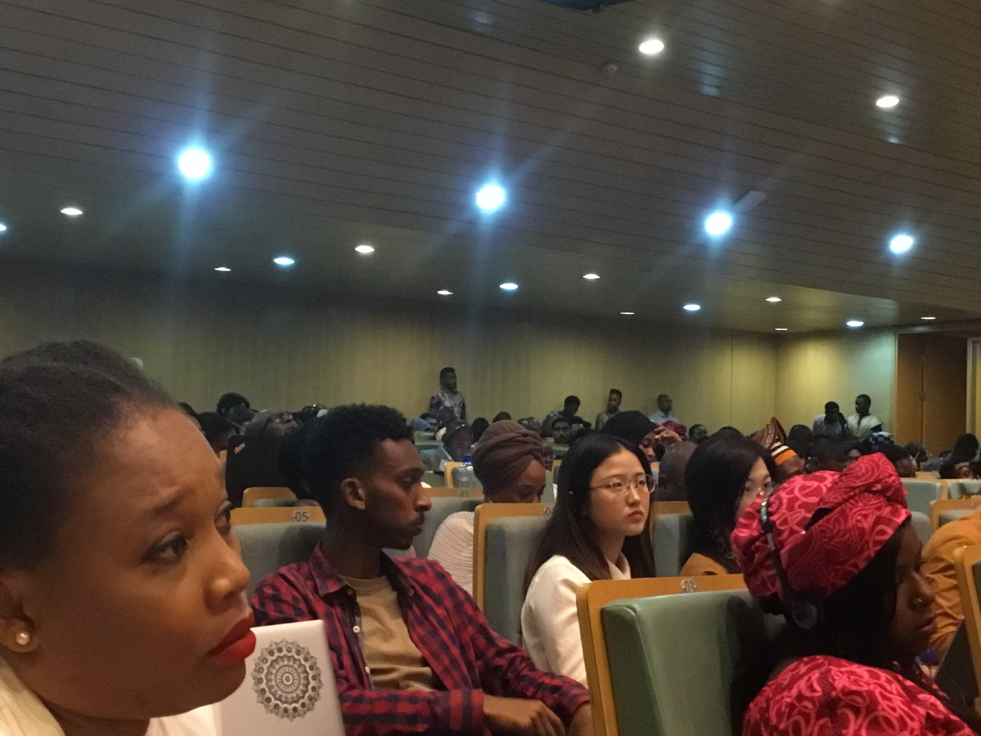

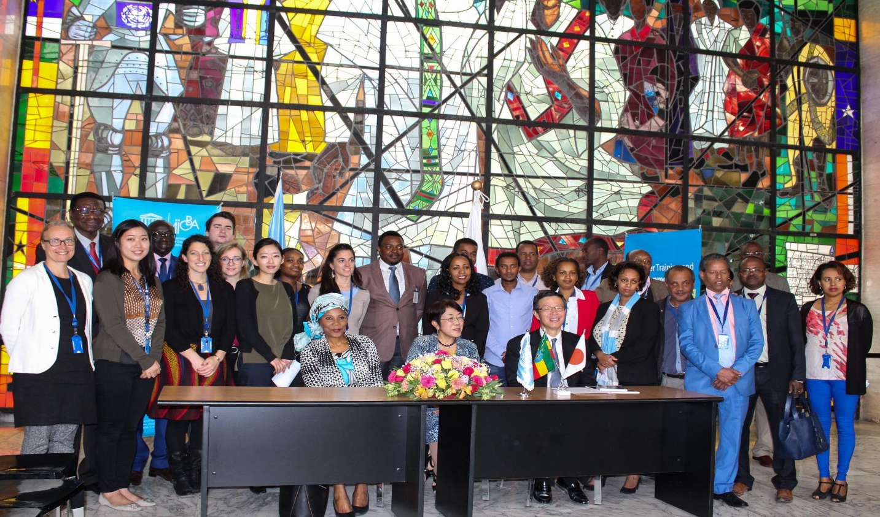
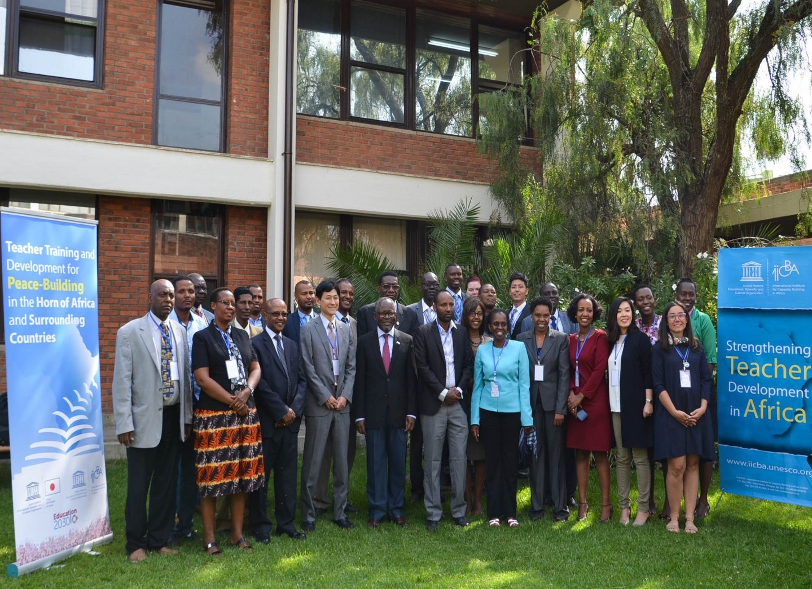
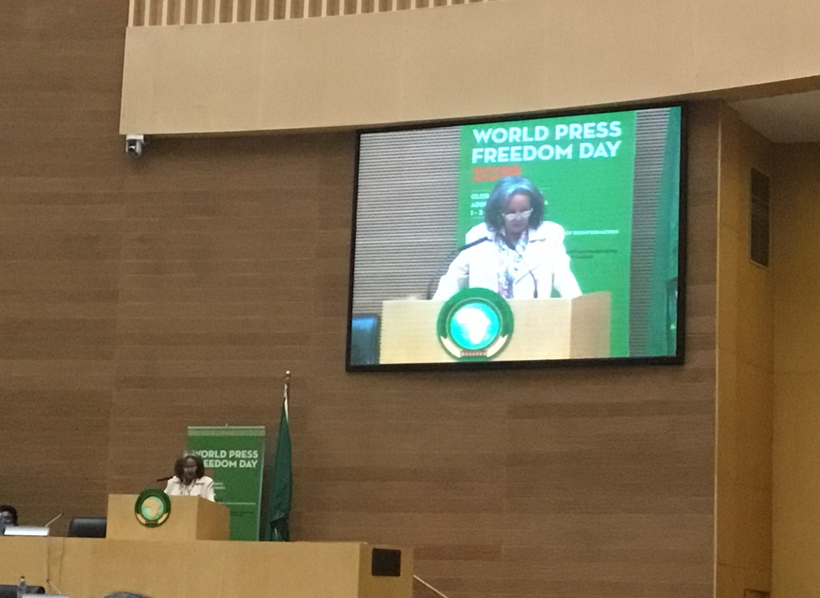
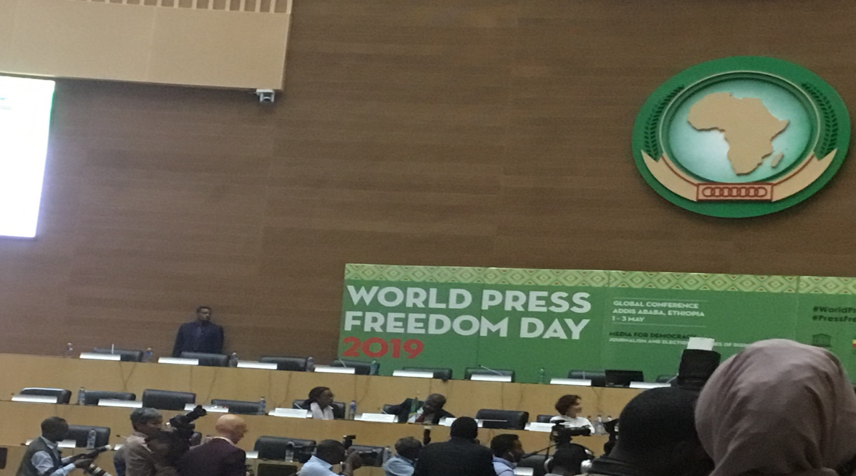
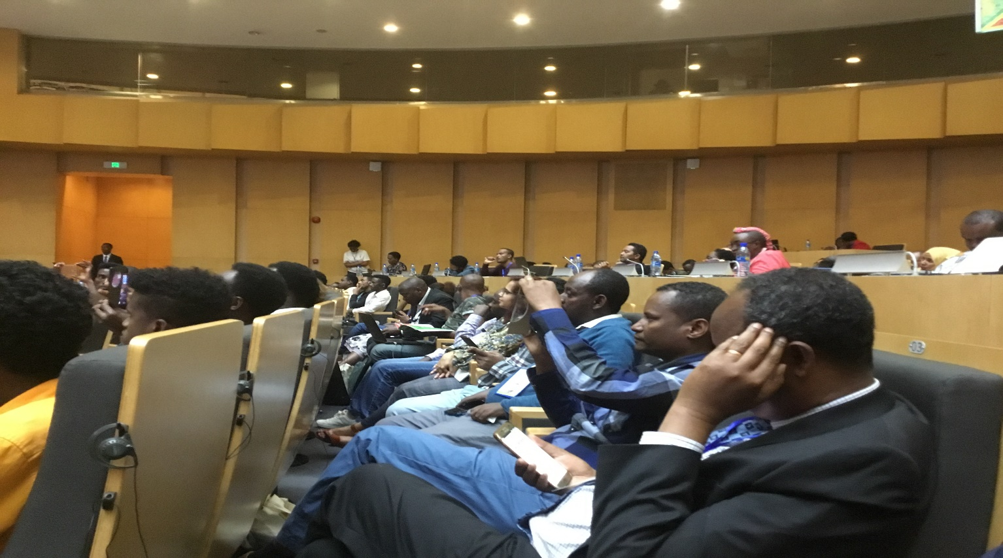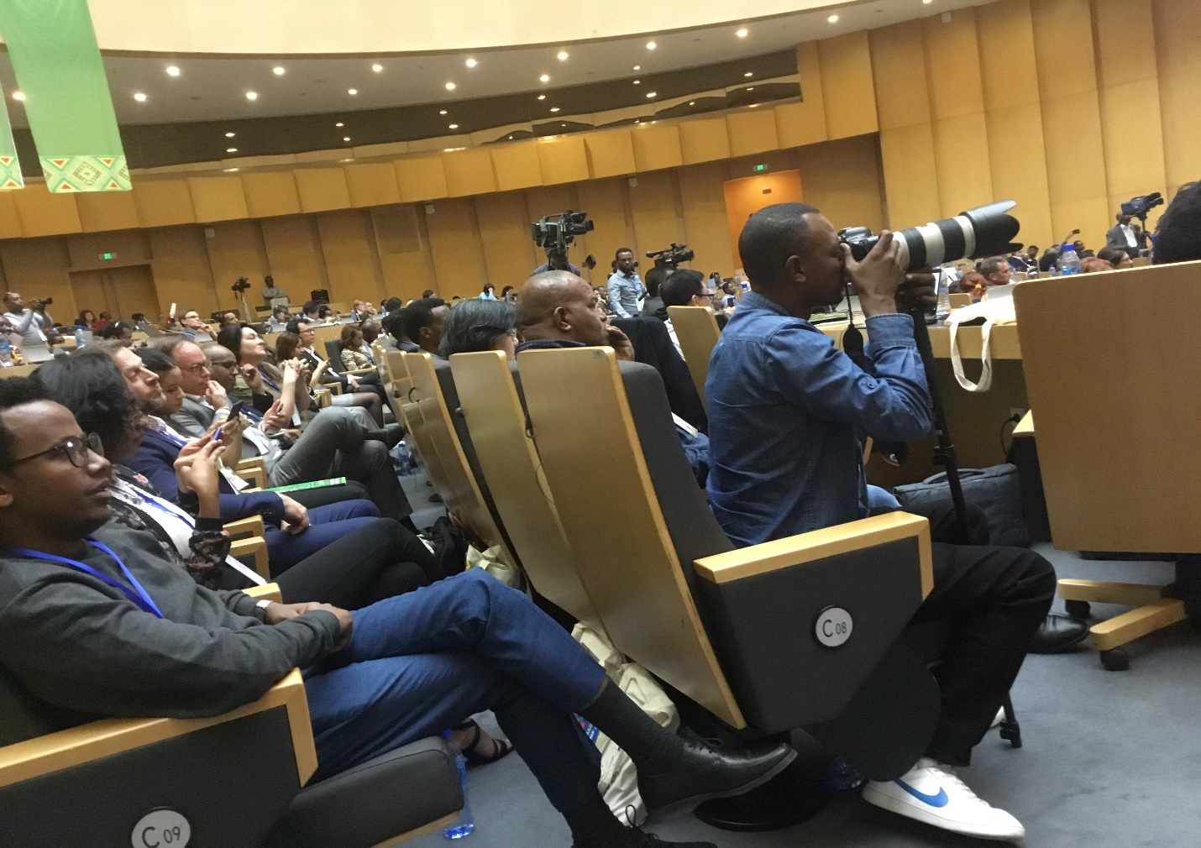

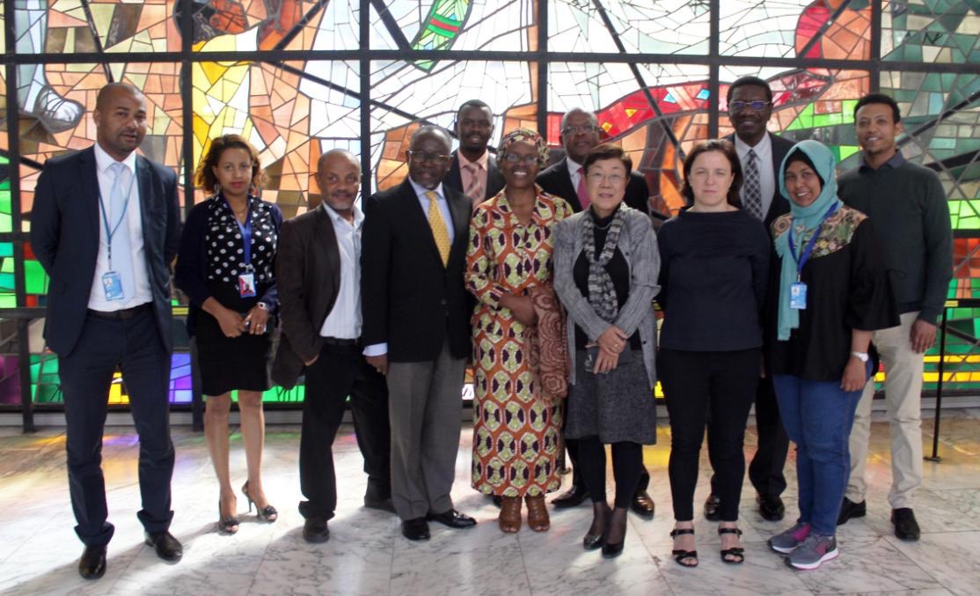

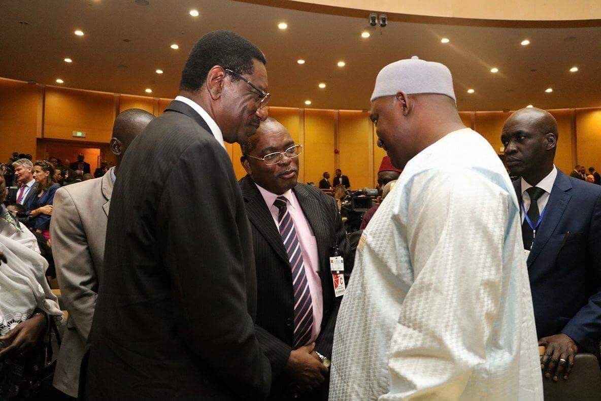
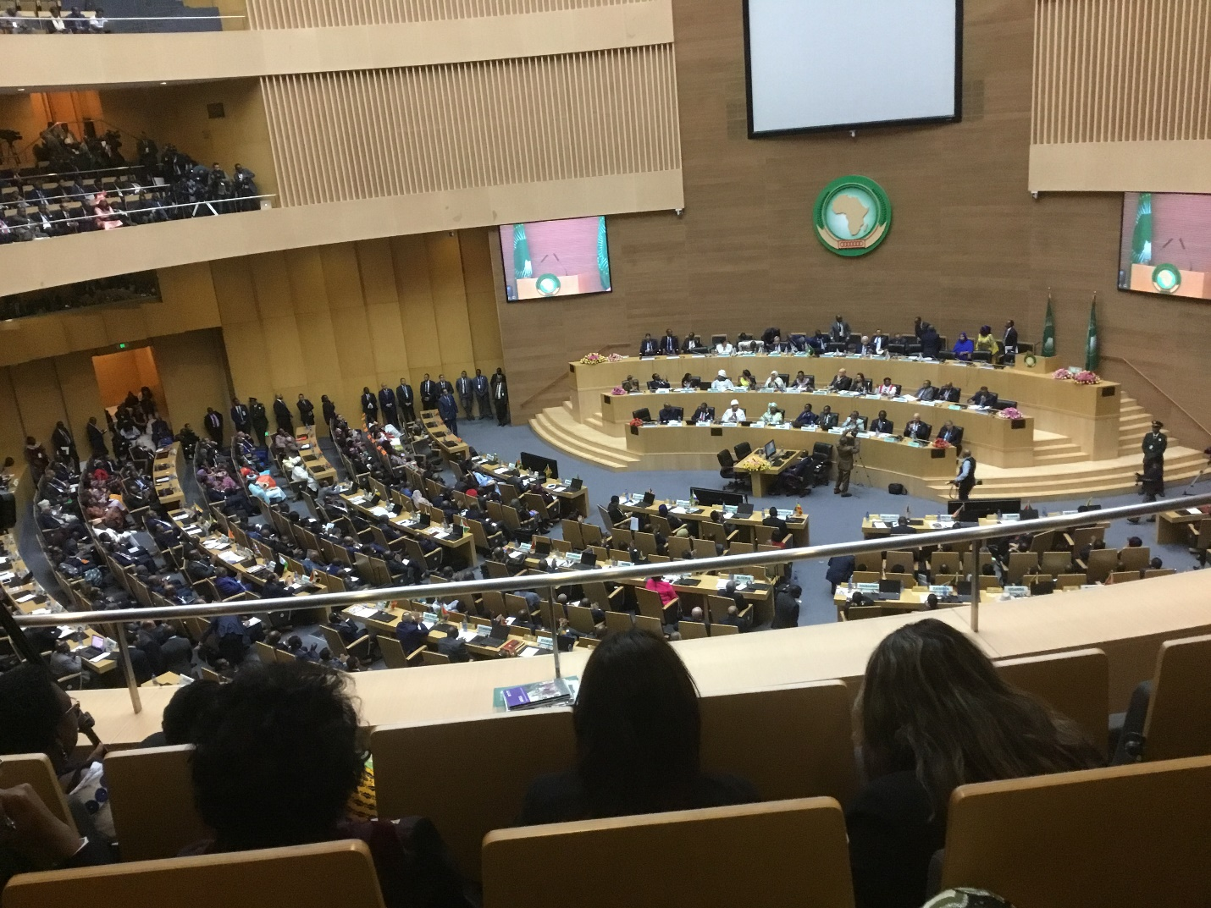

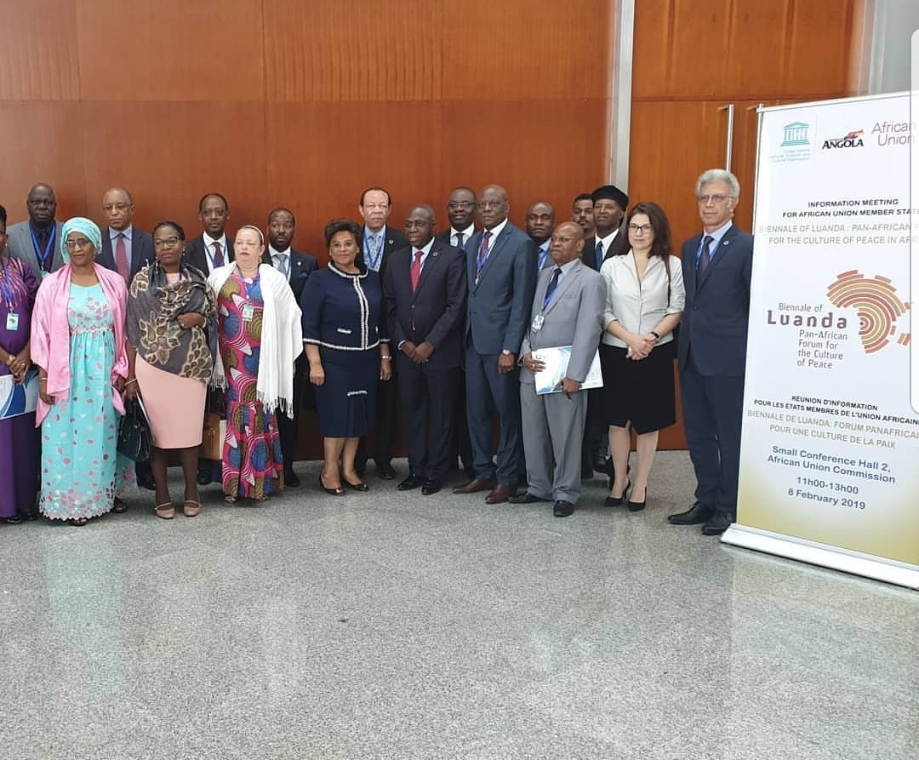

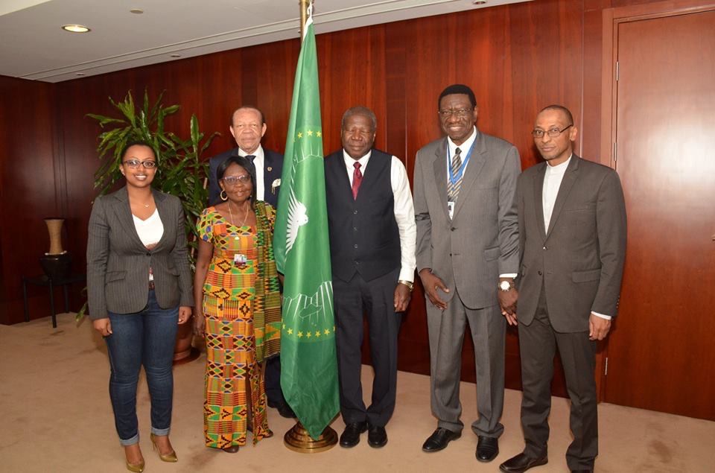

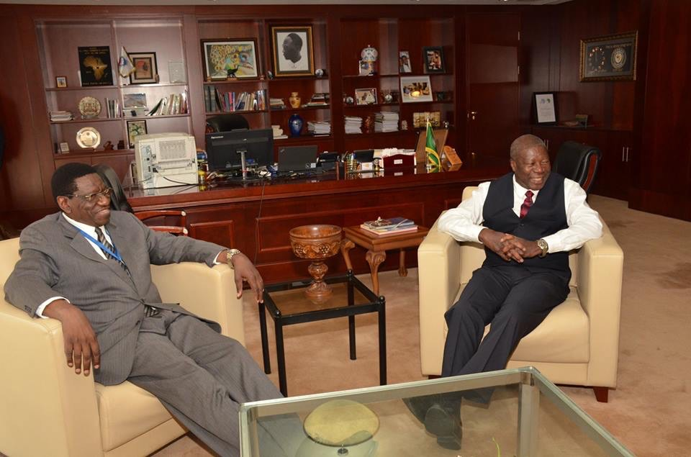

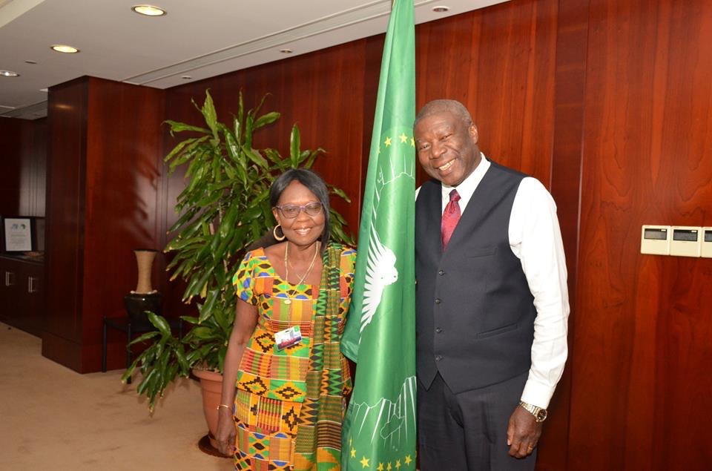

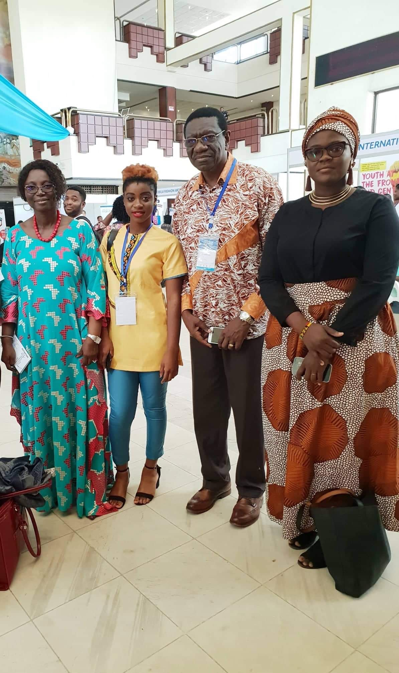
Note: The following needs to be added in the document by Mr Lawalley
- A short description about the photos included above
- Pictures of Press Meetings held by CAFOR needs to be included.
- Add about capital newspaper articles about 2-3 pages
Note: The following needs to be added in the document by Mr Michael
- Mr Michael to insert details of the newspaper articles from the CAFOR website
- Add photos of the Journalists
- Mr Michael to change the title from – Resource Mobilisation Strategy to CAFOR Activity Report from 2018-2020 in cover page.

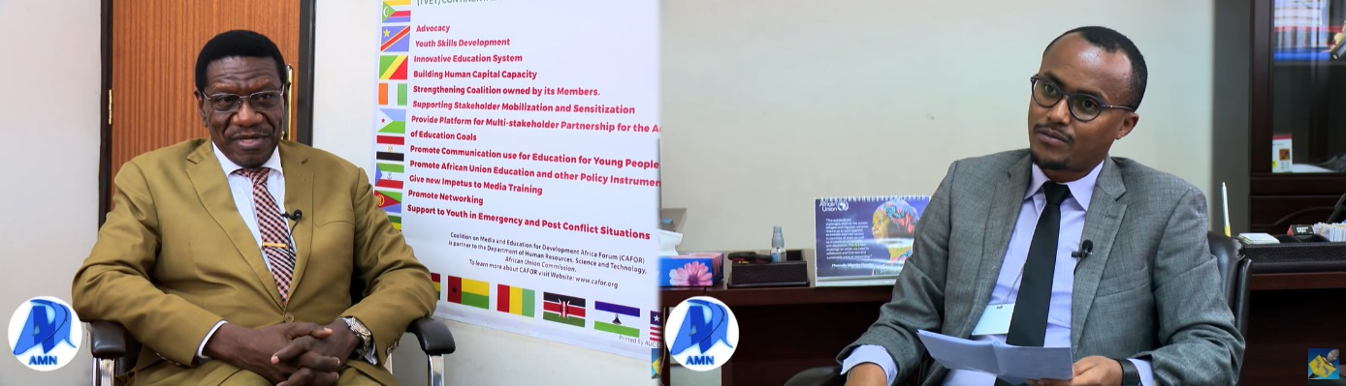
  - CAFOR with the press

.
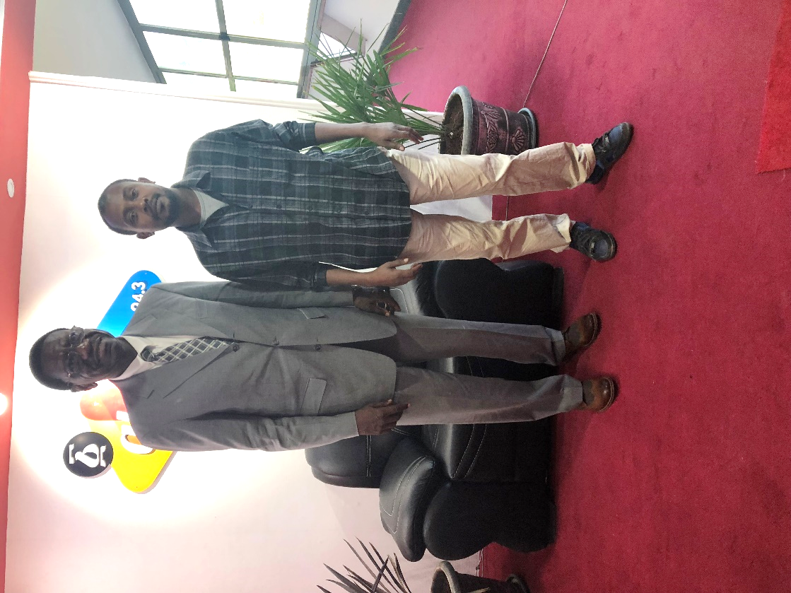
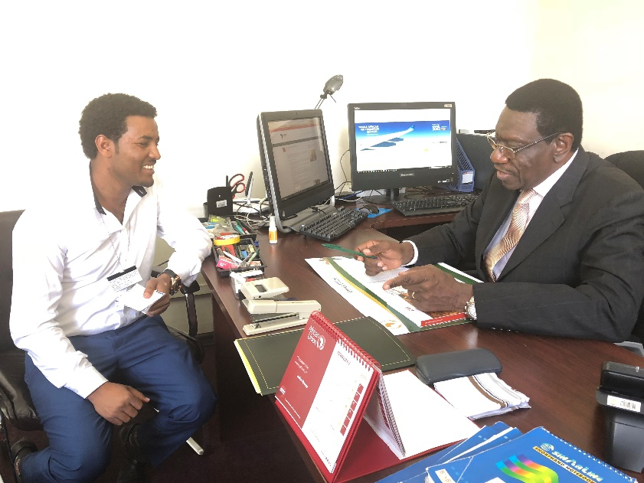
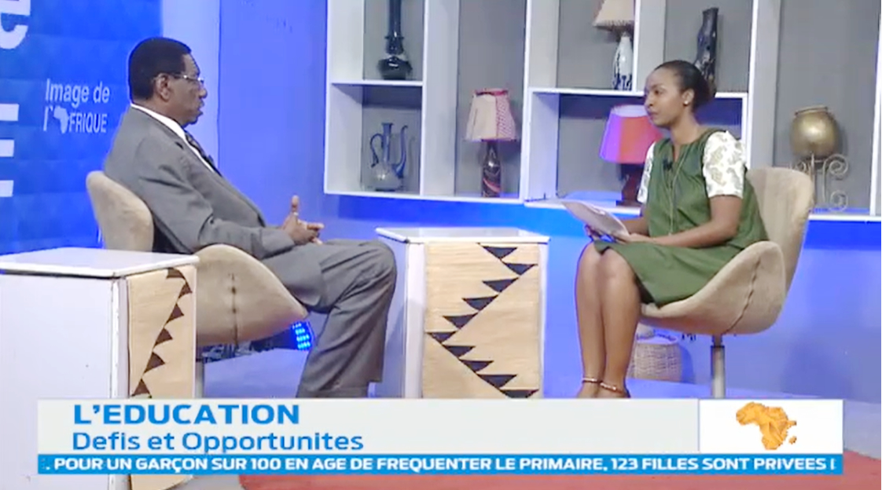

te

